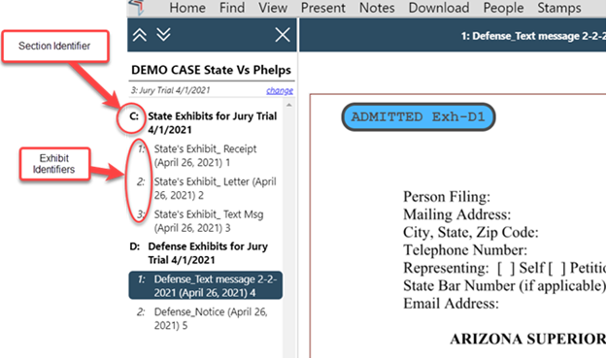

Your consideration of the information provided after the rules comment period has closed is much appreciated.

Please let me know if you have any questions.
Thank you,

 | Summer Dalton  Project Manager  Administrative Office of the Courts  1501 W. Washington, Ste. 410  Phoenix, AZ 85007  Work: 602.452.3496

