Lisa M. Panahi, Bar No. 023421
General Counsel
State Bar of Arizona
4201 N. 24th Street, Suite 100
Phoenix, AZ 85016-6288
(602) 340-7236

IN THE SUPREME COURT
STATE OF ARIZONA
In the Matter of:  PETITION TO AMEND RULE 56 OF THE ARIZONA RULES OF CIVIL PROCEDURE | Supreme Court No. R-20-0040  COMMENT OF  THE STATE BAR OF ARIZONA

Pursuant to Rule 28(e) of the Arizona Rules of Supreme Court, the State Bar of Arizona (the “State Bar”) hereby submits the following as its comment to the above-captioned Petition.
The State Bar of Arizona opposes this Petition to allow individual trial court judges to eliminate separate statements of facts as part of motion for summary judgment briefing.
I. The history and purpose of separate statements of facts.
Summary judgment has been a feature of Arizona practice since at least the Code of 1939. A.C.A. §§ 21-1210 ̶ 21-1216. The burden of the moving party to show there is no genuine issue as to any material fact has been a constant. That burden was implicit in § 21-1212, recognized in early case law, see e.g., Corporation Comm’n v. Southern Pac. Co., 67 Ariz. 87, 94 (1948), and ultimately made explicit in Rule 56.
How the facts are “stated” has evolved over time. Under the 1939 Code, the trial court looked to “the pleadings, depositions, and admissions on file, together with the affidavits, if any.” A.C.A. § 21-1212. Separate statements of facts were first required in 1985 by Rule 4 of the Uniform Rules of Practice for the Superior Court. That rule was repealed effective December 1, 2000 when Rule 56 was amended to require separate statements of facts.
It may be assumed that a need for change was perceived when the Uniform Rule was adopted. The apparent objectives of the Uniform Rule and Rule 56 were to standardize the practice of presenting the facts, impose requirements on their presentation (i.e., concise, numbered paragraphs), and facilitate the determination of whether a fact dispute exists. As the petitioner observes, “separate SOFs could help a judge to quickly determine if the parties disputed material facts because the response would be a simple 'admit' or 'deny' (or words to that effect)."
II. The proposed amendment.
The petition would return Arizona practice, at least before some judges, to the pre-1985 practice. The reasons for doing so are two perceived problems with the current rule and two supposed benefits of the amendment.
The petition asserts that two problems are associated with statements of fact. First, lawyers misuse statements of facts. Specifically, lawyers are said to use the statements of facts for supplemental briefing beyond the presumptive page limits, fail to state the facts concisely, and misplace the statement of additional facts when disputing a movant's facts.
Second, separate statements of facts are reported to make the process more cumbersome for judges using TurboCourt and viewing exhibits on a monitor because the typical structure of memoranda and statements of facts creates a multistep process that does not make it easy to locate a particular exhibit. Specifically, a party’s memorandum refers to a paragraph in the statement of facts, which paragraph in turn refers to an exhibit. In the petitioner’s experience, the exhibits are often not numbered or bookmarked to facilitate their location.
The petition contends that the proposed amendment will also benefit lawyers and clients. Lawyers will not need to create a separate statement or respond to one, and need not worry about overlooking an argument buried in the facts. And clients will be spared the expense associated with statements of facts.
III. Reasons for denying the petition.
A. There are other solutions to the perceived problems.
Judges can address the misuse of statements of facts in the following ways without going to the extreme of eliminating them.
Judicial action. Judges can enforce compliance with the rule. They can strike a noncompliant statement of facts and order the offending party to resubmit it.
Judicial inaction. Judges can ignore argument in statements of facts. As Judge Rayes wrote in the case cited by petitioner, "[w]hen reviewing the non-movant's separate controverting statement of facts, the Court therefore may disregard everything but the word 'admitted' or 'disputed,' and the corresponding references to the record." Hunton v. American Zurich Ins. Co., 2018 WL 1182552, *3 (D. Ariz. Mar. 7, 2018).
Education. On a broader scale, lawyers can be educated regarding proper practice. Judges can emphasize the rule's requirements and warn of the consequences of noncompliance in their individual online protocols and in minute entries in individual cases. And CLE providers can conduct seminars featuring judge faculty members.
Regulating exhibit references. Statements of facts and attachments can be made more user friendly by amending the rule to require that the attachments be sequentially numbered and bookmarked or hyperlinked, and referred to in the motion and statements of fact by page number. Precedent is found in the rule regarding appendices to appellate briefs. Its concepts could be borrowed from and adapted to statements of facts.
(d) Appendix Filed Electronically. A party that files a brief electronically may file a separate appendix or may file a combined brief and appendix as a single document, with the appendix following the brief.
(1) Page Numbering. The pages in an appendix must be numbered sequentially. If a party files a combined brief and appendix, the first page of the appendix must include a number sequential to the last page of the brief. For a separately filed appendix, the numbers should start with the cover page of the appendix.
(2) Multiple Volumes. If a separate appendix is more than one volume, page numbering should restart for each volume and include an identifier that distinguishes each volume (e.g., APPV1-001, APPV2-001).
(3) Bookmarks and Hyperlinks. Each item in the appendix table of contents must include a bookmark or hyperlink to the item in the appendix. If feasible, a combined brief and appendix must contain bookmarks or hyperlinks to items in the appendix whenever these items are cited in the brief.

ARCAP Rule 13.1.
B. Elimination of statements of facts is not a cure-all.
Eliminating separate statements of facts will not eliminate various troublesome practices. As Judge Rayes observed:
Movants too often include immaterial, expositional facts in their separate statements, or take liberties in their characterization or paraphrasing. In turn, non-movants too often use their separate controverting statements to argue over the legal significance of facts – or even semantics – and flood the pages with additional information that is immaterial to the specific issue presented by the motion.

Hunton v. American Zurich Ins. Co., supra at *4. Changing where lawyers are required to state the facts will not prevent bad practices in the manner of their statement. It will merely move those practices into the memoranda. If a lawyer cannot state the facts concisely in a separate statement of facts, that lawyer will do no better in stating the facts in a memorandum.
C. Elimination of statements of facts will not be beneficial.
If lawyers do not have to file separate statements of facts, the moving party will still have to present the same facts in the motion, and the opposing party will still have to present any controverting facts in the response. No appreciable cost savings will result.
Although not mentioned as a benefit in the petition, eliminating separate statements of facts will not reduce a trial judge’s reading burden. Instead, doing so may increase that burden because the facts will be incorporated in the necessarily longer memoranda read by judges. When separate statements of facts are used, trial judges need not read them in every case. Only when the response asserts a genuine issue of material fact must the trial judge look to the statements, and then only to the pertinent paragraphs.
D. Elimination of statements of facts causes other problems.
Lack of a clear, simple record. Without separate statements of facts, the work of both the trial court and appellate court is adversely affected. Separate statements of facts, through side-by-side comparison, serve to neatly and quickly show whether there is a genuine issue of material fact supported by admissible evidence. Requiring separate statements of facts in concise, numbered paragraphs is more likely to produce a useful set of facts than will unregulated narratives in the memoranda. One appellate judge on the State Bar’s Civil Practice and Procedure Committee observed that appellate review of summary judgments without statements of facts could effectively become Anders cases in which the court must search the record for any dispute as to a material fact.
Lack of uniform practice. The proposed rule gives individual judges discretion to order parties to forego separate statements of facts. Consequently, practice could vary from one division to another, which is generally not desirable. Absent a compelling need for variance, the rules and practices should be uniform, especially for such a significant procedure as a motion for summary judgment.
Page limits. Elimination of separate statements of facts requires the facts to be included in the memoranda supporting and opposing the motion. That will either affect the ability to comply with the page limits or require modification of the page limits. Increasing page limits is an imperfect solution. The number of pages necessary to show that there is no genuine issue of fact varies from case to case. A statement might be as short as two pages in a collection action on an account or a promissory note. A motion for summary judgment on a more complex claim, or on a number of claims, will necessarily require more pages. Currently, there is no page limit on separate statements of facts; nor should there be. If the motion’s page limit is increased from 17 pages as would be necessary, the movant in a case in which the facts can be stated in less than the number of additional pages will have more than 17 pages to use for argument. Conversely, a movant in a complex case requiring more than the additional number of pages allowed for inclusion of the facts in the memorandum will have less than 17 pages for argument. Neither consequence is desirable. A party’s ability in a complex case to seek leave to exceed the page limit is not an ideal solution. Such permission is never assured, and seeking permission involves another procedural step with attendant delay and expense.
CONCLUSION
The State Bar of Arizona respectfully requests that the Court deny the Petition for the foregoing reasons.

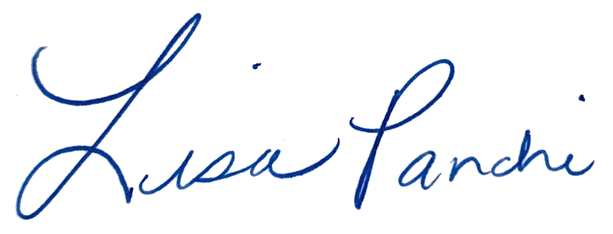
RESPECTFULLY SUBMITTED this 30th day of April 2021.

Lisa M. Panahi
General Counsel

Electronic copy filed with the
Clerk of the Supreme Court of Arizona
this 30th day of April 2021.

by: PSeguin

