Lisa M. Panahi, Bar No. 023421
General Counsel
State Bar of Arizona
4201 N. 24th Street, Suite 100
Phoenix, AZ 85016-6288
(602) 340-7236

IN THE SUPREME COURT
STATE OF ARIZONA
In the Matter of:  PETITION TO ADD NEW RULE 22.1 TO THE ARIZONA RULES OF FAMILY LAW PROCEDURE | Supreme Court No. R-21-  PETITION

Pursuant to Rule 28(a)(1), Arizona Rules of Supreme Court, the State Bar of Arizona (the “State Bar”) hereby requests expedited consideration of the following Petition. The State Bar respectfully requests that the Court consider this Petition at its August 2021 Rules Agenda and proposes the following abbreviated comment period: comments due on or before June 15, 2021; and reply due on or before June 29, 2021.
Pursuant to Rule 28(a), Ariz. R. Sup. Ct., the State Bar hereby petitions the Court to amend the Rules of Family Law Procedure by adding new Rule 22.1 to address the handling of exhibits.

BACKGROUND

This petition is a proposal to amend Rule 22 of the Arizona Rules of Family Law Procedure (ARFLP) to standardize the marking of exhibits for evidentiary hearings and trials.
Presently, the ARFLP does not establish a consistent procedure for the numbering or lettering of party exhibits. As a result, the practice for the identification of hearing exhibits varies by county and by judge within the county, and at times, by matter before the same judge. For example, Pinal County uses a system by which one party’s exhibits are numbers and the other party’s exhibits are letters. In Maricopa County, all parties’ exhibits are numbered, and most Minute Entries state that the Petitioner’s exhibits will be numbered first, with the Respondent’s exhibits following thereafter.
In practice, this leads to confusion and inefficiency for attorneys, pro per litigants, and the court. When the parties are unable to coordinate their exhibit numbers in advance, which happens regularly and particularly in cases where one or both parties are unrepresented by counsel, the Respondent does not know what number to use for their first exhibit because they do not know the last number of Petitioner’s exhibits. If Petitioner’s exhibits are submitted late, then Respondent’s exhibits will be numbered first.
Although many judges try to have their exhibit list distributed in advance of the hearing, the list may be distributed after trial outline and exhibit binder preparation has occurred. The result is often confusion and inefficiency when preparing for trial or providing an exhibit binder to the judge. The tabbed binder provided to the judge and opposing party may not match the official exhibit list. The outline prepared for trial also contains references to exhibits which have a different number on the official exhibit list. Trial time, which is already limited in some counties, is reduced by efforts to locate and reference the correct official exhibit number. This also creates confusion on the record when the binder-tabs and official exhibit numbers are not consistent, especially in preparation for an appeal.
This is a challenge for both attorneys and pro per litigants. Coordination of exhibits are particularly challenging when pro per litigants are ordered not to directly communicate pursuant to a no-contact order. Attorneys may be in a better position to make last-minute changes to the numbering of exhibits with the help of administrative support staff; pro per litigants are generally at a disadvantage in this respect.
Compounding the issue during the current pandemic, most hearings and trials are being held via video conference. Confusion regarding the exhibit numbers is even more difficult to address and clarify by video. In person, documents can be physically shown to opposing counsel, party, a witness, or the judge to ensure clarity. The same convenience is not afforded during video hearings and/or trials.
A uniform system to easily identify exhibits of the respective petitioner or respondent will lead to judicial efficiency and create an effective presentation of evidence and preservation of the record for appeal.
The current Rules do not provide a uniform system; therefore, proposed Rule 22.1 seeks to address the issues raised in this Petition.
CONCLUSION
The State Bar of Arizona respectfully requests that the proposed new rule set forth in the attached Appendix be approved to provide clarity and a uniform manner of handling evidentiary exhibits.
RESPECTFULLY SUBMITTED this 30th day of April 2021.
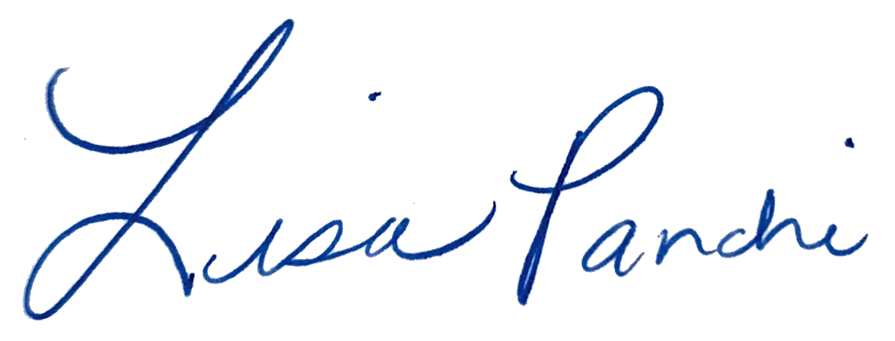

Lisa M. Panahi
General Counsel

Electronic copy filed with the
Clerk of the Supreme Court of Arizona
this 30th day of April 2021.

by: PSeguin

