April 9, 2021

SUBMITTED ELECTRONICALLY

Chief Justice Robert Brutinel
Arizona Supreme Court
1501 W. Washington 4th Fl.
Phoenix, AZ 85007

Dear Chief Justice Brutinel,

The Washington Association of Criminal Defense Lawyers (“WACDL”) submits this letter in support of Proposed Supreme Court Rule 24.

WACDL is an association made up of attorneys practicing criminal defense law in Washington State. It was formed in 1987 to improve the quality and administration of justice. The objectives and purposes of this organization are: (a) To protect and insure by rule of law those individual rights guaranteed by the Washington and Federal Constitutions, and to resist all efforts made to curtail such rights; (b) To improve the professional status of all lawyers and to encourage cooperation between lawyers engaged in the furtherance of our objectives through publications, education, and mutual assistance; and (c) To engage in all activities on a local, state and national level that will advance the purposes for which this organization is formed in order to promote justice and the common good of the citizens of the United States.

WACDL urges the Arizona Supreme Court to adopt Proposed Rule 24 on Jury Selection, which was modeled on Washington’s General Rule 37 (“GR 37”). The Washington Supreme Court adopted GR 37 in April of 2018 to address the intractable problem of discrimination in jury selection. Batson has not worked. The procedures it established are not “robust enough to effectively combat race discrimination in the selection of juries.” State v. Saintcalle, 309 P.3d 326, 329 (Wash. 2013). Indeed, “[t]oday in America, there is perhaps no arena of public life or governmental administration where racial discrimination is more widespread, apparent, and seemingly tolerated than in the selection of juries.” Equal Justice Initiative, Illegal Race Discrimination in Jury Selection: A Continuing Legacy (August 2010) (“EJI Report”) at 4.

Proposed Rule 24’s “reasonable person” standard addresses Batson’s key flaws. First, lawyers who engage in purposeful discrimination “can easily assert facially neutral reasons for striking a juror, and trial courts are ill equipped to second-guess

those reasons.” Batson, 476 U.S. at 106 (Marshall, J., concurring). Second, Batson “requires a finding of ‘purposeful discrimination,’” but “discrimination is often unconscious.” Saintcalle, 309 P.3d at 338. The proposed test will reduce discrimination by acknowledging the operation of implicit bias in the exercise of peremptory challenges.

But the objective standard on its own is insufficient, and this Court should also adopt the presumptively invalid justifications for exclusion set forth in subsections (g) and (h) of the proposed rule. As to subsection (g), negative experiences with the police or justice system are highly correlated with race and rarely relevant to fitness to serve. See Saintcalle, 309 P.3d at 362 (Gonzalez, J., concurring) (citing study noting that striking all persons with a relative in prison could disproportionately exclude racial minorities); Vida B. Johnson, Arresting Batson: How Striking Jurors Based on Arrest Records Violates Batson, 34 Yale L. & Pl’y Rev. 387, 394 (2016) (noting there is “no question” that racial disparities exist with respect to police contacts and arrests); It's still too easy to push blacks, minorities off of juries, USA Today (December 14, 2017) (describing case in which black potential juror was excluded, despite assuring lawyers he could be fair, because he expressed concerns about unfair law enforcement practices).

Proposed subsection (h) is equally important because demeanor-based justifications for exclusion are often rooted in bias. For example, a party’s “own conscious or unconscious racism may lead him easily to the conclusion that a prospective black juror is sullen, or distant, a characterization that would not have come to his mind if a white juror had acted identically.” Batson, 476 U.S. at 106 (Marshall, J., concurring). The concern is not merely hypothetical. Studies show attorneys “frequently justify [peremptory] strikes by making unverifiable assertions about African-American potential jurors’ appearance and demeanor.” EJI Report at 18. Because “we now know that implicit biases can lead members of different races to perceive members of other races as lazy, or hostile, or threatening,” we have an obligation to address the issue by reforming the approach to demeanor-based peremptory challenges. Judge Mark W. Bennett, Unraveling the Gordian Knot of Implicit Bias in Jury Selection: The Problems of Judge-Dominated Voir Dire, the Failed Promise of Batson, and Proposed Solutions, 4 Harv. L. & Pol’y Rev. 149, 164 (2010). Proposed subsection (h) appropriately addresses the issue by requiring notification and corroboration prior to a demeanor-based dismissal.

Overall, adopting Proposed Rule 24 will improve the administration of justice in Arizona. Anecdotal evidence indicates that jury selection in Washington has become more fair and less discriminatory in the three years since GR 37 was adopted. First, the rule has greatly increased awareness of the issue, and this educational effect appears to have resulted in a much more careful, limited exercise of peremptory challenges by attorneys. Second, when attorneys do exercise questionable peremptory strikes, judges are much more willing to sustain GR 37 objections than they were under Batson’s impossible standard. Finally, while appellate courts had never reversed for a Batson violation in the decades prior to Saintcalle, 309 P.3d at 335, they have enforced GR 37 when both prosecutors and defense attorneys have attempted to skirt its anti-bias imperatives. See State v. Listoe, 475 P.3d 534, 536 (Wash. Ct. App. 2020) (reversing where objective observer “could view race as a factor in the State's use of the peremptory challenge); State v. Omar, 460 P.3d 225, 226, review denied, 475 P.3d 164 (2020) (affirming trial court’s disallowance of defense peremptory challenge because “an objective observer could view race as a factor in the use of the challenge”). Although no rule is perfect, GR 37 is far more effective than Batson, and Proposed Rule 24 would likewise improve the administration of justice in Arizona.

WACDL thanks this Court for considering Proposed Rule 24, and respectfully urges the Court to adopt it in its entirety.

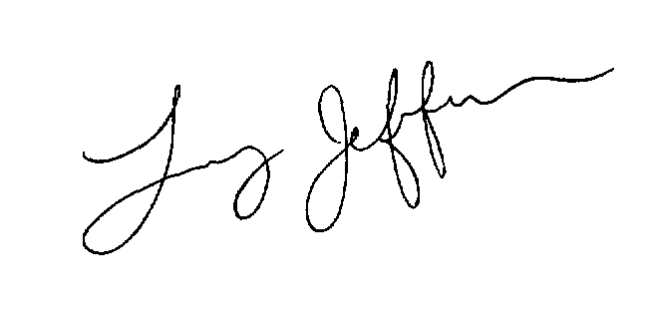
Sincerely,

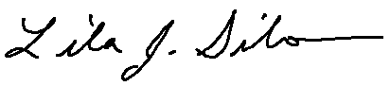
Lila J. Silverstein Larry Jefferson
Washington Appellate Project WACDL President
GR 37 co-drafter and WACDL
rep on GR 37 Working Group

Available at: https://www.usatoday.com/story/opinion/policing/2017/12/14/jury-selection-race-policing-usa-discrimination/706549001/.

