Vice Chief Justice Ann A. Scott Timmer, Chair
Attorney Regulation Advisory Committee
Arizona Supreme Court
1501 W. Washington St.
Phoenix, AZ 85007
IN THE SUPREME COURT
STATE OF ARIZONA

In the Matter of:  PETITION TO AMEND RULE 42.1, ARIZ. R. SUP. CT. | )  )  )  )  )  )  )  ) | Supreme Court No. R-21-0018  Comment of the Attorney Regulation Advisory Committee in Support of Proposed Rule Change

Pursuant to Rule 28, Rules of the Supreme Court of Arizona, the Attorney Regulation Advisory Committee (“ARC”) respectfully submits this comment in support of the above-referenced proposed rule amendments with the modification to allow a Compliance Lawyer of a licensed Alternative Business Structure to request ethics opinions on behalf of the Alternative Business Structure.
Attached as an appendix is a draft of the proposed amendment, modified to allow the Compliance Lawyer of an Alternative Business Structure to request an ethics opinion on behalf of the Alternative Business Structure. In addition, the modification corrects a typographical error found in 42.1(b)(1)(A).
ARC respectfully requests the Supreme Court adopt the amendments to Rule 42.1 as modified by the language of the appendix.
RESPECTFULLY SUBMITTED this 22nd day of April, 2021.
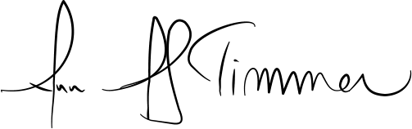

________________________________________
Vice Chief Justice Ann A. Scott Timmer, Chair
Attorney Regulation Advisory Committee

