Vice Chief Justice Ann A. Scott Timmer, Chair
Attorney Regulation Advisory Committee
Arizona Supreme Court
1501 W. Washington St.
Phoenix, AZ 85007
IN THE SUPREME COURT
STATE OF ARIZONA
In the Matter of:  PETITION TO AMEND RULE 34(f)(4)  ARIZ. R. SUP. CT. | )  )  )  )  )  )  ) | Supreme Court No. R-21-0013  Comment of the Attorney Regulation Advisory Committee

The Arizona Supreme Court’s Attorney Regulation Advisory Committee respectfully submits this comment regarding Rule Petition R-21-0013. During its review and discussion, it was noted the Committee does not fully support the petition as written. Nevertheless, a unanimous motion was made to support a revision to Rule 34(f) that would repeal the eligibility criteria set forth under Rule 34(f)(4). This revision would permit all applicants to be eligible for admission on motion on the basis the applicant has been admitted to and engaged in active practice of law in an appropriate jurisdiction for three of the last five years immediately preceding the date upon which the application is filed.
Therefore, the Committee respectfully recommends the Arizona Supreme Court revise Rule 34(f) and repeal Rule 34(f)(4), to grant eligibility for admission on motion on the basis the applicant fulfills the active practice of law timeframe requirement set forth under Rule 34 (f)(1)(A).
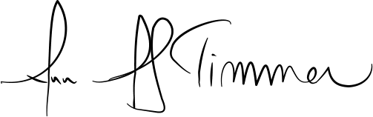
RESPECTFULLY SUBMITTED this 22nd day of April, 2021.

__________________________________________________
Vice Chief Justice Ann A. Scott Timmer, Chair
Attorney Regulation Advisory Committee

