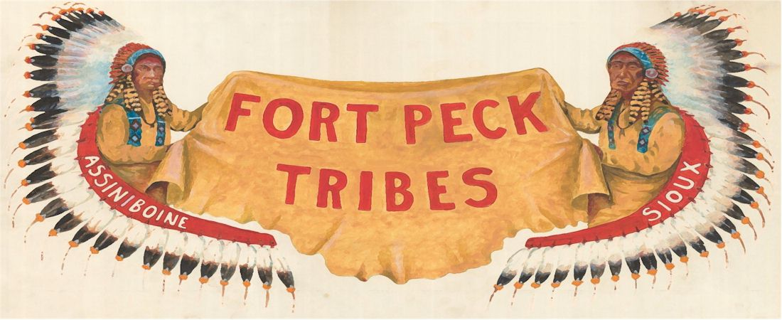

April 30, 2020

Submitted Electronically Only Via Court Rules Forum
Arizona Supreme Court Rules Forum
Arizona Supreme Court
1501 West Washington Street, Room 402
Phoenix, AZ 85007-3329

Re: Arizona Supreme Court Rule 39
Honorable Justices of the Arizona Supreme Court:
The Ft. Peck Tribes ICWA Office is writing in support of the proposed amendment to allow an exception for the pro hac vice associate counsel requirement and fee for non-member attorneys representing Indian Tribes in Indian Child Welfare Act Proceedings.
Members of the Fort Peck Tribes have settled across the United States. The Fort Peck Tribes receive a large volume of notices on dependency actions that have triggered the Indian Child Welfare Act (ICWA) involving potential tribal members who reside off the reservation outside of the State of Montana.
If all state jurisdictions were to require local counsel association and fees for pro hac vice purposes from the Fort Peck Tribes in ICWA cases, the administrative and financial burden would substantially limit the Fort Peck Tribes’ ability to advocate meaningfully on behalf of all their children.
Beyond the clear financial burden for the Fort Peck Tribes to hire attorneys all around the Country, multiple attorneys hamper the ability of the Tribes to efficiently maintain a consistent response for all their tribal children in ICWA matters. Each attorney would have to be brought up to speed on the cultural customs and norms of the Tribes along with current Tribal policies, procedures, and services regarding tribal children in dependency actions under ICWA.
Adoption of this amendment would improve the Fort Peck Tribes’ participation in Arizona proceedings involving tribal children and allow for the best communication between all the parties, thus improving the outcomes for tribal children in the Arizona court system. Thank you for your consideration of this letter of support.

Sincerely,

Georgette Hogan Boggio
ICWA Counsel on behalf of Ft. Peck Tribes

Cc: Hon. Randall Howe, Vice-Chair, Arizona State, Tribal, and Federal Court Forum (TribalCourtForum@courts.az.gov)

