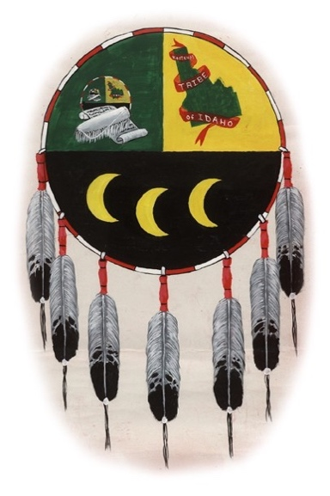 | Kootenai Tribe of Idaho  P.O. Box 1269  100 Circle Drive  Bonners Ferry, ID 83805  Ph# (208) 267-3519  Fax (208) 267-2960

April 28, 2020

Filed Electronically via Azcourts.gov

RE: Supreme Court Rule 39

The Kootenai Tribe of Idaho comments in support of the proposed amendment to Supreme Court Rule 39 which would waive pro hac vice requirements for out of state tribal attorneys participating in child welfare hearings pursuant to the Indian Child Welfare Act (ICWA).

The Indian Child Welfare Act is a critical law that helps protect the best interests of our Indian children and promotes the stability of Indian tribes and families. ICWA recognizes that removing children from Indian communities harms children who are denied the benefit of tribal culture and community.

Removing barriers to tribal involvement in these cases will reduce the financial burden on Tribes' limited resources and help with early tribal involvement and better outcomes for our children.

The proposed amendment will promote better protection for Indian children in Arizona Courts and should be approved.

Sincerely,

Gary Aitken, Jr.
Chairman

