Hon. Ann A. Scott Timmer, Chair
Attorney Regulation Advisory Committee
Arizona Supreme Court
1501 W. Washington St.
Phoenix, AZ 85007

IN THE SUPREME COURT
STATE OF ARIZONA

In the Matter of:  PETITION to Amend SC Rule 32 – The People Exercising Final Authority Over Attorney Licensing and Discipline After the State Bar Has Made Their Decision – Attorneys Have Rights Also | )  )  )  )  )  )  )  )  )) | Supreme Court No. R-20-0026  Comment of the Attorney Regulation Advisory Committee

The Attorney Regulation Advisory Committee (“ARC”) respectfully recommends that the Arizona Supreme Court deny Petition R-20-0026 (“Due Process for Attorneys”) (the “Petition”). ARC’s recommendation is based on two considerations.
First, ARC disagrees with the Petition’s premise that Arizona attorneys lack due process under the current rules governing lawyer discipline proceedings. Under the current system, the State Bar must prove by clear and convincing evidence that a lawyer has committed a violation of one or more rules governing lawyer conduct. The lawyer receives notice of the charges, an opportunity to be represented by counsel, to cross-examine witnesses, and to present evidence and argument in the lawyer’s defense. Lawyer discipline cases are heard by a panel consisting of the Presiding Disciplinary Judge (who also makes all legal and evidentiary rulings), a member of the State Bar of Arizona, and a member of the public. Following a decision on the merits by the hearing panel, either the respondent lawyer or the State Bar can appeal the decision directly to the Arizona Supreme Court. ARC believes this system provides adequate protection and opportunity for a fair hearing, and there is no public policy need or justification for the Petition’s suggestion that lawyers should also have an option to demand a trial by jury in Superior Court.
Second, ARC believes the Petition is deficient because it lacks specificity and fails to present specific language for a rule change. That being said, even if the Petition had contained specific language for a rule change consistent with the stated purpose of the Petition, ARC would nevertheless recommend denying the Petition because of the public policy considerations stated above.
Based on the foregoing, ARC respectfully urges the Arizona Supreme Court deny this Petition.
RESPECTFULLY SUBMITTED this 21st day of April, 2020.
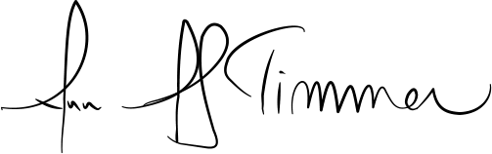

_________________________________
Hon. Ann A. Scott Timmer, Chair
Attorney Regulation Advisory Committee

