Hon. Ann A. Scott Timmer, Chair
Attorney Regulation Advisory Committee
Arizona Supreme Court
1501 W. Washington St.
Phoenix, AZ 85007

IN THE SUPREME COURT
STATE OF ARIZONA

In the Matter of:  PETITION TO AMEND RULES 33, 34, 35 AND 37, RULES OF THE SUPREME COURT OF ARIZONA | )  )  )  )  )  )  )  )  ) | Supreme Court No. R-19-0044  Comment of the Attorney Regulation Advisory Committee in Support of Proposed Rule Change

Pursuant to Rule 28(e), Rules of the Arizona Supreme Court, the Attorney Regulation Advisory Committee (ARC), respectfully urges this Court to adopt the proposed amendments to Rules 33, 34, 35 and 37, Rules of the Arizona Supreme Court, as proposed in this petition.
RESPECTFULLY SUBMITTED this 21st day of April, 2020.
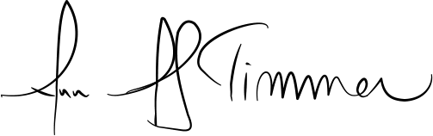

_________________________________
Hon. Ann A. Scott Timmer, Chair
Attorney Regulation Advisory Committee

