Hon. Ann A. Scott Timmer, Chair
Attorney Regulation Advisory Committee
1501 W. Washington St.
Phoenix, AZ 85007
IN THE SUPREME COURT
STATE OF ARIZONA
In the Matter of:  PETITION R-20-0020 TO AMEND  RULES 34 THROUGH 37, RULES  OF THE SUPREME COURT OF  ARIZONA | Supreme Court No. R-20-0020  Comment of Attorney Regulation Advisory Committee
The Arizona Supreme Court’s Attorney Regulation Advisory Committee (“ARC”) supports the petition to amend Rules 34 through 37 of the Rules of the Supreme Court of Arizona, with two members (Judge Lawrence Winthrop and Attorney Member Scott Rhodes) opposing proposed Rule 34(m).
In all but one instance, ARC unanimously supports the proposed changes to Rules 34 through 37. The proposed amendments are appropriate refinements of the rules governing admission to the practice of law in Arizona and ARC recommends the Supreme Court approve them. As to proposed Rule 34(m), a majority of ARC supports the proposed amendment to allow the Committee on Character and Fitness to decline to allow the withdrawal or deferral of an application for admission once an applicant has submitted an associated Character and Fitness Application. In the rare instance where an applicant has been deceitful in his or her application, the Committee should have the authority to make a decision on the application based on the submitted information rather than allowing the applicant to unilaterally withdraw his or her application and reapply with a new application at a later date. Rule 34(l) allows an applicant to abandon an application before it is considered complete by the Committee.
RESPECTFULLY SUBMITTED this 21st day of April, 2020.
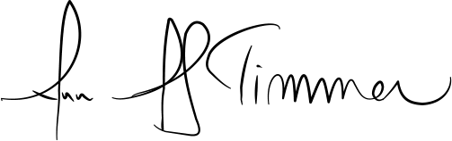

_________________________________
Hon. Ann A. Scott Timmer, Chair
Attorney Regulation Advisory Committee

