Tracy L. Ward
7683 W. Maroni Avenue
Peoria, AZ 85382
623.842.3182
TracyWard2006@yahoo.com

IN THE SUPREME COURT
STATE OF ARIZONA
In the Matter of:  PETITION TO AMEND RULE 43 OR THE ARIZONA RULES OF SUPREME COURT | Supreme Court No. R-19-0030  REPLY IN SUPPORT OF PETITION AND TO THE  STATE BAR OF ARIZONA’S COMMENT

Pursuant to Rule 28(D) of the Arizona Rules of Supreme Court, Petitioner hereby submits the following as her Reply in support of her petition and to the State Bar of Arizona’s (the “State Bar”) Comment.
The proposal makes changes and additions to Rule 43, Ariz. R. Sup. Ct., to update requirements, clarify and define terms and expand the use of technology that will help both lawyers and their clients.
DISCUSSION
Petitioner submitted the proposed changes to Rule 43 to update, clarify and allow the use of technology as it continues to advance in an effort to help both lawyers and their clients. Petitioner disagrees with the State Bar that these changes would remove protections for the public. Petitioner’s proposed changes do not change the responsibilities of lawyers to maintain internal controls or maintain the proper recordkeeping for all funds held in trust.
- In response to proposed amendments to Rule 43(b)(2) (i), (ii) and (iii):
Amendments to terminology should not be contained in a comment. Changes that will help lawyers remain in compliance should not be placed in the fine print of a rule. Changes should be placed within the text where they are pertinent.
The additional definitions proposed for the subsections of Rule 43(b)(2)(B)(i), (ii), and (iii) are necessary. Regarding subsections (i) and (ii), it should be clear to lawyers that they must identify the payee and payor and what those terms mean. This information is frequently incorrect when it comes to deposits entered on the ledgers. Lawyers, their staff, accountants or others who are entering this information do not realize that they must, for example, identify Grandma having provided the funds; instead, they simply enter the client’s name on the ledger. Lawyers are entitled to know the specific requirements. Comments, after all, are intended to
explain and illustrate the meaning and purpose of the Rules, not to add requirements. See Preamble [21], Rules of Professional Conduct, Rule 42, Ariz. R. Sup. Ct. For this reason, the proposed changes to these subsections should be added to the Rule and not buried in the fine print.
As to subsection (iii), ambiguity is already in this part of the rule and should be clarified. This subsection currently states that “any unexpended balance” is required. The State Bar has determined that “unexpended balance” means a running balance on the ledgers. Petitioner requested that the definition of “unexpended balance” be defined as either a running balance or an ending balance. By excluding the ending balance definition, this affects popular software programs such as Quicken. An unexpended balance is always available, however, reports printed from Quicken show an ending balance rather than a running balance. Lawyers can always look back in time at specific dates to see a balance. Programs such as Quicken are date based, meaning the user can set the time period in which they would like to see a report. (See Exhibit A – Sample Quicken Administrative and Client Ledger Reports). The last figure on a running balance report and the last figure on a report with an ending balance would be exactly the same figure. (See Exhibit B – Sample QuickBooks Administrative and Client Ledger Report). The same is true for the check register/ledger in Quicken. (See Exhibit C – Sample Quicken Check Register/Ledger). In addition, when the lawyer is entering transactions into Quicken they see the running balance. (See Exhibit D – Screenshot of Quicken Account).
If a lawyer submits a report from Quicken in a discipline matter, it is cited as a violation of this subsection even though the unexpended balance is clearly part the report.
- In response to proposed amendment in Rule 43(b)(2)(D):
a. Petitioner did not suggest that lawyers should be allowed to substitute “codes” as the payor or payee or to replace any other information required on the ledgers. The idea that a deposit slip provides an audit trail is out of date. A deposit slip simply shows: date, amount, financial institution and partial account number. Without the lawyer specifically writing client information on the slip/receipt it would be nothing but a piece of paper with transaction information. Again, if the lawyer submitted records to discipline and did not have a deposit slip/receipt with client information written on it, it is considered another violation regardless whether all the information was properly entered on the ledgers. All cleared deposits and disbursements appear on the bank statement. Using the transaction code from the bank statement requires the lawyer to more closely review transactions on the bank statement and match them specifically with their ledgers. Technology is only going to continue to advance. Allowing the use of codes does not change the fact that lawyers are required to identify the payee/payor on their ledgers.
b. Petitioner agrees that Rule 43(b)(2)(D) does not require lawyers to maintain documentation of the monthly three-way reconciliation and only requires them to conduct one. The State Bar states “such a requirement is unnecessary for an adequate examination of the trust account.” But if the State Bar believes a three-way reconciliation is unnecessary, then why bother prosecuting lawyers who do not conduct one? Absent an admission from a lawyer, how can the State Bar prove no three-way reconciliation was completed in a discipline matter since the rule does not require any documentation of such? One can argue that the rule states that it needs to be completed each month. It does not state that it has to be completed correctly. The lawyer could know that the trust account has been off $5.00 for the last 10 years, but they still conducted the reconciliation each month. This Rule contains no information that all three pieces of the reconciliation need to match, what to do if they do not match and that they need to keep that documentation. While all of that should be included in the Rule, that may require a future rule petition. Lawyers should be required to keep documentation of the three-way reconciliation to assist them in recordkeeping and to protect their clients.
- In response to proposed amendment to Rule 43(b)(3)(B):
This language is necessary to inform lawyers that they need to replace funds removed by a chargeback only if they disbursed the funds prior to the chargeback or if any fees were charged as part of the transaction. It is additional information to help lawyers understand when they need to replace funds when a chargeback occurs.
- In response to proposed amendment to Rule 43(b)(5):
a. Petitioner has requested that the instrument used to disburse from the IOLTA account not have to be identified as such. IOLTA accounts are thought to contain significant amounts of money. Lawyers and their IOLTA accounts are routinely targeted by scams. The State Bar, other jurisdictions, financial institutions and the American Bar Association have issued warnings of fraud numerous times to lawyers. LawPro (Lawyer’s Professional Indemnity Company) in Canada lists every fraud they receive regarding lawyers (see www.avoidaclaim.org). The ABA posted an article on March 31, 2017 of a man convicted of defrauding more than 100 lawyers out of $23 million. By keeping the IOLTA label, this just continues to advertise this account. As previously mentioned, all cleared transactions IOLTA are on the bank statement. Uncleared and cleared transactions are required to be entered by lawyers on their ledgers. There is no reason to have “IOLTA” printed on a check, debit/credit card or other electronic disbursement.
According to the 2019 Association for Financial Professionals Payments Fraud and Control Survey Report (underwritten by J.P. Morgan), checks are the number one method of fraud for businesses. While there is positive news that the number decreased from between 2017 and 2018, that number is still at 70 percent. Why are checks the number one method of fraud? A check contains all the information necessary to commit fraud, including: check style (size, color, type), account structure, account number, routing number, financial institution, numbered sequence, and signature. In addition, a check passes through many hands. It is no wonder why checks are the number one method of fraud. Checks are no longer the safe method of disbursing.
The same is true about wire transfers, which the State Bar prefers as a method of disbursement. The same AFP study found that 43% of fraud is conducted by wire transfers making them the second highest method of fraud.
The current rule already allows for electronic transfers. As defined by the Consumer Financial Protection Bureau (https://www.consumerfinance.gov/policy-compliance/rulemaking/regulations/1005/3/) electronic funds transfers means any transfer of funds that is initiated through an electronic terminal, telephone, computer, or magnetic tape for the purpose of ordering, instructing, or authorizing a financial institution to debit or credit a consumer’s account. The term includes but is not limited to:
- Point-of-sale transfers;
- Automated teller machine transfers;
- Direct deposits or withdrawals of funds;
- Transfers initiated by telephone; and;
- Transfers resulting from debit card transactions, whether or not initiated through an electronic terminal.
Funds transfers also includes:
- A deposit made at an ATM or other electronic terminal (including a deposit in cash or by check) provided a specific agreement exist between the financial institution and the consumer for EFTs to or from the account to which the deposit is made.
- A transfer sent via ACH. For example, social security benefits under the U.S. treasury’s direct-deposit program are covered, even if the listing of payees and payment amounts reaches the account=holding institution by means of a computer printout from a correspondent bank.
- A preauthorized transfer credited or debited to an account in accordance with instructions contained on magnetic tape, even if the financial institution holding the account sends or receives a composite check.
- A transfer from the consumer’s account resulting from a debit-card transaction at a merchant location, even if no electronic terminal is involved at the time of the transaction, if the consumer’s asset account is subsequently debited for the amount of the transfer.
- A transfer via ACH where a consumer has provided a check to enable the merchant or other payee to capture the routing, account, and serial numbers to initiate the transfer whether the check is blank, partially completed, or fully completed and signed; whether the check is presented at POS or is mailed to a merchant or other payee or lockbox and later converted to an EFT; or whether the check is retained by the consumer, the merchant or other payee, or the payee’s financial institution.
- A payment made by a bill payer under a bill-payment service available to a consumer via computer or other electronic means, unless the terms of the bill-payment service explicitly state that all payments, or all payments to a particular payee or payees, will be solely by check, draft, or similar paper instrument drawn on the consumer’s account, and the payee or payees that will be paid in this manner are identified to the consumer.
CONCLUSION
Updating the terminology, clarifying and defining terms, increasing documentation options and allowing the use of advancing technology will help lawyers remain in compliance with the rules and better serve their clients. Petitioner requests that this Court amend Rule 43, Ariz. R. Sup. Ct., as proposed.
RESPECTFULLY SUBMITTED this 31st day of May, 2019.

/s/ Tracy Ward
Tracy Ward

EXHIBIT A
(Page 1)

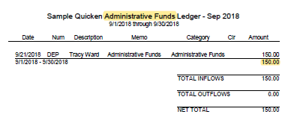

EXHIBIT A
(Page 2)

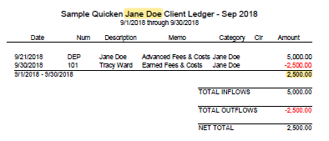

EXHIBIT B

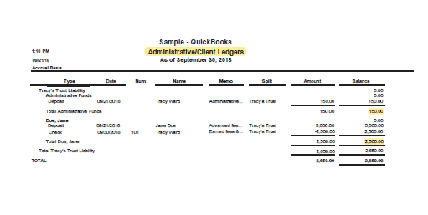

EXHIBIT C

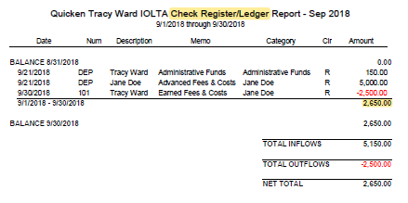

EXHIBIT D

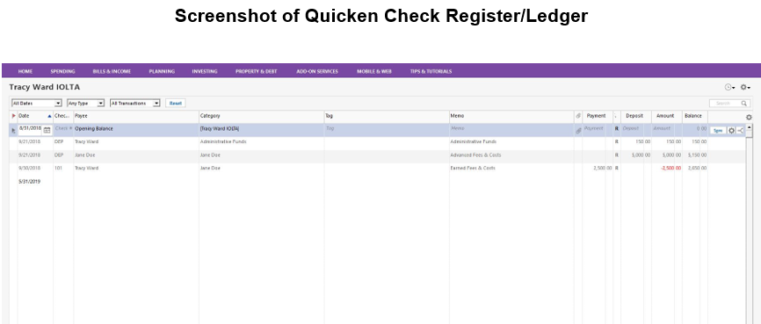

This view is what the lawyer sees when reviewing the ledger or entering transactions while in Quicken. This is also true of the client ledger transactions.

