Mauricio R. Hernandez (#020181)
mo@lawmrh.com
P.O. Box 7347
Goodyear, AZ 85338
(623) 363-2649

IN THE SUPREME COURT
STATE OF ARIZONA
In the Matter of:  PETITION TO AMEND RULES 32(c) AND (d) OF THE ARIZONA RULES OF SUPREME COURT | Supreme Court No. R-19-0005  COMMENT IN SUPPORT OF PENDING PETITION

In accordance with Rule 28(d), Ariz. R. Sup. Ct., the undersigned submits the following Comment in support of the Petition.
The Petition hearkens to legislative efforts in 2016 (HB2221); in 2017 (HB2295); and in 2018 (HB2119) to bifurcate the regulatory and non-regulatory functions of the State Bar of Arizona (SBA). These efforts, which will continue in the absence of other relief, are in accord with the Legislature’s legitimate interest in the protection and maintenance of the health, safety, or welfare of Arizonans. Moreover, these efforts are consistent with the lawful authority of a coequal branch of state government to protect the constitutional rights of all its citizens; to ensure transparency of governance; and to assure the SBA fulfills its recently-adopted public protection mission. Lawmakers, like the Petitioner, aspire to the goal of eliminating the existing regulator/trade association conflict of interest by bifurcating those two functions. Under the active supervision of this Court, the proposed bills provided for mandatory assessments to be expended only for the following regulatory functions: (1) admitting an attorney to the practice of law; (2) maintaining attorney records; (3) enforcing the ethical rules that govern attorneys; (4) regulating any continuing legal education mandates for attorneys; (5) maintaining attorney trust account records; (6) preventing the unauthorized practice of law; and (7) maintaining the client protection fund, board of legal specialization and the appointment of conservatorships to protect client interests. The SBA would establish, collect and use voluntary membership dues from an attorney for any lawful activity not included in the foregoing enumerated functions.
Like the proposed bar reform bills, implicit in the Petition’s provision to keep lawyer regulation and discipline as it is and under Court oversight --- but separate from the Bar’s non-regulatory activities --- is the preeminence public protection must be accorded over the Bar’s traditional trade association functions.
Limiting forced funding solely to lawyer regulation strengthens attorney First Amendment rights. It’s long past time for lawyers to start reclaiming these rights. Their erosion has too often been unknowingly allowed in many spheres, not just with respect to compelled speech and association.
The Petition offers a first step on the road to reclaiming these cherished First Amendment freedoms. It’s not surprising, though, that the SBA rises again in opposition. Arizona’s legal establishment has not always been on the correct side of safeguarding the free speech rights of Arizona’s lawyers.
The SBA has, for instance, long taken an expansive interpretation of the permissible activities it alone deems “essential” to its mission and purpose. So its current promises of heightened transparency are less than assuring. This is why a non-Bar-contracted, truly independent and disinterested audit listing every expenditure is so crucial.
Petitioner’s proposed amendments to Rule 32 properly rely on “exacting scrutiny,” a standard now required under Janus v. AFSCME, 138 S. Ct. 2448 (2018). This means that forcing lawyers to join and fund the SBA’s non-regulatory trade association activities must now “‘serve a compelling state interest that cannot be achieved through means significantly less restrictive of associational freedoms.’” Id. at 2465 (quoting Knox v. SEIU, 567 U.S. 298, 310 (2012)).
DISCUSSION
- In a changing lawyer regulatory landscape, the status quo is no longer viable.

Queen Gertrude said in Hamlet, the other player ‘doth protest too much.’ Here the SBA also protests “too much” when the Petitioner calls the integrated bar a “fad of the past century.” But the description is apt. What was once in vogue in the last century will no longer hold sway in this one. The opinion in Janus reversing the First Amendment precedent in Abood v. Detroit Bd. of Educ., 431 U.S. 209 is a game-changer. As James Coppess, associate general counsel for the American Federation of Labor and Congress of Industrial Organizations, writes at Scotus Blog,
Finally, the Janus majority opinion indicates that requiring lawyers
to pay bar association fees as a condition of practicing law is
unconstitutional. As Kagan notes repeatedly in her dissent, without
any denial by Alito, the court had relied upon Abood to “bless [ ] the
constitutionality” of “mandatory fees imposed on state bar members.”
Indeed, the court’s lead decision establishing the constitutionality of
mandatory bar fees, 1961’s Lathrop v. Donohue, treats the issue as
having been settled in 1956 by Railway Employees’ Dept. v. Hanson,
the same Railway Labor Act precedent that Janus criticizes Abood for
following. If Abood “went wrong” relying on Hanson, then so did
Lathrop. And it follows that the Supreme Court compounded its
error in 1990 with Keller v. State Bar of California by relying entirely
on Abood in setting the constitutional limits on mandatory bar fees.

In 2013, the Nebraska Supreme Court reached its own important watershed ordering bifurcation of the Nebraska Bar Association. While not expressly decided to resolve a conflicted mission, the Court severed the integrated bar by formalizing as part of its judicial branch the Attorney Services Division. Along with other regulatory activities, the Division oversees licensing and discipline.
By separating these functions from the Nebraska Bar’s non-regulatory activities, the Court presciently sought to “ensure that the Bar Association remains well within the limits of the compelled-speech jurisprudence of the U.S. Supreme Court and avoid embroiling this court and the legal profession in unending quarrels and litigation over the germaneness of an activity in whole or in part, the constitutional adequacy of a particular opt-in or opt-out system, or the appropriateness of a given grievance procedure.”
On October 2, 2017, California Governor Jerry Brown signed SB 36 into law that set the California Bar’s annual lawyer licensing fee and narrowed the Bar’s focus to protecting Californians. Like Nebraska’s now bifurcated bar; Arizona’s repeated legislative bar reform efforts; and the instant Petition, SB 36 separated the voluntary sections from the regulatory functions and created a private, non-profit professional trade association.
According to State Bar Executive Director Leah T. Wilson, “SB 36 supports the State Bar in our ongoing reforms to focus on our mission of public protection.” Wilson went on to add, “While transition and change can present challenges, I am confident that we are on the right track to best serve the people of California.”
It took considerable effort for California to whittle away at the lawyer regulatory status quo to accomplish its reforms. But California achieved reform with legislative unanimity and the ultimate endorsement of the State Bar and the state supreme court. This demonstrates how far out of step the SBA is with the times. The Bar in Arizona has instead long adopted an ‘if ain’t broke – don’t fix it’ mentality. But like typewriters, telegraphs, and fax machines, something that doesn’t need fixing needs replacing with something better.
It wasn’t until January 1, 2017 -- some 84 years after its creation – that the SBA finally expressly enshrined, as directed by this Court, that the State Bar “exists to serve and protect the public with respect to the provision of legal services and access to justice.” Arizonans, the state legislature, and concerned lawyers had, however, already expressed their displeasure over the subordination of the public’s consumer protection interests in favor of lawyers, particularly those perceived to possess superior resources and greater influence.
To further underscore how the status quo no longer works, consider the other reform efforts in the months after Janus. Lawsuits against mandatory bar associations in Oregon, Oklahoma, Texas and Wisconsin have been filed to free lawyers from compelled speech and coerced association. It’s conceivable even more will follow.
And on a separate but related track, a proposal to repeal the State Bar Act and turn the bar's essential duties over to the Washington State Supreme Court has been working its way through the Washington State Legislature.
Amidst all of this, it remains hardly surprising hidebound mandatory bars
continue opposing change.
The profession has resisted change. When it did institute change, the change was directed not at the existing members of the profession, but at new entrants. Mostly, change that has come has been forced by influences of society, culture, economics, and globalization—not by the profession itself. Watergate, communist infiltration, the arrival of waves of immigrants, the litigation explosion, the civility crisis, and the current economic crisis have blended with dramatic changes in technology, communications, and globalization.(citation omitted) In each of these instances, the profession held fast to its history and ways long after those ways had become anachronistic. (citation omitted) The profession seems to repeat the same question in response to every crisis: How can we stay even more “the same” than we already are?

- The “integrated bar” continues sowing confusion.

No sooner after this Court had directed the SBA under a modified rule to expressly prioritize public protection “with respect to the provision of legal services and access to justice,” the SBA was announcing its Public Service Center. In a mass email announcing the Center to members, the SBA declared it was about “improving the public’s access to justice” in accord with the new mission statement ordered by the aforementioned amended rule.
Integral to the new Center was the incorporation of a web-based referral platform helping lawyers (for an extra annual cost) to prospect for clients and get more business. Arizonans seeking legal help would complete an online form stating their legal needs to create a “legal project.” Participating SBA members would review the posted projects that could be either paid or pro bono. Interested members then disclosed their profile, fees if applicable, and other related information to the prospective client. Although the SBA’s email promoted the new lawyer referral program as an access to justice initiative targeted at pro bono and low bono clients, this objective was merely incidental to the undertaking. “It’s magical thinking to believe that by running a client lead-generator to grow the business of members, the state bar will also be helping the large swath of Arizonans who can’t afford to hire a lawyer,” I said in a commentary critical of the Center in The Record-Reporter. “Ventures like this,” I asserted, “arise when a trade association promoting the interests of its members tries to also serve the interests of the public.” But the most telling statement in the SBA’s mass email highlighting its conflicted mission was this, “Our job today is to find the best way to help both the public and our members.”
Although the SBA’s mission has now been clarified by this Court, members still view a mandatory bar not just as a type of regulatory state agency but as a member association charged with helping and promoting the profession. The most visible manifestation is found among those running its governing board -- notwithstanding that as “insiders” one would presume they should know better.
- The SBA’s programs and functions, beyond lawyer regulation, are neither intricate, unique, or exclusive to an integrated bar.

In the face of external challenges to its continued Ivory Tower existence, the SBA has persisted conflating not just its dual mission as regulator and trade association but it has conjured up a fallacious nexus tying lawyer professionalism, civic-mindedness, and aspirational ideals to an integrated status. But there is no nexus between public protection and an integrated bar or between lawyer professionalism and an integrated bar. Lawyers in all jurisdictions, whether voluntary or mandatory, take similar oaths to uphold the Constitution; to act with professionalism; to abide by ethical principles; to conduct themselves with integrity; and to discharge client obligations to the best of their abilities. Nor is there a non-severable connection between an integrated bar and non-regulatory programs and activities like an ethics hotline, member assistance program, or practice management assistance. Attached Exhibit A makes abundantly clear that these and other services are not exclusive to an integrated bar but common offerings of voluntary bar jurisdictions.
In its Comment opposing the Petition, the SBA makes claims about apparent “intricacies [that] cannot be summarily separated into two subsets without a thorough understanding and thoughtful contemplation of what should be deemed regulatory and what could constitute the ‘other functions’ voluntary approach the Petition takes.” It characterizes the Petitioner’s bifurcation approach as “cavalier” because “the benefits of the State Bar’s programs to our members and the public is (sic) too important.” Comment at 7.
The SBA’s non-regulatory programs cannot, by any objective measure, be deemed imperative to fulfilling the enumerated regulatory and disciplinary functions needed to protect the public.
But to suit its ends, the SBA has historically taken an expansive interpretation of the permissible uses for its members’ dues. Under Keller, a mandatory bar may constitutionally fund activities germane to the goals of regulating the legal profession or improving the quality of legal services out of the mandatory dues of all members. Mandatory dues, as the Court said, “may not, however, in such manner fund activities of an ideological nature which fall outside of those areas of activity.”
When members object, for instance, to its lobbying activities, the SBA relies on a key talking point. It asserts it is “Keller-pure.” But it’s only under a tortured enlargement of the Keller criteria and the broad interpretation under Article XIII of the SBA’s bylaws that such dubious assertions are maintained. Article XIII outlines the Bar’s “Keller-pure” policy. Section 13.01 provides that the SBA:
“Shall not, except as provided herein, use the dues of its members to fund activities of a political or ideological nature that are not reasonably related to:
1. (A) The regulation and discipline of attorneys;
2. (B) Matters relating to the improvement of the functioning of the justice system;
3. (C) Increasing the availability of legal services to the public;
4. (D) Regulation of attorney trust accounts;
5. (E) The education, ethics, competence, integrity and regulation of the legal profession; and
6. (F) Any other activity authorized by law.”
The criteria, however, are so vague and overbroad that the final ‘catch-all,’ “any other activity authorized by law,” appears superfluous.
- Proposed bifurcation assures greater transparency concerning the spending of mandatory member assessments than under the SBA’s new public records policy.

In the past, the SBA asserted its tax exempt private non-profit status as its basis for noncompliance with Arizona Public Records Law (APRL). Since then, the SBA has touted a new public records policy. During the last legislative term SBA lobbyists circulated the SBA’s “HB2119 Fact Sheet” declaring “the sponsor doesn’t seem to understand that we are already subject to public records by court rule.” The SBA’s public records policy is indeed a new development. However, it falls short of Arizona’s more robust APRL, as Exhibit B highlights. Most troubling, the SBA’s records policy gives it the last word on any access denial appeal. The amount of sunshine the SBA is willing to tolerate therefore remains solely its own discretion.
By explicitly requiring expense itemization, the Petition assures a better mechanism than the Bar’s new open records policy to ensure that members’ dues are used only for germane regulatory purposes. The SBA’s public records approach is, on the other hand, replete with exemptions. Conversely, what the Petition makes clear is that when spending other people’s mandatory dues, the bottom line especially after Janus, is the SBA must comply with the First Amendment.
CONCLUSION
For the reasons stated herein, the undersigned agrees with Petitioner’s recommendation and urges the Court to approve the Rule 32 amendments.

RESPECTFULLY SUBMITTED this 29th day of April, 2019.

/s/ Mauricio R. Hernandez
Mauricio R. Hernandez

EXHIBIT A

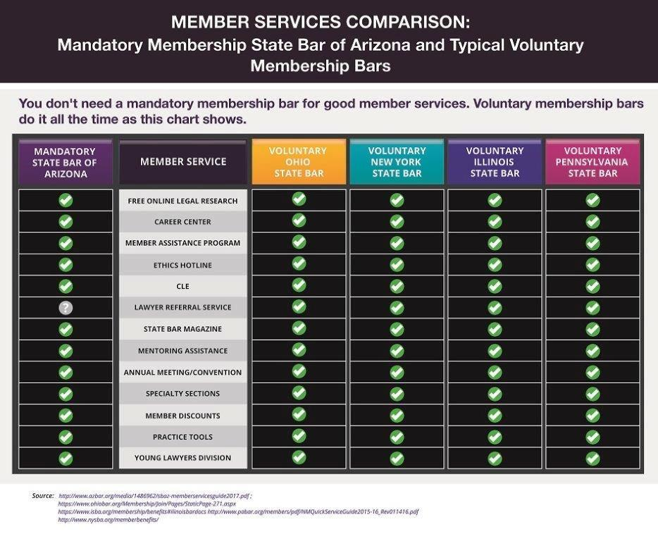

EXHIBIT B
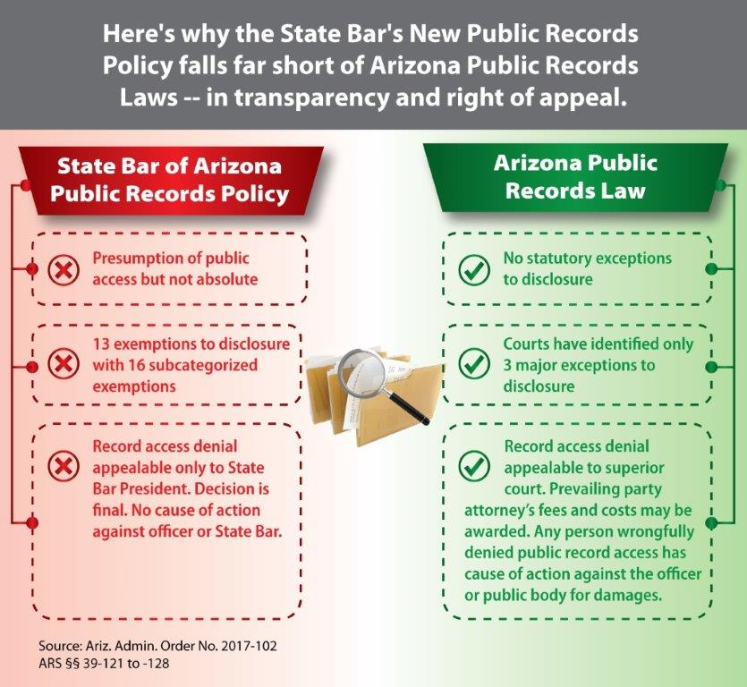

State v. Beadle, 326 P.2d 244 (Ariz. 1958) “The purpose of an Act, promulgated under the State's police power, is to protect the public health, safety or welfare.”
Still timely is the observation: “The legitimacy of Arizona Supreme Court decisions allocating the final word in these areas of overlapping authority is always suspect, because the court becomes the arbiter of its own power vis-à-vis the legislature. In today’s political climate, marked by a paucity of lawyers serving in state legislatures, the court may be especially vulnerable to legislative challenge. It is therefore vital to ensure that the court’s separation of powers jurisprudence is up to the task of protecting judicial independence while giving the legislature its due, avoiding needless confrontation, and garnering public respect.” See Ted Schneyer, Who Should Define Arizona’s Corporate Attorney-Client Privilege?: Asserting Judicial Independence Through the Power to Regulate the Practice of Law, 48 Ariz. L. Rev. 419 (2006).
Over time, the mission of the SBA has been a study in evolving and often confusing nuance – so much semantical eyewash – invoked when needed to finesse albeit unsuccessfully its immutable, irreconcilable conflicted character as concomitant regulator serving the public’s interests and professional trade association serving its lawyers. The evolution is ascribable in part to its legislative genesis. Under-defined and ambiguous in scope, the State Bar Act of 1933 empowered the Bar “to aid in the advancement of the science of jurisprudence and in the improvement of the administration of justice” and to formulate and enforce with court approval, rules of professional conduct, examination and admission to practice law. See State Bar Act of 1933, SB11, 11th Legislature, Chapter 66, 1933. Consequently, 86 years later mission-mystification still reigns as noted, infra. in SBA Board Election Candidate statements published on the SBA website in 2017 and for example, in 2019. The SBA’s dual mission confuses not only members, including its would-be leaders, but more significantly, the general public. Indicative is that almost a generation after its creation, SBA leaders in 1961 took notice of “An additional major responsibility to its members and the public. Its mission is designed in the public interest, and this design is illustrated by the slogan: Service to Society through Professional Relationships.” See Our State Bar Associations: The State Bar of Arizona, 47 A.B.A.J. 809 (August 1961). Until recently, mission explicit “public protection” was notable not by its ambition but by its absence. Just 9 years ago the SBA mission statement made no mention of any express public protection mandate declaring instead it “serves the public and enhances the legal profession by promoting the competency, ethics and professionalism of its members and enhancing the administration of justice.” And as recently as 2016, mission mix-up persisted in a recommendation of the SBA’s own “Governance Report Study Group.” The Study Group was charged by the Board of Governors with reviewing and making recommendations concerning the Report of the Supreme Court Task Force on the Review of the Role and Governance Structure of the State Bar of Arizona. Concerning the Task Force’s proposed mission statement that the State Bar’s “core mission is protecting and serving the public,” the Study Group declared at Recommendation No. 3, “The Study Group believes that the Task Force’s recommended mission state-ment (sic) that the State Bar’s ‘core mission is protecting and serving the public’ is inaccurate and unwise. The Study Group believes that the proposed new mission statement improperly emphasizes public protection, which is historically not a primary role of the Bar.” The Board voted unanimously to delete these two startling spot-on admissions but the beans were spilled just the same. Bar Community, Board of Governors October Meeting Review, Arizona Attorney, January 2016, at 47. These days almost 9 decades after the State Bar Act, the SBA now says it “exists to serve and protect the public with respect to the provision of legal services and access to justice. Consistent with these goals, the State Bar of Arizona seeks to improve the administration of justice and competency, ethics and professionalism of lawyers practicing in Arizona.” Mission Statement, State Bar of Arizona, available at https://www.azbar.org/aboutus/mission-vision-andcorevalues/
The SBA has willfully mischaracterized the bills as calculated by the Legislature to create a professional licensing and disciplinary board like those regulating the state’s other occupations and professions. See SBA, Bills Regarding the Bar and Pending Rules Petition, http://www.azbar.org/media/1398723/rulespetitionfactsheet.pdf. Parenthetically, even if true, not all lawyers necessarily see such a legislatively-created licensing and disciplinary board as an evil.
During the 53rd Legislature in 2018, the SBA again opposed bar reform legislation and lobbied lawmakers with what it called a “HB 2119 Fact Sheet.” The Sheet chided the chief sponsor for using the term “trade association to describe the Bar.” The SBA Fact Sheet said, “It shows an inherent lack of understanding about the Bar’s structure and function. A trade association exists for its members.” Little matter the SBA takes exception with the lawmaker’s description. It is what it is. The SBA files its annual tax returns under Section 501 (c) (6) of the Internal Revenue Code that exempts non-profit “business leagues” like “trade associations” having a common interest. “A business league is an association of persons having some common business interest, the purpose of which is to promote such common interest and not to engage in a regular business of a kind ordinarily carried on for profit. Trade associations and professional associations are business leagues.” Charities and Non-profits, Other Non-Profits, Requirements for Exemption, Business Leagues, IRS, available at https://www.irs.gov/charities-non-profits/other-non-profits/business-leagues
See generally Margaret Tarkington, Voice of Justice, (2018) noting, “Most lawyers don’t realize that they lack First Amendment rights. They are aware of the Supreme Court’s protection of lawyer advertising and proceed on the assumption that they possess the full panoply of First Amendment rights. Yet the caselaw does not bear that out in many regulatory and disciplinary contexts. Particularly, when attorneys are acting as an attorney in their role as an “officer of the court,” attorneys cannot and should not assume that they can obtain First Amendment protection from regulation or professional discipline.”
See Bates v. State Bar of Arizona, 433 U.S. 350 (1977) and Baird v. State Bar of Arizona, 401 U.S. 1 (1971).
See generally Appellant’s Reply Brief at 2, Fleck v. Wetch, No. 16-1564 (8th Cir. Apr 16, 2019).
James Coppess, Symposium: Four propositions that follow from Janus, SCOTUSblog (June 28, 2018, 2:36PM, https://www/scotusblog.com/2018/06/symposium-four-propositions-that-follow-from-janus/
In re Petition for a Rule Change to Create a Voluntary State bar of Nebraska, 286 Neb. 1018, 841 N.W.2d. 167 (2013)
See https://supremecourt.nebraska.gov/attorneys/attorney-services-division
Credit the Nebraska Supreme Court’s foresight. Almost two months to the day after its December 6, 2013 ruling, attorney Arnold Fleck filed suit against the North Dakota Bar Association to vindicate his First Amendment rights against compelled speech and association. Since then, by overruling Abood, the U.S. Supreme Court’s Janus decision has galvanized new lawyer litigation to make clear that mandatory bars around the nation must now follow an “exacting scrutiny” constitutional standard -- not what Keller said was a reasonableness standard to resolve compulsory membership and compelled speech.
841 N.W.2d. 179-180.
Press Release, State Bar of California, State Bar Prepares to Implement Historic Reforms Following Gov. Brown Signature on the Agency’s Annual Fee Bill, (Oct. 2, 2017) available at http://www.calbar.ca.gov/About-Us/News-Events/News-Releases/state-bar-prepares-to-implement-historic-reforms-following-gov-brown-signature-on-the-agencys-annual-fee-bill
See, for instance, Arizona Legislature, House Ad Hoc Study Committee on Mandatory Bar Associations, public testimony of October 19, October 26, November 16, and December 7, 2015 archived and available at https://www.azleg.gov/archivedmeetings/?Year=2015
Mike Scarcella, US Supreme Court Labor Ruling Cited in Challenges to Mandatory Bar Dues, Daily Business Review, (Feb. 14, 2019) https://www.law.com/dailybusinessreview/2019/02/14/us-supreme-court-ruling-fuels-suits-challenging-mandatory-bar-fees-392-47478/
Angela Morris, Oklahoma Bar Argues Mandatory Dues Are Constitutional in Lawyer’s First Amendment Suit, Texas Lawyer, (April 25, 21019) https://www.law.com/texaslawyer/2019/04/25/oklahoma-bar-argues-mandatory-dues-are-constitutional-in-lawyers-first-amendment-suit/?slreturn=20190328001400
Debra Cassens Weiss, Suit Challenges Mandatory Bar Membership in State Bar Because of Immigrant Support, Diversity Initiatives, ABA J., (March 12, 2019) http://www.abajournal.com/news/article/suit-challenges-mandatory-membership-in-texas-because-of-immigrant-support-diversity-initiatives
See Editorial Board, After Janus, Free the Lawyers, WSJ (April 25, 2019)
See FAQ House Bill 1788, Washington State Bar Association at https://www.wsba.org/about-wsba/legislative-affairs/faq-house-bill-1788 and also see Amy Radil, WA Supreme Court Could Take Over For ‘Struggling’ Bar Association, KUOW radio, NPR affiliate, (Mar 15, 2019) https://www.kuow.org/stories/state-legislature-could-dissolve-struggling-bar-association
James E. Moliterno, The Trouble With Lawyer Regulations, Emory Law Journal, Vol. 62, p. 101, (2013).
“Low bono is a term that many bar leaders, law faculty and new graduates have heard but may not fully understand. A definition of low bono is not yet included in Black's Law Dictionary but the frequency of its use is increasing in the legal profession. Low bono is used synonymously with the practices of offering reduced legal fees.” Luz E. Herrera, Encouraging the Development of Low Bono Law Practices, 14 U. Md. L. J. Race, Religion, Gender & Class 1 (2014). At https://scholarship.law.tamu.edu/facscholar/779
Mauricio Hernandez, Perspective, How not to address the legal needs of the public, The Record Reporter, (January 20, 2017) at 3.
Ibid.
Ibid.
To be fair, some of the perplexity about the Bar’s identity derives from the this dual hatted regulatory agency and trade association roles. When, for example, either the Bar’s disciplinary function or its licensing expenditures are challenged, the Bar can justify its actions as an arm of the state supreme court in regulating the practice of law. In such instances, the Bar is akin to a state agency. But when it spends member funds on non-regulation, then the Bar has a harder task justifying the compulsory collection of funds meant to promote and improve the business conditions of its membership. See, for examples, Bates v. State Bar of Arizona 433 U.S. 350, 361 (1977) and Hoover v. Ronwin, 466 U.S. 558 (1984).
In 2017, the mission confusion was evidenced in board candidates’ campaign statements where both aspirants and incumbents asked either for “the opportunity to serve my fellow lawyers” or to be “a voice for solo and young lawyer” so that “the needs of our members are voiced and heard” or who pledge to “make sure the Bar is here to help attorneys, not hurt them.” Consistent with its perceived longstanding trade association role, there were pledges “to ensure the Bar is working for its members” or that it “performs more services for the membership.” Two years later during 2019 elections, not much changed. One reelected incumbent ran this year on a platform wanting the State Bar “to continue to work for “the little guy” – the solo-practitioner, the public defender, the public interest lawyer.” Another reelected board member – by far the highest vote-getter - reaffirmed his 2017 platform to “make sure the Bar is here to help attorneys, not hurt them and to ensure Bar dues promote and help attorneys.” See 2019 Board of Governors Candidate’s Campaign Statements, https://www.azbar.org/aboutus/leadership/boardofgovernors/2019electioncandidates/2019boardofgovernorscandidatesstatements/

