Mike Palmer, Head
Coalition to Stop Abuse of Civil Harassment Law
18402 N. 19th Ave., #109
Phoenix, AZ 85023
mikepalmer_az@yahoo.com

IN THE SUPREME COURT
STATE OF ARIZONA

In the Matter of:  PETITION TO AMEND  RULE 25(b), ARIZONA RULES OF PROTECTIVE ORDER PROCEDURE | Supreme Court No. R-__-_____  Petition to Amend Rule 25(b),  Arizona Rules of  Protective Order Procedure
Pursuant to Rule 28, Rules of the Supreme Court, Mike Palmer, writing on behalf of the Coalition to Stop Abuse of Civil Harassment Law, petitions this Court to amend Rule 25(b) of the Rules of Protective Order Procedure to define a "series of acts" to be at least three events, as Maine and Massachusetts have done.
I. Brief History of civil IAH law
It's necessary to know a little history about civil Injunction Against Harassment (IAH) law to understand why it's necessary for this Court to update what constitutes a "series of acts." (Our Legislature, in its non-infinite wisdom, did not define a "series of acts" in A.R.S. § 12-1809, the statute governing civil IAH's. And so this policy decision falls to the Court.)
The statute governing civil Injunctions against Harassment came into being in1984, more than 30 years ago.
Back then, law enforcement agencies were reluctant to get involved in domestic matters between husband and wife, considering them private matters. But Minneapolis had just finished its landmark Minneapolis Domestic Violence Experiment. And Time Magazine ran a cover about Domestic Violence in 1983.
Criminal DV Order of Protection law was narrow in its scope, not yet having grown to encompass all the various relationships - including those between unmarried couples (dating/romantic) - that it does now. Also back then, there were no criminal Harassment or Stalking laws, as there are now.
And so the Legislature created civil IAH law with bona fide victims of Domestic Violence in mind. As the Arizona COA said, "The legislature likely intended A.R.S. § 12-1809 to provide a civil (i.e., non-criminal) method to help protect citizens from stalkers or perpetrators of domestic violence." (LaFaro v. Cahill, 56 P. 3d 56, 62 - Ariz Ct of Appeals, 1st Div., Dept B 2002.)
But nowadays the scope of criminal OOP law has become so broad, it covers just about every type of DV matter there is. Why go for a civil IAH when a more powerful OOP is available?
II. Purpose
As a result, we are seeing a shift in the demographics, where more and more non-DV litigants are petitioning for civil IAH's.
But since the Legislature intended for civil IAH law to help victims of DV, it is ill-suited for non-DV matters like neighbor against neighbor. For example, it was never the legislature's intent that, in a minor dispute between neighbors, cops would advise one neighbor that he could get a civil IAH against another, which is what cops are required to do for victims of domestic violence.
But that's how civil IAH's are being used/abused today.
And so while, in a 9/11-type scenario, where two airplanes crash in to Twin Towers, it makes sense to require only two events in a DV related matter to trigger a civil IAH. But a low bar of two events to trigger a civil IAH in non-DV related matters, like between neighbors, does not make sense.
Nor is it right. (I.e., is not the interest of justice.)
First, from a purely logical and common sense point of view, two events usually do not establish a pattern. For example, IQ tests always give a series of three (or more) numbers before asking what follows. That's because you can't tell from two events if there's a pattern/intent.
Second, two events does not give the potential defendant ample notice that his/her behavior is annoying someone. Say that you're Forrest Gump, obsessed with a less accommodating version of Jenny. The first time you chase after Jenny, she's not happy to see you. But she figures it's the first time, probably won't happen again. When you chase her again, she begins to wonder if this is a pattern. So she puts you on notice and tells you to stop. When, in your obsession, you chase her a third time, now you've harassing her. And you know it. But how could you have known you were harassing someone at two events?
Third, according to A.R.S. § 12-1809(S), you only have to annoy someone to "harass" them. Requiring only two events of annoying someone is such a low threshold that we all could find ourselves enjoined. As a federal judge told her litigants during a Harassment suit, if being annoying is evidence of harassment "I could sue all of you here today." (Exhibit 1.)
Fourth, the Court is wasting its own resources by defining a "series of acts" at a low two events.
The Court does not keep records of how many civil IAH's are appealed, nor of those appealed, how many are vacated. (Per a Public Records Request last year. See Appendix. As an aside, the Court might consider collecting the data for the questions we asked.) Our anecdotal observation is that almost every civil IAH that's been appealed has been vacated.
There are a number of reasons for this high rate of reversal. Better application of the law by real judges at the Superior court level; less emotion during an appeal if it happened that a woman plaintiff cried crocodile tears during a contested hearing, etc. But one disturbing reason we've observed for this high rate of reversals is because JP's often coach the plaintiff to offer a second event when initially petitioned with only a single event.
While this is symptomatic of a deeper problem in our "justice" system, the pain can be alleviated if the Court requires three events for a "series of acts" instead of two.
We presume this is why the Massachusetts and Maine legislatures set their "series of acts" to three, to minimize the waste of judicial resources and a waste of lives.
You might say "What's the big deal? Why do we need to set a higher bar? It's only a civil Injunction."
The big deal is, while, yes, it's only a civil Injunction, it's a civil Injunction with Draconian criminal punishment for violating it.
This is another (now unnecessary) vestige from the law's DV roots. If you violate a civil IAH, it is an automatic arrest. No discretion allowed for the police officer, per A.R.S. § 12-1809(M). (The reasoning being that passions typically run high in DV matters, and someone who violates a No Contact DV order has probably snapped and needs to be arrested NOW.)
A real world example of the abuse this brings: Rick Bailey was the victim of a bogus civil IAH by his neighbor. (Eventually vacated on appeal, at the cost of $5,000 for an attorney. Money which Rick never got back from his false accuser.)
Rick went to court for a contested hearing. His sly neighbor held the courtroom door open for him. Rick said, "Thank You."
WHAM! His neighbor had him arrested for violating the "No Contact" order. The police officer had no choice. So now Rick has a criminal record courtesy of a CIVIL IAH, thank you very much.
So it's not just a civil Injunction. There's a criminal Sword of Damocles hanging over one's head. Which might not be easy to dodge in, say, a small town setting where everyone runs into each other all the time.
So in a sense, a civil IAH is a nascent criminal matter. As such, the standard for "conviction" should be much higher than it is. Hawaii uses probable cause to issue ex parte Injunctions. (See our petition to Amend ARPOP Rule 38(g).)
Sadly, non–DV plaintiffs have learned to turn what was meant to be a shield into a sword. Even those who know better. For example, I was at a public meeting discussing civil IAH's. One of the attendees was a Legislative Liaison for a County Attorney. Apparently she got frustrated with another attendee during the meeting. He wanted to continue the discussion after the meeting. Ironically, she implied that she would seek an Injunction against him, telling him to not contact her about the meeting, even though her official government email account. Such is life in the real world of civil IAH's.
The Court can help mitigate abuse like this by amending Rule 25(b) to say "A series of acts means at least three two events."
SUBMITTED this 10th day of January 2019.

By /s/Mike Palmer

EXHIBIT 1
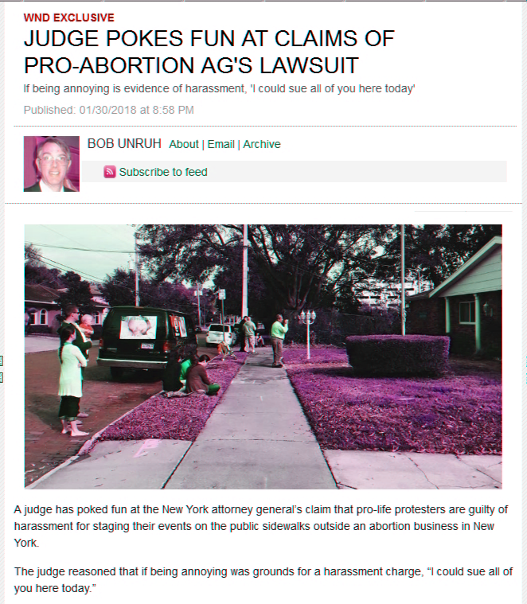

APPENDIX

Good afternoon, Mr. Palmer,

We have done as best we can to respond to your request for data. This data is published in the Annual Data Book available online at http://www.azcourts.gov/statistics. Asterisks indicate fiscal year 2017 data is preliminary and may change prior to publication.

1. Approximately how many petitions for civil IAH's were filed statewide in 2015, 2016 and 2017?
FY 2017*: 16,730
FY 2016: 16,610
FY 2015: 16,928

2. Of those petitions, for those years, what percentage were issued?
FY 2017*: 12,983
FY 2016: 12,526
FY 2015: 12,642

3. Of those issued, what percentage, for those years, were issued ex parte? We do not collect this data.

4. Of those total injunctions issued, for those years, what percentage were contested?
FY 2017*: 3,952
FY 2016: 3,921
FY 2015: 3,705

5. Of those contested, for those years, what percentage were continued/modified? (I.e., not quashed.) We do not collect this data.

6. Of those IAH's that were continued after a contested hearing, for those years, what percentage were appealed? We do not collect this data.

7. Of those that were appealed, for those years, what percentage were vacated? We do not collect this data.

Respectfully,

Heather Murphy
Director of Communications
Arizona Supreme Court and
Administrative Office of the Courts
1501 West Washington Street
Phoenix, AZ 85007

The Coalition is a loose collection of Arizona residents (including a Law Enforcement officer) who have been abused by civil Injunction law. (I.e., who have been vindicated on appeal, but whose reputations will forever be tarnished - much like what happened to U.S. Supreme Court Justice Brett Kavanaugh.)
You can still see vestiges of law's intent in the current statute, which still sometimes interchanges the word "victim" [of Domestic Violence] for plaintiff. See also the current statute on criminal Domestic Violence, which still calls the plaintiff in a DV matter the "victim." (A.R.S. § 13-3601(A)(1).) Consistent with this, previous ARPOP Rule 1(B)(1)(d) actually said "... in these rules, the term 'victim' is used interchangeably with 'plaintiff.'"
The Justices individually should consider taking day trips to visit JP and Magistrate courts around the State. Like the TV show Undercover Boss, it might be eye-opening.

