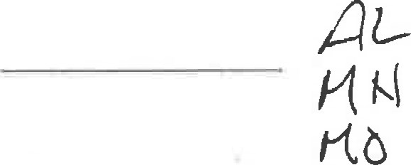
COMMITTEE ON EXAMINATIONS
1501 W. Washington Street, Suite 104
Phoenix, Arizona 85007-3222 602452-3971
May 12, 2017
Kenneth David Eckhauser 12452 N 145th way
Scottsdale, AZ 85259-2120

Re: Arizona Uniform Bar Examination —February 2017
Your Uniform Bar Examination (UBE) score fails to meet the requirement for admission in Arizona. In order to be eligible for admission in Arizona, you were required to achieve a combined score of at least 273.
Scaled Score for Written Portion 129.9
Plus your MBE score 129.7 = Total Combined Score of 260
Your UBE score may be portable to other UBE jurisdictions. You can view a map of UBE jurisdictions at http://www.ncbex.org/about-ncbe„exams/ube/ at the link "Map of UBE Jurisdictions," Please contact individual jurisdictions to determine if your score might confer eligibility.
If you wish to apply for the July 2017 exam pursuant to Supreme Court Rule 34(e)(2), please return the enclosed Application for Examination form with the appropriate fee, posfinarked on or before May 31, 2017. Faxed or emailed applications cannot be accepted. Please review Supreme Court Rule 35(c)(2) for additional information regarding applying to sit for a subsequent examination.
If the July 2017 exam will be your fourth or more attempt, you must request permission to write per Supreme Court Rule 35(c)(3) no later than May 31, 2017.
Accommodations requests and/or requests for permission to write granted for a prior examination do not "carry over" to subsequent examinationsè Should you wish to request permission to write or an accommodation you must do sofor each exam. See attached application for direction on accessing required forms.
Please see reverse side of this letter for additional information regarding scores below 273,
Sincerely,
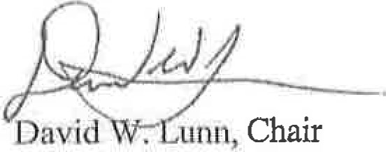
Committee on Examinations

David W Lunn - Chair Rod Galarza • Jacqueline Ganier • Nora Greer
Frankie Jones Tanja Kelly • Kelly LoCascio Rorlc Massey • Howard D Sukenlc
Rebecca Van Doren • Lisa S Wahlln • Adam Zlckerman
 | APPLICATION FOR JULY 2017 EXAMINATION    Certffit.dtion OiVi5ion  JULY 25 ((MEE/MPT) AND 26 (MBE) carg  PHOENIX CONVENTION CENTER 

HAND
IN BLACK INK, PRINT FULL NAME AND ADDRESS
 |  |  |  |  |  | u |  |  | 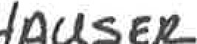 |  | SUBMIT TO:  Committee on Character and Fitness  Supreme Court of Arizona  1501 W. Washington, #104  Phoenix, AZ 85007-3222
 |  |  |  |  |  | 
 |  |  |  |  |  |  |  |  | 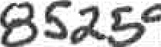
Print clearly in the name and address block above. You wili receive a photocopy of this page as receipt of your filed application. Call 602-452-3971 if you do not receive this receipt within fourteen ( 14) days of mailing or filing.
It is your responsibility to sublïlit this application, supporting documents and fees in accordance with the CiliTent Rules for Admission. No application will be accepted if delivered or postmarked after May 31, 2017.
Have you included these items?
$580 Fee - Must be received, postinarked, or hand delivered by May 3 1 , 20 ] 7
ÿ<Notice of Intent to Test Via Laptop - please sign request on back of this form if you intend to use your laptop for essays. This is not the official registration. vou must still register and pay fees to Extegrit.y registration.
Permission to write - if testing in Arizona for the 4 ^{th} or more time attach the permission to write request fbrm to this application (withdrawal before exajn is not counted). Form can be located on the Attorney Admissions website under miscellaneous forms. www.azeouris.gov/cld/Attorney-Admissions/Miscellaneous-Forms must be received, postmarked, or hand delivered by May 3 1 , 20 7
Testing Accommodations — Check box only ifyou will be requesting accomrnodations for this exam.
Have you previously requested accommodations for Arizona UBE testing? YES NO
See www.agcourts.gov/cld/attorneyaclmissions for more information on docupnents required, Complete request and supporting cåocwnents must be received, postmarked, or hand delivered by May 3 201 7.
[2 Check or Money Order made payable to: ARIZONA SUPREME COURT
Check or Money Order # in the amount of: $

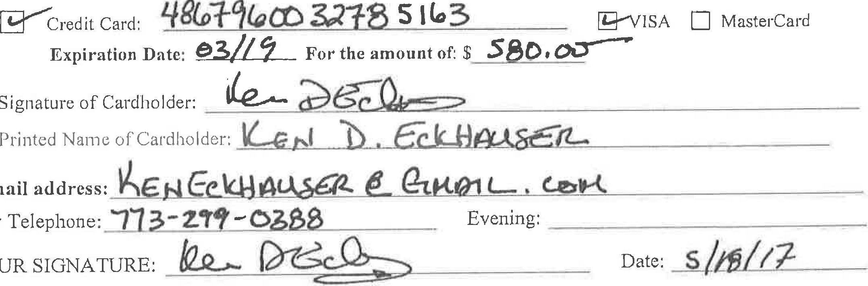Expiration

YOUR
E-mail
Day
COMMITTEE ON EXAMINATIONS
1501 W. Washington Street, Sulte 104
Phoenix, Arizona 85007-3222 602-452-3971 attorneyadmisslons@court$.az.gov
June 14, 2017
Kenneth David Eckhauser
12452 N 145th way
Scottsdale, AZ 85259-2120 July 25 and 26, 2017
Phoenix Convention Center 100 North Third Phoenix AZ 85004

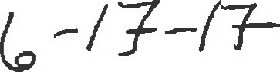
RE: ARIZONA UNIFORM BAR EXAMINATION — JULY 2017
Your request to sit for the Arizona Uniform Bar Examination to be held July 2017 has been considered.
Based on the information you provided, pennission is granted, by a majority vote.
Processing of your application by the Character and Fitness Committee will commence in chronological order of receipt.
Committee on Examinations
Committee on Character and Fitness

COMMITTEE ON CHARACTER AND FITNESS
1501 W. Washington Street, Sulte 104
Phoenix, Arizona 85007-3222 602-452-3971 attorneyadmissionsõcourts.az.gov
June 16, 2017
Kenneth David Eckhauser 12452 N 145th way
Scottsdale, AZ 85259-2120
July 25 and 26, 2017
Phoenix Convention Center
100 North Third Street, Phoenix AZ 85004

RE: ARIZONA UNIFORM BAR EXAMINATION JULY 2017
Your application has been received and reviewed in accordance with the Rules for Admission of the Arizona Supreme Court.
You are certified to sit for the examination based on receipt by the Court of:
Received- APPLICATION FOR ADMISSION
Received - SUPPORTNG DOCUMENTATION
Received- APPLICATION FEES
Received- EVIDENCE OF GRADUATION
If your method of payment is rejected by the Finance Department, you will be notified that you are no longer certified to sit for the examination. You will not be re-certified unless the deficiency is satisfied in full by the filing deadline. If the deficiency is not satisfied in full by the filing deadline, your application will be involuntarily withdrawn pursuant to Rule 34(k).
Our records reflect you have submitted the following items which are not required to sit for the exam but will be required to complete the admissions process:
Received CHARACTER REPORT
Received VALID MPRE ŠCORE
Received COMPLETION OF ARIZONA LAW COURSE
You can view the workflow status in your e-License account under Activities, View License Status.
You are required to advise the Committee, in writing, of any material changes to your application
Attorney Admissions will periodically email information to you prior to the exam. Make sure your browser is set to allow receipt of email from the court. In the past, browser settings have blocked the delivery of court email. It is your responsibility to periodically check the top of the Attorney Admission website homepage for announcements: www.a7.courts.gov/cld/Attorney-Admissions. These announcements provide timely examination information and updates and may alert you to missed communications.
Committee on Character and Fitness
Committee on Examinations
COMMITTEE ON CHARACTER AND FITNESS
1501 W. Washington Street, Suite 104
Phoenix, Arizona 85007-3222 602-452-3971 August 11, 2017
Kenneth David Eckhauser 12452 N 145th way
Scottsdale, AZ 85259-2120

RE: ARIZONA UNIFORMBAREXAMINATlON—JULY2017
Pursuant to your request, your name was removed from the list of applicants for the above examination, In accordance with rules for admission of applicants to the practice of law in Arizona:
Rule 37 (continued)
(d) An applicant who submits an application for admission by examination and who has paid the fees required by these rules and thereafter withdraws the application or fails to appear for the examination applied for, shall be entitled to a partial refund or credit of the fees paid, as established by the Court, provided the applicant notifies the Committee in writing no later than the filing deadline for that examination as set by the Court. (Emphasis added.)
As your withdrawal letter was received after the filing deadline, you are not eligible for a partial refund.
If you elect to file for an examination subsequent to July 2017, you will be required to submit a new application for admission online and mail supporting documents. Registration for February 2018 begins August 15, 2017 to November 30, 2017.
Committee on Character and Fitness
Committee on Examinations
From: Loza, Evelyn ELoza@courts.az.gov 8
Sublect: RE: Arizona Uniform Bar Examination - July 2017
Date: May 2017 at 3:23 PM
To: Ken Eckhauser keneckhauser@gmail.com
Thank you for the quick reply. I will wait for the form so the request can be forwarded to the Committee on Examinations.
Thank You,

Arizona Supreme Court
Certification and Licensing
Attorney Admissions Unit
1501 W Washington,Suite 104
Phoenix, AZ 85007

602-452-3378
Fax 602-452-3958

From: Ken Eckhauser
Sent: Thursday, May 18, 2017 3:08 PM
To: Loza, Evelyn <ELoza@courts.az.gov>
Subject: Re: Arizona Uniform Bar Examination - July 2017
Ms. Loza,
I apologize for my oversight. I will personally deliver the form to the Character and Fitness office tomorrow. Thank you for letting me know about the missing form.
Ken Eckhauser
On May 18, 2017, at 14:00, Loza, Evelyn wrote:
Hello Mr Echhauser,
Attorney Admissions received your application and letter requesting permission to write for the July 2017 Arizona Uniform bar examination. However, you must submit a permission to write request form. This process was included in the July 2017 exam application. Please print and mail the permission to write form by May 3 1, 2017,
Thank You,


From: Ken Eckhauser keneckhauser@gmajl com
Subject: Re: Character Report
Date: June 8. 2017 at 9:18 AM
To: Loza, Evelyn El-oza@courts.azgov
Thank you.
On Jun 8, 2017, at 08:55, Loza, Evelyn wrote:

Good Morning,
The Committee is still reviewing your request. I hope to have a respond by mid next week. Once I get a response I will let you know,
Thank You,
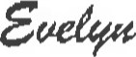 2034
Arizona Supreme Court
Certification and Licensing
Attorney Admissions Unit 1501 W Washington,Suite 104
Phoenix, AZ 85007

602-452-3378
Fax 602-452-3958
<image001.png>
From: Ken Eckhauser
Sent: Wednesday, June 07, 2017 11:30 AM
To: Loza, Evelyn
Subject: Re: Character Report
Good morning,
I received the laptop registration email for the upcoming July 2017 bar exam, I personally delivered the registration materials in full on May 19 and the registration fee has already been deducted from my bank account, as well I am a fourth time exam taker and have yet to learn whether I have been approved by the Committee to sit for the July 2017 exam. The registration period for laptops closes on June 21 and I would like to inquire as to when i might learn of the Committee's decision concerning my approval or non-approval to sit for the July 2017 exam.
Ken Eckhauser
On May 25, 2017, at 14:07, Loza, Evelyn wrote:
If I'm understanding correctly, you're requesting a copy of your Character and Fitness application to be send to another jurisdiction. If so, you will need to submit a written request and pay the fee
of $30. I can send the application to your directly or to the state.
If wish to request a copy of your application, submit a written request and include a check or money order payable to the Supreme Court of Arizona.
Thank You,

Arizona Supreme Court
Certification and Licensing
Attorney Admissions Unit
1501 W Washington,Suite 104

Phoenix, AZ 85007 602-452-3378
Fax 602-452-3958
<image001.png>
From: Ken Eckhauser
Sent: Wednesday, May 24, 2017 8:47 AM
To: Attorney Admissions
Subject: Character Report
Attorney Admissions,
If a State requires that they receive a copy of our character and fitness report from the Arizona Committee, may I mail a prepaid envelope to the Arizona Committee to use, or shall I inform the other State, should I apply in the future, that the Arizona Board will only mail this information to the applicant?
Kenneth D. Eckhauser
Ken Eckhauser
Sent from my IPhone
From: Lozel Evelyn El-oza@courts.az.gov
Subject: RE: Character Report
Date: July 20, 2017 at 3:04 PM
To: Ken Eckhauser keneckhauser@gmail.com
Sorry for the late response. I have been in training for the last couple of week so it has delayed in processing your request, I will process your request and mail the copy tomorrow. So they should expect to get the copy by next week.
Thank You,

Arizona Supreme Court
Certification and Licensing
Attorney Admissions Unit
1501 W Washington,Suite 104
Phoenix, AZ 85007

602-452-3378
Fax 602-452-3958
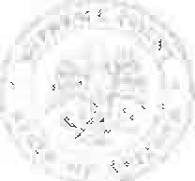
From: Ken Eckhauser [mailto:keneckhauser@gmail.com]
Sent: Wednesday, July 19, 2017 11:11 AM
To: Loza, Evelyn <ELoza@courts.az.gov>
Subject: Character Report
Good Morning Ms. Loza,
I am writing to learn if Arizona has had the opportunity to send a copy of my character and fitness application to the Minnesota State Board of Law Examiners? Payment for the document has posted and I would simply like to infom the Minnesota Board as to whether the document is in transit or will be in the near future. Thank you for your time.
Kenneth D. Eckhauser
On Jun 8, 2017, at 8:55 AM, Loza, Evelyn wrote:
Good Morning,
The Comrnitt.ee is still reviewing vour reauest, I hoop to have a resoond bv mid next
week. Once I get a response I will let you know,
Thank You,

Suelqu
Arizona Supreme Court
Certification and Licensing
Attorney Admissions Unit 1501 W Washington,Suite 104
Phoenix, AZ 85007
602-452-3378 Fax 602-452-3958
<image001.png>
From: Ken Eckhauser
Sent: Wednesday, June 07, 2017 11:30 AM
To: Loza, Evelyn
Subject: Re: Character Report
Good morning,
I received the laptop registration email for the upcoming July 2017 bar exam. I personally delivered the registration materials in full on May 19 and the registration fee has already been deducted from my bank account, as well I am a fourth time exam taker and have yet to learn whether I have been approved by the Committee to sit for the July 2017 exam. The registration period for laptops closes on June 21 and I would like to inquire as to when i might learn of the Committee's decision concerning my approval or non-approval to sit for the July 2017 exam.
Ken Eckhauser
On May 25, 2017, at 14:07, Loza, Evelyngov> wrote:
If I'm understanding correctly, you're requesting a copy of your Character and Fitness application to be send to another jurisdiction. If so, you will need to submit a written request and pay the fee of $30Þ I can send the application to your directly or to the state.
If wish to request a copy of your application, submit a written request and include a check or money order payable to the Supreme Court of Arizona.
Thank You,

Arizona Supreme Court
Certification and Licensing
Attorney Admissions Unit
1501 W Washington,Suite 104
Phoenix, AZ 85007
602-452-3378
Fax 602-452-3958
<image001.png>
From: Ken Eckhauser
Sent: Wednesday, May 24, 2017 8:47 AM
To: Attorney Admissions gOV>
Subject: Character Report
Attorney Admissions,
If a State requires that they receive a copy of our character and fitness report from the Arizona Committee, may I mail a prepaid envelope to the Arizona Committee to use, or shall I inform the other State, should I apply in the future, that the Arizona Board will only mail this information to the applicant?
Kenneth D, Eckhauser

