David K. Byers
Administrative Director
Administrative Office of the Courts
1501 W. Washington, Suite 411
Phoenix, AZ 85007
(602) 452-3301
Projects2@courts.az.gov

IN THE SUPREME COURT

STATE OF ARIZONA

In the Matter of )
)
PETITION TO AMEND RULES )
11.5 and 11.6 OF THE ARIZONA ) Supreme Court No. R-18-____
RULES OF CRIMINAL )
PROCEDURE )
_______________________________)

Pursuant to Rule 28 of the Arizona Supreme Court, David K. Byers, Administrative Director, Administrative Office of the Courts, and Chair of the Supreme Court Task Force on Fair Justice for All: Court-Ordered Fines, Penalties, Fees, and Pretrial Release Policies (“the Task Force”) respectfully petitions this Court to amend Rules 11.5 and 11.6 of the Rules of Criminal Procedure. The amendments to Rules 11.5 and 11.6 are set forth in Appendix A.

- Background of the Proposed Rule Amendments. The members of the Task Force’s Subcommittee on Mental Health and the Criminal Justice System (“the Subcommittee”) recommended these proposed changes to Rules 11.5 and 11.6. The Subcommittee’s membership is comprised of an extensive cross section of professionals from the criminal justice and mental health communities. They include judges, prosecutors, public defenders, court administrators, physicians, academics, and mental health advocates (see Appendix B). The Task Force charged the Subcommittee “to recommend rules and procedures needed to implement new provisions of SB 1157 relating to competency hearings.” The Task Force further directed the Subcommittee “to recommend if any current court rule or statutes should be modified to enable the courts to more effectively handle individuals in the justice system who have mental health issues.” (See Appendix C). The members of the Subcommittee unanimously support the proposed amendments. The Task Force has reviewed the Subcommittee’s proposal and has given it a favorable review.

- History of 2017 Changes to Rule 11. In 2017, the Court amended Rule 11 on three occasions. First, in R-17-0041, the Court ordered amendments to Rules 11.2, 11.3, 11.5, and 11.7 on an emergency basis, effective August 9, 2017. That Order conformed Rule 11 to the statutory changes made in the 2017 legislative session. In part, the legislative changes allow limited jurisdiction courts, with the permission of the presiding judge, to exercise jurisdiction over competency hearings in misdemeanor cases arising out of that jurisdiction. Second, in R-17-0002, the Court approved the restyling of the Arizona Rules of Criminal Procedures, effective January 1, 2018. Restyled Rule 11 incorporated the substantive changes from the earlier emergency petition, R-17-0041. Finally, on December 13, 2017, the Court entered an order in R-17-0041 further amending Rules 11.4, 11.5, and 11.7, as restyled in R-17-0002, effective April 2, 2018. This Petition proposes additional changes to Rule 11.5 and 11.6.

- Purpose and Explanation of the Proposed Rule Amendments. The proposed rule changes follow through on the Task Force’s directives and should enable the courts to more effectively handle individuals in the justice system who have mental health issues. The proposed amendments to Rules 11.5 and 11.6 are fall into one of three categories:
(A) substantive changes to permit a limited jurisdiction court to order restoration treatment if the defendant is found incompetent but restorable [Rule 11.5(b)(2)];
(B) clarifying language to delineate the differences between what a limited jurisdiction court and the superior court may do if a defendant is found incompetent but not restorable [Rule 11.5(b)(3)]; and
(C) clarifications to timeframes for the restoration of competency treatment orders.

- Substantive changes to permit a limited jurisdiction court to order restoration treatment if the defendant is found incompetent but restorable.

Amendments to Rule 11.5(b)(2) substantively expand the jurisdiction of a limited jurisdiction court to allow it the option to order competency restoration treatment if it finds the defendant incompetent but restorable. Currently under Rule 11.5(b)(2), the limited jurisdiction court has only two options: dismiss the charges on the State’s motion or transfer the case to the superior court for further proceedings. The amendment adds a third option: if authorized by the presiding judge of the superior court, the limited jurisdiction court may choose to order competency restoration treatment.
There are several reasons to allow limited jurisdiction courts to order competency restoration treatment. First, allowing a limited jurisdiction court to order treatment and monitor progress is consistent with the policies that supported statutory changes to permit these same courts to conduct Rule 11 hearings. Holding Rule 11 hearings in limited jurisdiction courts provides a defendant easier access to
the courts. In 2015, the Supreme Court established a pilot program that authorizes

two municipalities to conduct Rule 11 proceedings. The Task Force’s Subcommittee recognized many benefits to this pilot program including a speedier resolution of Rule 11 proceedings with an average time from initial motion to conclusion being 45-50 days (see Appendix D). Furthermore, Glendale and Mesa reported to the Subcommittee other benefits for holding Rule 11 proceedings in their courts. Defendants were more likely to keep their medical appointments because the doctors scheduled the examinations either at the courthouse or close by. Since the municipal courthouse was usually closer to the defendant’s home than the superior courthouse, defendants were more likely to appear for their scheduled hearing dates.
The pilot program has shown measurable improvements in case management, improved service to defendants, particularly those suffering from mental illness, and a cost savings realized from fewer missed medical appointments and speedier resolution of cases. Building on the beneficial results of holding Rule 11 proceedings locally, the defendant may continue to benefit if the same court that conducted the defendant’s Rule 11 proceeding retains control of the restoration to competency process.
Second, municipalities have always been responsible to pay the costs for Rule 11 proceedings and restoration, even when the misdemeanor case is transferred to the superior court (A.R.S. § 13-4512). Therefore, since the local jurisdictions have been responsible for the costs of mental competency evaluations and any subsequent competency restoration treatment, the local court should be the court to decide whether to order the treatment.
Third, the proposed amendment to allow a limited jurisdiction court to order competency restoration treatment is conditioned upon the approval of the presiding judge of that county. A presiding judge would grant authorization only to those courts that have established the proper protocols, procedures, and training. On a final note, the Subcommittee noted when making this proposal that nothing in the language of SB 1157 precludes a limited jurisdiction court from retaining jurisdiction under these circumstances (see Appendix E).
B. Clarifying language delineating the difference between what the limited jurisdiction courts and what the superior court may do if a defendant is found incompetent but not restorable.

The amendment to Rule 11.5(b)(3) clarifies that when a defendant is incompetent and not restorable, a limited jurisdiction court may only dismiss the charges on the State’s motion or transfer the case to the superior court for further proceedings. The amendment is intended to resolve any ambiguity regarding the limits of the limited jurisdiction court’s authority. Unlike the superior court, the limited jurisdiction court may not remand the defendant to an evaluating agency approved and licensed under Title 36 to being civil commitment proceedings under A.R.S. § 36-501 et seq., order the appointment of a guardian under A.R.S. § 14-5301 et seq., or retain jurisdiction and enter further orders as specified in A.R.S. § 13-4517 and § 13-4518.
The amendment to Rule 11.5(b)(3) provides clarity. Additionally, it conforms Rule 11.5(b)(3) to the same drafting style of Rule 11.5(b)(2) by breaking out the jurisdiction of the superior court and the limited jurisdiction court into two separate subparts.
C. Clarifying changes to timeframes for the restoration of a defendant to competency.

The amendments make several changes to Rule 11.5 and 11.6 to strike language relating to specific timeframes for court ordered restoration treatment. A treatment order, or combination of orders, shall not be in effect for more than the maximum possible sentence the defendant could have received, excluding sentence enhancements (A.R.S. § 13-4515(A)). In misdemeanor cases, the maximum term of incarceration will be less than the 15-month or 21-month time periods currently cited in the rules. The amendments strike these time periods and clarify that these treatment orders are to be in effect within the timeframes allowed by law. For purposes of internal consistency, the reference to 21 months in 11.5(b)(3) has also been changed to within the timeframes allowed by law.

II. Preliminary Comments. While the Task Force’s Subcommittee on Mental Health and the Criminal Justice System included a very comprehensive cross-section of the criminal justice and mental health communities and the proposed rule amendments were either specifically recommended or promote one or more Task Force’s directives to the Subcommittee, the specific language of this petition has not been circulated to other criminal justice system or mental health stakeholders for comment before filing. Therefore, an opportunity for comment as part of the Court’s review is recommended.
Wherefore, petitioner respectfully requests that the Court amend the Rules of Criminal Procedure as proposed in Appendix A.
RESPECTFULLY SUBMITTED this 10th day of January, 2018.

By /s/___________________________
David K. Byers, Administrative Director
Administrative Office of the Courts
1501 W. Washington Street, Suite 411
Phoenix, AZ 85007
(602) 452- 3301
Projects2@courts.az

APPENDIX A
(language to be removed is shown in strikethrough, new language is underlined)
(amendments are to the Rules in effect on April 2, 2018)

Rule 11.5 Hearing and Orders

- [No change]

- Orders.

(1) [No change].

(2) If Incompetent but Restorable.

- Generally. If a limited jurisdiction court determines that a defendant is incompetent, it must either dismiss the charges on the State’s motion, or transfer the case to the superior court for further proceedings. Upon transfer from a limited jurisdiction court, or if a superior court determines that the defendant is incompetent, it must order competency restoration treatment, unless there is clear and convincing evidence that the defendant will not regain competence within 15 months.

(A) Superior Court. If a superior court determines that the defendant is incompetent, it must either dismiss the charges on the State’s motion or order competency restoration treatment, unless there is clear and convincing evidence that the defendant will not regain competence within the timeframes allowed by law.

(B) Limited Jurisdiction Court. If a limited jurisdiction court determines that the defendant is incompetent, it must dismiss the charges on the State’s motion, transfer the case to the superior court for further proceedings pursuant to A.R.S. §13-4517, or, if authorized by the presiding judge of the superior court, order competency restoration treatment, unless there is clear and convincing evidence that the defendant will not regain competence within the timeframes allowed by law.

(C) Extended Treatment. The court may extend treatment for 6 months beyond the 15-month limit as permitted by law if it finds that the defendant is progressing toward competence.

(D) through (F) [No changes]

(3) If Incompetent and Not Restorable.

(A) Superior Court. If the superior court determines that the defendant is incompetent and that there is no substantial probability that the defendant will become competent within 21 months the timeframes allowed by law, the court may on request of the examined defendant or the State do one or more of the following:

(i) Remand the defendant to an evaluating agency approved and licensed under Title 36 to begin civil commitment proceedings under A.R.S. §§ 36-501 et seq.;

(ii) Order appointment of a guardian under A.R.S. §§ 14-5301 et seq.; or

(iii) Release the defendant from custody and dismiss the charges without prejudice.

(iv) Retain jurisdiction and enter further orders as specified in A.R.S. §§ 13-4517 and 13-4518.

(B) Limited Jurisdiction Court. If a limited jurisdiction court determines that the defendant is incompetent and that there is no substantial probability that the defendant will become competent within the timeframes allowed by law, the court must do one of the following:

- Dismiss the action on the State’s motion; or

- Transfer the case to the superior court for further proceedings pursuant to A.R.S. §13-4517.

(4) [No change]

(c) and (d) [No changes]

Rule 11.6. Later Hearings

(a) [No change]

(b) [No change]

(c) [No change]

(d) Finding of Continuing Incompetence. If the court finds that the defendant is still
incompetent, it must proceed in accordance with Rules 11.5(b)(2) or (3). If the court
determines that there is a substantial probability that the defendant will regain competence in the foreseeable future, then the court may renew and may modify the
treatment order for no more than an additional 180 days as permitted by law.

(e) [No change]

Appendix B

Fair Justice Task Force
Subcommittee on Mental Health and
the Criminal Justice System
__________________________________________________________
CHAIR

Mr. Kent Batty
Court Administrator
Superior Court in Pima County

MEMBERS

Ms. Susan Alameda
Treatment Specialist, Probation
Administrative Office of the Courts

Dr. Tommy K. Begay
Clinical Assistant Professor
U of A, College of Medicine

Ms. Mary Lou Brncik
Director and Founder
David’s Hope Services

Ms. Kelsey Commisso
Detective
Phoenix Police Department

Ms. India Davis
Program Manager
Pima County Behavioral Health

Mr. Jim Dunn
Executive Director/CEO
Natl. Alliance on Mental Illness

Ms. Vicki Hill
City Prosecutor
City of Phoenix

Ms. Josephine Jones
Deputy Director
Maricopa Office of the Public Advocate
Ms. Kathleen Mayer
Deputy County Attorney
Pima County Attorney’s Office

The Hon. Joseph Mikitish
Judge
Superior Court in Maricopa County

Dr. Dawn Noggle
Mental Health Director
Maricopa County Correctional Health Serv.

Ms. Carol Olson
Director
Desert Vista Hospital

Ms. Nancy Rodriguez
Deputy Director
Maricopa County Clerk of Superior Court

Dr. Michael Schafer
Professor and Director
ASU Center for Applied Behavioral Health

Ms. Mary Ellen Sheppard
Assistant County Manager
Maricopa County

The Hon. Susan Shetter
Judge
Tucson City Mental Health Court

The Hon. Barbara Spencer
Commissioner
Superior Court in Maricopa County

The Hon. Christopher Staring
Judge
Court of Appeals, Division II

Ms. Lisa Surhio
Assistant Public Defender
Pima County Public Defender’s Office

Ms. Sabrina Taylor
Detective – Regional CIT Coordinator
Phoenix Police Department

Mr. Paul Thomas
Court Administrator
Mesa Municipal Court

Ms. Juli Warzynski
Deputy County Attorney
Maricopa County Attorney’s Office

Ms. Danna Whiting
Administrator
Pima County Office of Behavioral Health

STAFF

Ms. Theresa Barrett
Court Programs Unit Manager
AOC

Ms. Jennifer Albright
Senior Court Policy Analyst
AOC

Mr. Don Jacobson
Sr. Special Projects Consultant
AOC

Ms. Jodi Jerich
Sr. Court Policy Analyst
AOC

APPENDIX C

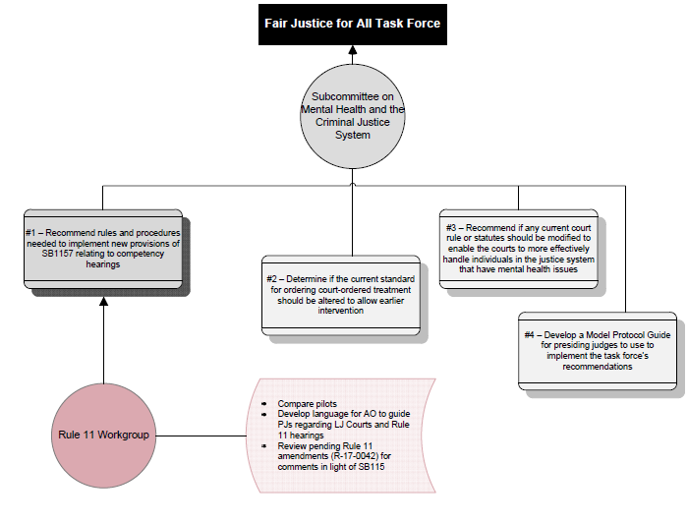

APPENDIX D

Mesa Municipal Court Rule 11 Proceedings Statistics through 9/2017

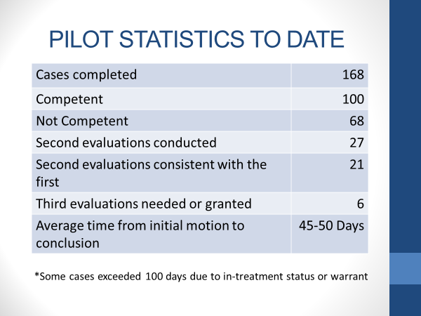

Glendale City Court Rule 11 Proceedings Statistics through 9/2017

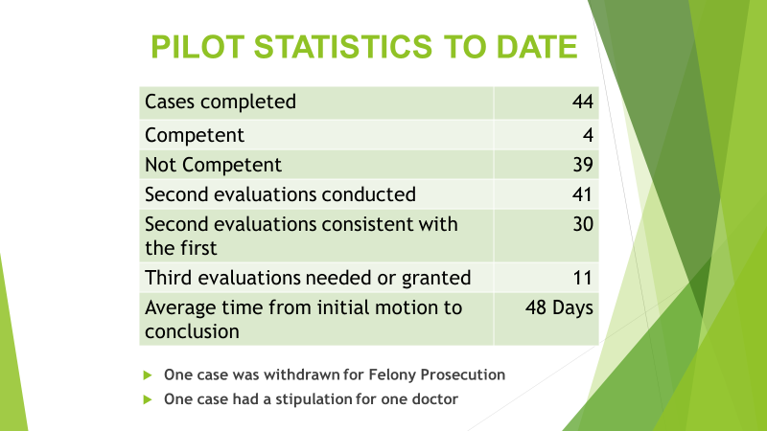

APPENDIX E

Senate Engrossed
State of Arizona
Senate
Fifty-third Legislature
First Regular Session
2017

CHAPTER 14

SENATE BILL 1157

AN ACT

amending section 13-4503, Arizona Revised Statutes; relating to competency hearings.

(TEXT OF BILL BEGINS ON NEXT PAGE)

Be it enacted by the Legislature of the State of Arizona:
Section 1. Section 13-4503, Arizona Revised Statutes, is amended to read:
13-4503. Request for competency examination; jurisdiction over competency hearings; referral
A. At any time after the prosecutor charges a criminal offense by complaint, information or indictment, any party or the court on its own motion may request in writing that the defendant be examined to determine the defendant's competency to stand trial, to enter a plea or to assist the defendant's attorney. The motion shall state the facts on which the mental examination is sought.
B. Within three working days after a motion is filed pursuant to this section, the parties shall provide all available medical and criminal history records to the court.
C. The court may request that a mental health expert assist the court in determining if reasonable grounds exist for examining a defendant.
D. Once Except as provided in subsection E of this section, after any court determines that reasonable grounds exist for further competency proceedings, the superior court shall have exclusive jurisdiction over all competency hearings.
E. The presiding judge of the superior court in each county, with the agreement of the justice of the peace or municipal court judge, may authorize a justice court or municipal court to exercise jurisdiction over a competency hearing in a misdemeanor case that arises out of the justice court or municipal court.
F. A justice of the peace or municipal court judge, with the approval of the presiding judge of the superior court and the justice or judge of the receiving court, may refer a competency hearing to another justice court or municipal court that is located in the county.

APPROVED BY THE GOVERNOR MARCH 14, 2017.

FILED IN THE OFFICE OF THE SECRETARY OF STATE MARCH 14, 2017.

The proposed amendments are to Rules 11.5 and 11.6 effective April 2, 2018.
Supreme Court Administrative Order No. 2015-092 authorized a limited jurisdiction mental competency proceedings pilot project in the superior court in Maricopa County to allow the Mesa Municipal Court and the Glendale City Court to conduct Rule 11 proceedings for misdemeanor cases originating in their courts. Judges from these municipalities preside over these proceedings as superior court judges pro tempore.

