On behalf of the People of Arizona
Martin Lynch
1120 W Broadway Rd, Apt 55
Tempe AZ, 85282

IN THE SUPREME COURT OF THE STATE OF ARIZONA
Supreme Court No. R-17-____
Ref R-16-0037 for Rule 72
PETITION TO AMEND RULE 72
ARFLP NUNC PRO TUNC
REQUEST FOR PERMISSION TO FILE THIS PETITION OUTSIDE THE RULE 28 TIMELINE
In the Matter of
PETITION TO AMEND RULE 72
OF THE RULES OF FAMILY LAW
PROCEDURE NUNC PRO TUNC
Pursuant to Rule 28, Rules of the Supreme Court, Martin Lynch, on behalf of the People of Arizona, and joined in the spirit of Peter Swann, Judge of the Arizona Court of Appeals and Paul McMurdie, Appellate Judge and former Presiding Judge of the Family Court of the Superior Court of Arizona in Maricopa County in R-16-0037 respectfully petitions this Court to adopt the attached proposed amendment to Rule 72 of the Rules of Family Law Procedure. Since this petition is thought to be Nunc Pro Tunc, to correct a mere clerical error, Petitioners respectfully request permission to file this petition outside the Rule 28 timelines to allow the Chief Justice of the Supreme Court to consider this proposal and take appropriate action at his earliest opportunity.
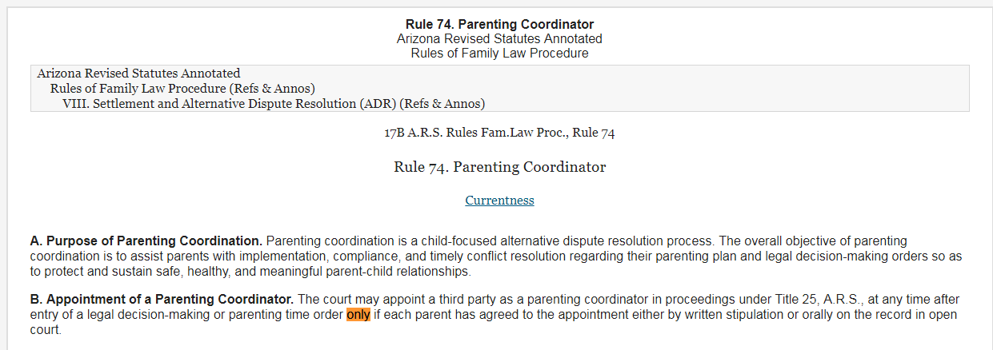

“Only if each parent has agreed to the appointment”

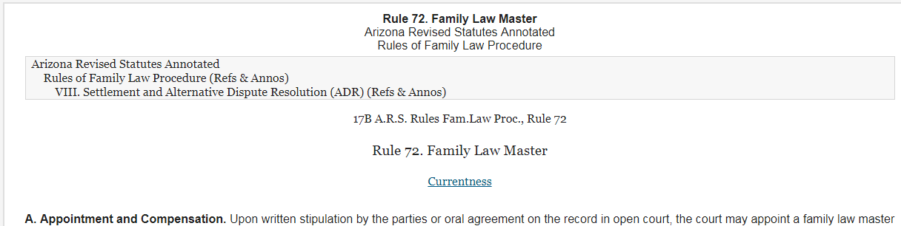
The esteemed Judiciary of our State realized in well-crafted arguments that forcing an expensive 3rd party upon litigants over their objections was a violation of their Civil Rights. Rule 74 was changed accordingly (above). See the word “only”.
A loop hole in this Rule 74 prohibition arose. Some Parenting Coordinators began seeking Sua Sponte appointments under Rule 72 as “Special Masters”. To preclude this renewed violation of Rights, the Court set out to apply the same protections to Rule 72 in R-16-0037 (see attached Petition of May 18, 2016). The change and the stated intent of the change were adopted and enacted effective Jan 1, 2017 (see attached one page order).
The People have discovered that some Family Court Judges have returned to making Sua Sponte appointments of “Special Masters” on their own motion over the objections of litigants under the revised Rule 72.
Judges Swann and McMurdie (affirmed by Chief Justice Bales) are clear in the intent of the amendment to Rule 72: Would (1) preclude the trial court from appointing a family law master on its own motion without the agreement of the parties.
The People seek a Nunc Pro Tunc correction by the Chief Justice to simply clarify by adding the word “ONLY” as the first word in the new amended Rule 72, which apparently has been inadvertently left out. This absent word has eviscerated the clear intent of the change stated in the Rule Petition R-16-0037 and subsequent administrative order rendered by the Chief Justice included herein.
The People believe this to be a mere “Nunc Pro Tunc” clerical error which can be easily and immediately corrected by administrative order signed by the Chief Justice at his convenience, under the administrative authorities granted to him by Art 6 Sect 3 of the AZ State Constitution. The People respectfully request the Chief Justice place the word “Only” as the first word in the amended Rule 72.
To all Family Court Judges: If you are considering making Sua Sponte appointments based upon a “clerical error” in Rule 72, please don’t do that. The intent of the changes recently implemented by the Arizona State Supreme Court are clear in the one page implementation order signed by the Honorable Chief Justice Scott Bales (attached).

Thank-you for protecting the Rights of the People.
October 2, 2017
/s/ Martin Lynch
1120 w Broadway Rd, Apt 55
Tempe AZ, 85282
602-550-6304

Invitation to Mr Barry Brody and Mr David Horowitz:

In a meeting of the ARFLP Task Force Friday Sept 29, 2017 chaired by former Chief Justice Berch, Mr Body commented that reduced appointments of third parties under Rules 72 and 74 was thought to be having a deleterious effect on the smooth function of the Family Courts. The People of Arizona join with Mr Brody in our shared concerns and note that problems in the Courts might have any number of causations beyond and perhaps including Sua Sponte appointments of third parties.
Petitioner has decades of experience using the scientific method to solve problems of organizational function or dysfunction. Ref ISO9001 and AS9100. If we do not fully understand the cause of the problem, there is little of no chance of devising or implementing a lasting solution.
Perhaps Mr Brody theorizes that Sua Sponte appointments would fix the problem. Petitioner theorizes that all PCs and Special Masters are people, and that all groups contain some who perform their functions well, some poorly, most fall somewhere in the middle. Petitioner can observe no process to identify the good or the poor practitioners and theorizes that the harm caused by poor practitioners has ruined the process for everybody, and undermined the integrity of the Judicial system in the minds of the People. Without “evidence” or data to support our theories, it is almost impossible to determine if either or neither of our theories are correct.
The Court Roster has about 100 practitioners and believes Mr Brody and Mr Horowitz accept appointments under Rules 72 or 74. Since they are both on the ARFLP Task Force chaired by Justice Berch, it is reasonable to presume they are at or near the peak of their profession. This Petitioner and The People would welcome their participation in identifying the true root cause of the problems as noted by Mr Brody and identifying and recommending sound solutions to Court Leadership based upon proven principles of problem solving.
Step #1: Mission Statement? What is any appointment under Rules 72 or 74 intended to achieve? (Build from there.)
Petitioner envisions a new reality where nobody cares about Sua Sponte appointments because the consumers have information “evidence” identifying the best practitioners. The People would seek out and retain the best providers until saturation, perhaps a maximum of 30 appointments (not 150). They would move down the list seeking appointments from the best available practitioners based upon their performance relative to the Mission Statement noted herein.
This would have the added benefit of motivating all providers to perform at the highest levels and constantly seek ways to improve their quality of service to the People. Petitioner and The People agree with Mr Brody that these processes can be improved and would welcome anyone’s participation in efforts to improve Court services to the People of Arizona.
Thank-you for your consideration.
/s/ Martin Lynch

