Elizabeth Finn
Presiding Judge
Glendale City Court
5711 W. Glendale Ave.
Glendale, Arizona 85301
Telephone: (623) 930-2400

ARIZONA SUPREME COURT

In Re:  PETITION TO AMEND RULE 37, FORM 11 OF THE ARIZONA RULES OF CIVIL TRAFFIC AND CIVIL BOATING VIOLATIONS |  | R-17-0034  Glendale City Court Comment to Petition to Amend Rule 37, Form 11 of the Arizona Rules of Civil Traffic and Civil Boating Violations

Pursuant to Rule 28 of the Rules of the Supreme Court, Elizabeth R. Finn, Presiding Judge of Glendale City Court submits these comments in opposition to the Petition to Amend Rules of Court Procedure for Civil Traffic and Civil Boating Violations, Form 11, Arizona Traffic Ticket and Complaint (ATTC). Respondent asks this Court to deny that portion of the request substituting the words “At or before the date and time indicated” for the words “At the date and time indicated” on the front side of all four copies of Form 11.

INTRODUCTION

The Administrative Office of Courts (AOC) petitioned this Court to amend Rule 37, Form 11, on an expedited basis. Although the petition relies on the report of the Fair Justice for All Task Force, it is important to note that not all language in the form was considered by the task force. The requested change concerns procedures which are crucial to protecting victims and the public. The abbreviated comment period does not provide sufficient time for victims, the public, and other stakeholders in the criminal justice system to thoroughly examine all issues attendant to the requested change and is therefore not in the interests of fair justice.

ARGUMENT
I
The complex issues and balancing of interests between the efficiency of the court system and the protection of the rights of victims should not be in conflict. Police, prosecutors and courts use the date on the complaint to inform victims when to appear in order to exercise their rights to be heard by the court. The simple change including “or before” the date on the ATTC removes the certainty of the date and time when a victim can appear to exercise their rights under Ariz. Const. Art. II, § 2.1.
3. To be present at and, upon request, to be informed of all criminal proceedings where the defendant has the right to be present.
4. To be heard at any proceeding involving a post-arrest release decision, a negotiated plea, and sentencing.

II
The court will need to schedule another appearance by the defendant for sentencing in order to preserve the victim’s right to be heard under the Constitution and Rule 39, Arizona Rules of Criminal Procedure.
III
The court will need to schedule another appearance by the defendant to preserve the defendant’s Constitutional rights as neither advisory council nor a public defender will be present during open court hours or traffic dockets.
IV
Prosecutors in limited jurisdiction courts are not routinely scheduled to appear Monday thru Friday and even if present would not have their case file for an unscheduled appearance by a defendant. The court once again would need to schedule another appearance by the defendant
V
The ATTC may not even have been filed in the court by law enforcement before the defendant appears and no authority exists for the court to accept the defendant’s copy of the complaint as formerly allowed under the abrogated Rules of Traffic Cases and Boating Cases, Rule 8 (c).

(c) A defendant may appear in person or in writing before the scheduled arraignment date and seek adjudication of a traffic or boating violation upon presentment of a copy of the charging document. Such an appearance shall constitute a waiver of applicable time limits and any objection to technical defects in the charging document or other available motions challenging the sufficiency of the allegations. If the court determines that the defendant’s change of plea to guilty/no contest (or for civil violations, responsible) is otherwise knowing, voluntary, and intelligent, and has a factual basis, the court may accept the copy of the complaint as the charging document for purposes of case initiation and adjudication of same. Upon timely receipt of the original charging document, the court shall file same as part of the initial case disposition and otherwise maintain proper records of the case resolution. Where no original is received, the court may take such steps as necessary to vacate the change of plea, dismiss the complaint, refund any payments, or otherwise restore the case to its initial posture as appropriate.
VI

There are many courts that do not have a judicial officer available every day or that do not operate five days per week. Defendants and others transporting them would be needlessly inconvenienced by appearing at a court when there is no judicial officer that can address their issue or even staff to schedule a future appearance.

VII

Lastly, the Committee on Limited Jurisdiction Courts never discussed the change to “At or before the date and time indicated” as part of the presentation by representatives of the Fair Justice for All Taskforce and did not file a petition requesting the change.
VIII
The following Judicial Officers join with the respondent in opposing that portion of the request substituting the words “At or before the date and time indicated” for the words “At the date and time indicated” on the front side of all four copies of Form 11.

Maria Brewer, Presiding Judge, Buckeye Municipal Court
Craig Jennings, Presiding Judge, Avondale Municipal Court
Sherri Rollison, Presiding Judge, Wickenburg Municipal Court
Michael Simonson, Presiding Judge, Goodyear Municipal Court
Gerald Williams, Justice of the Peace, North Valley Justice Court

Respectfully submitted this 7th day of July 2017.

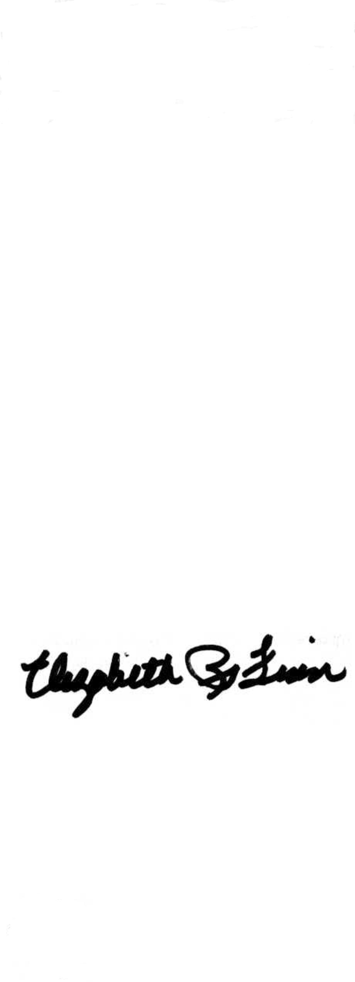

Elizabeth R. Finn
Presiding Judge
Glendale City Court

