Jessica J. Fotinos, Bar No. 019777
General Counsel
State Bar of Arizona
4201 N. 24th Street, Suite 100
Phoenix, AZ 85016-6288
(602) 340-7236

IN THE SUPREME COURT
STATE OF ARIZONA
In the Matter of:  PETITION TO AMEND VARIOUS RULES OF THE ARIZONA RULES OF CIVIL PROCEDURE AND ADOPT NEW RULE 7.5 | Supreme Court No. R-26-0017  NOTICE OF ERRATA

Pursuant to Rule 28(a) of the Arizona Rules of the Supreme Court, the State Bar of Arizona (“State Bar”) submits this Notice of Errata to fix an erroneous cross-reference in the proposed amendments.
Amended Appendices A and B to this Notice of Errata correct cross-references to Rule 26(d), Ariz. R. Civ. P. that were inadvertently left in Rules 26(e)(1) and (2). Any other remaining cross-references to Rule 26(d) were intentionally left intact, as the State Bar submits that they need not be changed to affect the changes proposed by the Petition.

RESPECTFULLY SUBMITTED this 1st day of May, 2026.
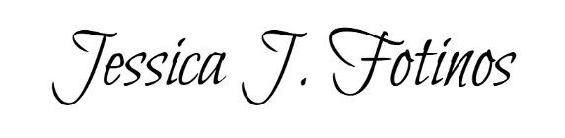

Jessica J. Fotinos
General Counsel

Electronic copy filed with the
Clerk of the Supreme Court of Arizona
this 1st day of May, 2026.

by: PSeguin

