Lisa M. Panahi
Bar No. 023421
State Bar of Arizona
4201 N. 24th Street, Suite 100
Phoenix, AZ 85016-6288
(602) 340-7236

IN THE SUPREME COURT
STATE OF ARIZONA
In the Matter of:  PETITION TO AMEND RULE 39(b)(12) OF THE RULES OF CRIMINAL PROCEDURE | Supreme Court No. R-25-0035  REPLY

The State Bar of Arizona (“State Bar”) hereby replies to the comments filed in response to its Petition to Amend Rule 39(b)(12) of the Arizona Rules of Criminal Procedure. The criticisms offered misunderstand both the purpose and the effect of the proposed changes. The Petition is a modest procedural proposal designed to enhance fairness, transparency, and efficiency in victim interview request process without undermining any party’s rights or imposing inappropriate burdens. The State Bar therefore requests that this Court adopt the proposed amendments without further modification.
- The Petition Does Not Presume Prosecutorial Misconduct or Neglect
Contrary to the comments submitted by APAAC and MCAO, the Petition does not presume that prosecutors are failing to discharge their duty to convey defense interview requests to victims. Rather, the Petition merely responds to the concerns raised by then-Chief Justice Brutinel in the Court’s August 31, 2023 referral letter, which invited consideration of whether a more structured interview request process might better serve all participants in criminal cases. The proposed amendment provides a mechanism that ensures requests are made and resolved through a process familiar to courts and parties—filed pleadings—thus reducing ambiguity and possible disputes about timing, content, or delivery of requests.
- The Amendment Promotes Fairness and Efficiency by Providing Structure and Clarity, Not Undue Work

The proposed change enhances procedural clarity and fairness by channeling victim interview requests through the filing of pleadings with the court. The filings do not require legal argument or court rulings and instead require minimal information in what will likely be form pleadings. Thus, contrary to the comments submitted by APAAC and MCAO, the filings will not create a burdensome workload. And, to the extent the filings are more burdensome than the current procedure, it is justified because it provides a transparent, court-supervised framework that benefits all stakeholders: victims, prosecutors, defense counsel, and the courts. A filing-based procedure ensures that disputes about notice, timing, or scope of interview requests are resolved through consistent judicial process, not ad hoc communication and litigation.

- The Amendment Does Not Require Defense Counsel to Convey Correspondence to Victims

MCAO’s objection that the proposed amendment improperly requires prosecutors to convey defense counsel communications to victims misconstrues the proposal’s text and function. The Petition does not ask prosecutors to send victims correspondence. Rather, it requires that victim interview requests be filed with the court. A filed pleading requesting an interview is not “correspondence.” Moreover, victims already have a right under Arizona law to receive notice of all pleadings filed in a case. The proposed rule change merely ensures that the request for an interview is included among such pleadings so that victims receive formal notice through existing mechanisms—not informal or unsolicited communication. And procedures are included in the proposed amendments to challenge any offending content in the filed interview request.
- The Petition Does Not Address First Amendment Issues Raised in Separate Litigation

ACLU’s criticisms that link this proposal to pending First Amendment litigation misconstrue its intent and scope. The Petition does not seek to resolve or influence any constitutional questions raised in the AACJ lawsuit. It does not regulate the content of communications or limit defense counsel’s ability to speak. It simply proposes a fair and consistent process for making requests to interview victims—one that respects victims’ rights while preserving the defense’s ability to seek access to information. Moreover, the Court, in its August 31, 2023 referral letter, has already indicated that it disagrees with ACLU’s original proposal and claim that interview requests through the prosecutor’s office offend the First Amendment.
- Differential Treatment of Prosecutors and Victim Counsel Is Warranted

The Maricopa Public Defenders’ argument that Victim Counsel should be treated the same as prosecutors is unwarranted for the reasons set forth in the Petition. Prosecutors and Victim Counsel differ in that the prosecutor is not representing the victim. This difference, and the resulting differing ethical obligations, renders it unnecessary for Victim Counsel to be subject to identical filing obligations.
- Making Filed Interview Requests Permissive Rather Than Mandatory Is Premature and Otherwise Defeats the Purpose of the Amendments.

The Maricopa Public Defenders’ further argument that filed interview requests should be permissive rather than mandatory, because interview requests may one day be deemed unconstitutional, should be rejected as speculative and premature. If interview requests are deemed unconstitutional, rules requiring them would not be enforceable, and, in any event, they could be amended in response. Further, making it permissive to file interview requests at this time would defeat the purpose of amendments—to ensure transparency and timeliness in all cases, not just those where defense counsel chooses to file a request.
RESPECTFULLY SUBMITTED this 30th day of May 2025.

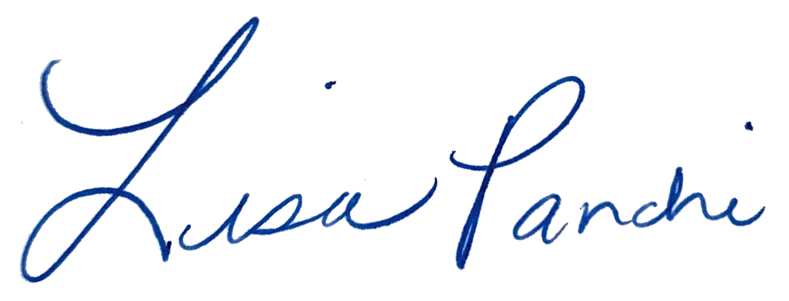
Lisa M. Panahi
FOR THE STATE BAR OF ARIZONA

Electronic copy filed with the
Clerk of the Supreme Court of Arizona
this 30th day of May 2025.

by: PSeguin

The AACJ lawsuit notably did not challenge Rule 39.

