Lisa M. Panahi
Bar No. 023421
State Bar of Arizona
4201 N. 24th Street, Suite 100
Phoenix, AZ 85016-6288
(602) 340-7236
IN THE SUPREME COURT
STATE OF ARIZONA
In the Matter of:  PETITION TO AMEND RULE 36 OF THE ARIZONA RULES OF PROTECTIVE ORDER  PROCEDURE; RULE 315 OF THE ARIZONA RULES OF PROCEDURE FOR THE JUVENILE COURT; AND RULE 901 OF THE ARIZONA RULES OF EVIDENCE | Supreme Court No. R-25-0030  STATE BAR OF ARIZONA COMMENT

introduction
Pursuant to Rule 28(a) of the Arizona Rules of Supreme Court, the State Bar of Arizona (“State Bar”) hereby submits this comment regarding Petition R-25-00030. The State Bar supports the goal of the Petition, namely, to provide courts with additional tools to address ever more sophisticated artificial intelligence (“AI”)-generated “deep fakes” that may be presented in judicial proceedings. The State Bar believes that additional work would be beneficial to cover additional rule sets, as well as to avoid technology-specific approaches that may be superseded by later developments.

THE PETITION
The Petition seeks to amend three different rules:
- Rule 36, Arizona Rules of Protective Order Procedure.
- Rule 315, Arizona Rules of Procedure for the Juvenile Court.
- Rule 901, Arizona Rules of Evidence.
Although the amendments themselves are different, the purpose of these amendments is the same: “to create consistent and sufficient methods for litigants and courts to address AI-generated or substantially altered evidence across case types.” Petition at 3.

THE PETITION IS A GOOD START, BUT MORE should BE DONE TO ADDRESS ADDITIONAL RULE SETS
The State Bar agrees that advances in artificial intelligence complicate the evaluation of the authenticity of evidence, and that revisions to court rules will be needed. The State Bar also agrees, with one limited exception noted below, with the proposed changes in the Petition. But the State Bar recommends that the Petition in its current form be denied simply to allow additional rule sets to be addressed, including at least Rule 11 of the Arizona Rules of Civil Procedure.
The standard for submission of evidence should not be so onerous as to require parties or counsel to scrutinize each document, photograph, or other item for authenticity. But the standard should also not be so lax as to permit overlooking reasonable indicia of fabrication. The State Bar suggests that when additional rule sets are addressed, the Court consider a standard similar to that contained in A.R.S. § 33-420 with respect to false liens, namely, penalizing a party or attorney who submits a document “knowing or having reason to know” that the document is forged, manipulated, or otherwise inauthentic. For instance, as currently drafted, revised Rules 36 and 315 allow the imposition of sanctions for presenting false or materially altered evidence, with no requirement that the attorney knew or had reason to know that the evidence was false. The Court should also avoid technology-specific standards or tests, as such specificity may be mooted by future developments.
Finally, the State Bar suggests that the proposed comment to Evidence Rule 901(b) (requiring disclosure of metadata) rests on the incorrect assumption that the proponent of evidence will know, or admit, that the evidence was created by artificial intelligence:
Further, to provide the adverse party with an opportunity to properly analyze the issue of authenticity of AI-generated evidence, the “record” provided by the proponent of the evidence must include the metadata for the material in question if reasonably necessary to assess the material’s authenticity.

Petition at 10. It is reasonable to require disclosure of metadata for evidence that is created by AI. But the indication that the proponent of the evidence “must include the metadata for the material in question if reasonably necessary to assess the material’s authenticity” assumes that the metadata exists and is available to the proponent. Damaging fabrications may predate metadata, such as photographs taken on film or photocopies of original documents. Metadata may not even be available, or only available if extraordinary measures are undertaken. Further analytical tools will likely be required, perhaps at disproportionate expense. The absence of the metadata may ultimately warrant the exclusion of the proffered evidence, but the requirements should not be absolute.
For the above reasons, the State Bar respectfully requests this Court deny Petition R-25-0030 to permit consideration of amendments to additional rule sets, including referring this issue to the Arizona Steering Committee on Artificial Intelligence and the Courts as appropriate.
RESPECTFULLY SUBMITTED this 1st day of May 2025.

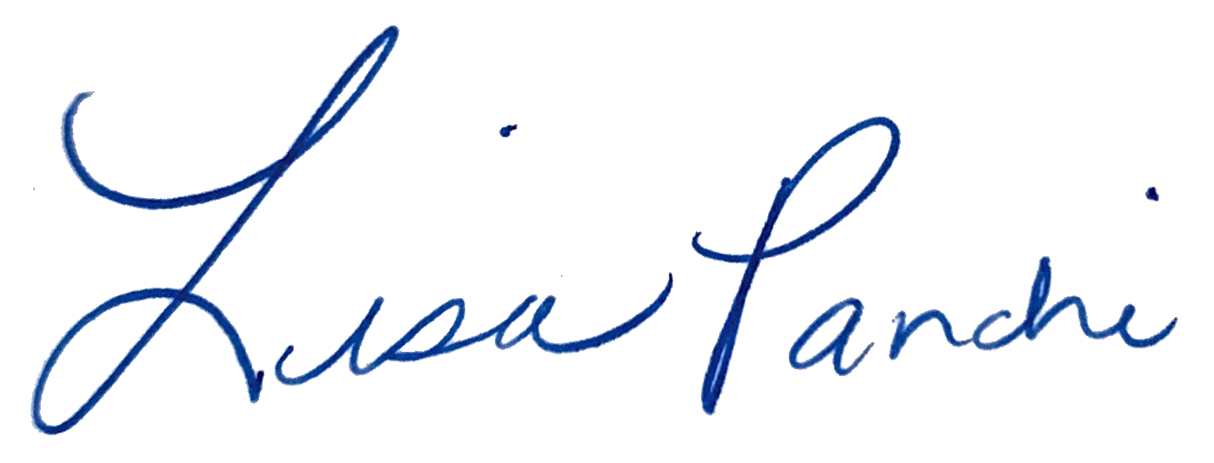
Lisa M. Panahi
FOR THE STATE BAR OF ARIZONA

Electronic copy filed with the
Clerk of the Supreme Court of Arizona
this 1st day of May 2025.

by: PSeguin

