Lisa M. Panahi
Bar No. 023421
State Bar of Arizona
4201 N. 24th Street, Suite 100
Phoenix, AZ 85016-6288
(602) 340-7236

IN THE SUPREME COURT
STATE OF ARIZONA

In the Matter of:  PETITION TO AMEND RULE 4.1(I) OF THE RULES OF CIVIL PROCEDURE FOR THE SUPERIOR COURTS OF ARIZONA; RULE 41(J) OF THE RULES OF FAMILY LAW PROCEDURE; RULE 113(B) OF THE JUSTICE COURT RULES OF CIVIL PROCEDURE; RULE 5(B), RULES OF SMALL CLAIMS PROCEDURE | Supreme Court No. R-24-0057  STATE BAR OF ARIZONA COMMENT

Pursuant to Rule 28(e) of the Arizona Rules of Supreme Court, the State Bar of Arizona (“State Bar”) hereby submits the following comment to the above-captioned Petition.
Introduction
The Petition suggests disharmony exists between A.R.S. § 29-3119 and the rules of procedure related to serving limited liability companies (LLC). As a solution, Petitioners recommend referencing A.R.S. § 29-3119 in the applicable Civil, Family, Justice Court, and Small Claims Court rules. While the State Bar acknowledges the concerns outlined in the Petition and believes the statutory and rule language need to be harmonized, the State Bar opposes the Petition as currently proposed. The State Bar believes more investigation is necessary.
Analysis
The Petition raises legitimate concerns regarding potential tension between the Arizona statute and the Rules of Civil Procedures for the Superior Courts of Arizona. However, it is the State Bar’s position that additional work is needed to address that tension with a more comprehensive solution.
The Petition’s proposal only contemplates LLCs, while the rules refer to various entity types (corporations, partnerships, and other associations). Several of these other entity types have corresponding statutes (e.g. A.R.S. §10-504 regarding Service on Corporations) and the State Bar believes a more complete analysis should be made to ensure clarity and accuracy for each entity type.
And, importantly, to the extent substantive changes are going to be made regarding how service is accomplished on legal entities in Arizona, a review and implementation of those changes should be thoughtful and thorough. For example, the State Bar is concerned about potential confusion regarding the statute’s allowance of (alternative) service by mail upon LLCs, while the rules typically require a finding of due diligence or reasonable efforts having been made first.
While the State Bar agrees an opportunity for improvement exists, it believes additional time and effort are required to reconcile the statutory and rule language of all entity types to provide a more complete solution. The State Bar has established a subcommittee to analyze the issues presented in the Petition to further develop a comprehensive solution to the issues raised in the Petition. The State Bar’s subcommittee will work in consultation with other relevant stakeholders, including the Arizona Process Servers Association
Conclusion
The State Bar opposes the Petition as presented and recommends the Court deny the Petition to provide the opportunity for further study on a more comprehensive approach to the proposed changes.
RESPECTFULLY SUBMITTED this 1st day of May 2025.

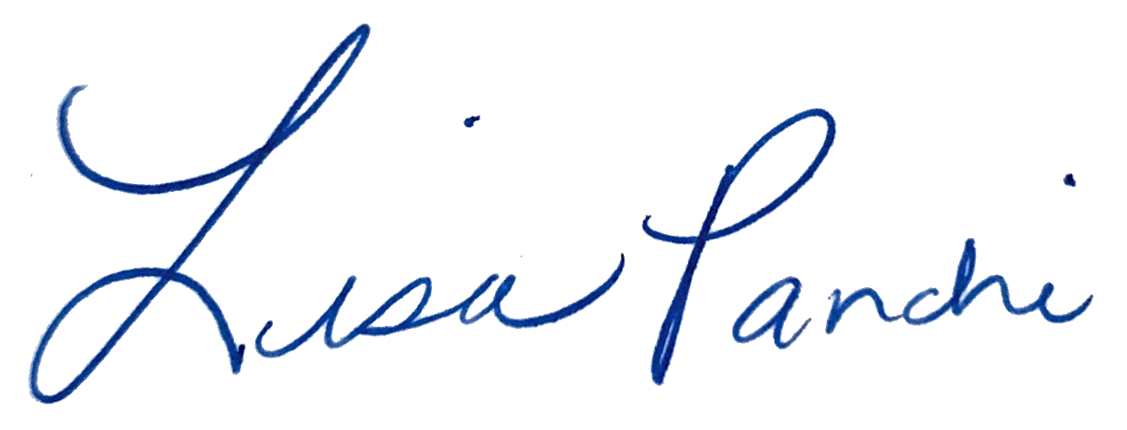
Lisa M. Panahi
FOR THE STATE BAR OF ARIZONA

Electronic copy filed with the
Clerk of the Supreme Court of Arizona
this 1st day of May 2025.

by: PSeguin

