Lisa M. Panahi
Bar No. 023421
State Bar of Arizona
4201 N. 24th Street, Suite 100
Phoenix, AZ 85016-6288
(602) 340-7236
IN THE SUPREME COURT
STATE OF ARIZONA
In the Matter of:  PETITION TO AMEND RULE 42 (ERs 1.16 AND 3.3), OF THE ARIZONA RULES OF SUPREME COURT | Supreme Court No. R-25-0029  STATE BAR OF ARIZONA COMMENT

The State Bar of Arizona supports Petition R-25-0029 and incorporates its comment to R-25-0030 that discusses its big-picture view on how to address “deep fakes” in litigation.
RESPECTFULLY SUBMITTED this 1st day of May 2025.

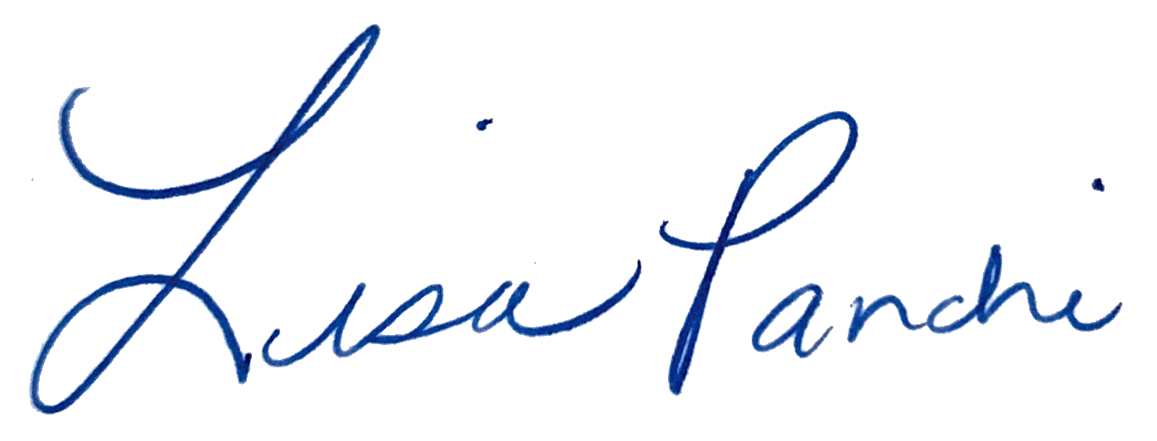
Lisa M. Panahi
FOR THE STATE BAR OF ARIZONA

Electronic copy filed with the
Clerk of the Supreme Court of Arizona
this 1st day of May 2025.

by: PSeguin

