Lisa M. Panahi
Bar No. 023421
State Bar of Arizona
4201 N. 24th Street, Suite 100
Phoenix, AZ 85016-6288
(602) 340-7266

IN THE SUPREME COURT
STATE OF ARIZONA
In the Matter of:  PETITION TO AMEND ARIZONA RULE OF PROCEDURE FOR SPECIAL ACTIONS 2(b)(1) | Supreme Court No. R-25-0002  STATE BAR OF ARIZONA COMMENT

Pursuant to Rule 28, Ariz. R. Sup. Ct., the State Bar of Arizona (“State Bar”) submits the following comment in support of Petition R-25-0002 (the “Petition”) filed by the Honorable D. Douglas Metcalf.
The Petition seeks to add a sentence to Rule 2(b)(1) of the Rules of Procedure for Special Actions (“Special Action Rules”) stating that “[a] party cannot seek original special action relief if an equally plain, speedy, and adequate remedy exists at law.” Having reviewed the Petition and examined the circumstance it seeks to address, the State Bar recommends that the Court grant the requested amendment but place alternative proposed language in a new Rule 3.1 of the Special Action Rules entitled “Original Special Actions Other than Statutory Special Actions.”
I. Analysis.
On August 22, 2024, in response to a Petition filed by the Court’s Task Force on Rules of Procedure for Special Actions (R-23-0055), this Court abrogated the Special Action Rules then in effect and adopted a proposed set of new rules applicable to special actions. Among other substantive and stylistic revisions, the new Special Action Rules were reorganized into four parts, Part I (General Provisions), Part II (Original Special Actions), Part III (Appellate Special Actions), and Part IV (Actions Involving Industrial Commission Awards). Additionally, a new Rule 12 setting forth factors supporting acceptance or denial of jurisdiction was included in Part III pertaining to appellate special actions. New Rule 12(a), which addresses the discretionary nature of appellate special action jurisdiction, provides that, “[i]n accepting or declining jurisdiction, the court is determining whether remedy by appeal is equally plain, speedy, and adequate.” The Task Force did not recommend inclusion of a corresponding rule pertaining to original special actions, and the Court did not adopt one.
The Petition posits that parties seeking original special action relief may argue that the lack of “equally plain, speedy, and adequate” language in Part II of the Special Action Rules may be construed to signal that parties may seek original special action relief without first exhausting available legal remedies. The State Bar agrees with Petitioner and recommends the Court grant the Petition but resolve the issue by placing language similar to that proposed in a new Rule 3.1 as described in this Comment.
The lack of reference to the need for parties to pursue equally plain, speedy, and adequate remedies available at law prior to pursuing original special actions creates an ambiguity as to applicability of this requirement to this class of special actions. Moreover, the continued viability of Arizona’s existing case law holding that special action relief is not available in the presence of an equally plain, speedy, and adequate remedy at law (see Petition at 3 citing Rhodes v. Clark, 92 Ariz. 31, 34-35, 373 P.2d 348, 350 (1962)) may be questioned by those who note the inclusion of the requirement in Rule 12(a) relating to appellate special actions and its omission from the Special Action Rules concerning original special actions.
As noted in Rule 3 of the Special Action Rules, various statutes authorize special actions which “are governed by [the Special Action Rules] unless the statute authorizing a particular special action contains specific procedures supplementing or contradicting these rules.” The Court’s extensive comment to Rule 3, in turn, catalogues a variety of both original and appellate statutory special actions. To render clear that the requirement that parties seeking special action relief must first pursue equally plain, speedy, and adequate remedies available at law in connection with non-statutory original special actions, the State Bar recommends that instead of addressing the issue raised by Petitioner in Rule 2(b)(1), a new Rule 3.1 instead be adopted, providing as follows:

Rule 3.1. Original Special Actions Other Than Statutory Special Actions
With respect to any original special action that is not a statutory special action as defined in Rule 3, the court may only take jurisdiction if there is no available equally plain, speedy, and adequate remedy at law.
II. Conclusion.
For the reasons set forth herein, the State Bar supports the Petition but recommends that the issue raised therein be addressed by inclusion of similar language in a new Rule 3.1 of the Special Action Rules.
RESPECTFULLY SUBMITTED this 1st day of May 2025.

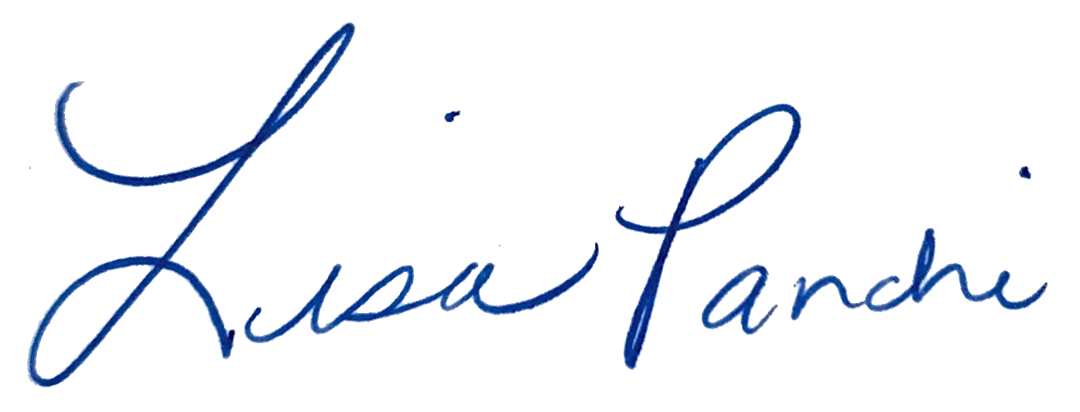
Lisa M. Panahi
FOR THE STATE BAR OF ARIZONA

Electronic copy filed with the
Clerk of the Supreme Court of Arizona
this 1st day of May 2025.

by: PSeguin

