Lisa M. Panahi
Bar No. 023421
State Bar of Arizona
4201 N. 24th Street, Suite 100
Phoenix, AZ 85016-6288
(602) 340-7236

IN THE SUPREME COURT
STATE OF ARIZONA
In the Matter of:  PETITION TO AMEND RULE 31.10 OF THE ARIZONA RULES OF CRIMINAL PROCEDURE and RULE 13 OF THE ARIZONA RULES OF CIVIL APPELLATE PROCEDURE | Supreme Court No. R-25-0013  STATE BAR OF ARIZONA COMMENT

Pursuant to Rule 28(e) of the Arizona Rules of Supreme Court, the State Bar of Arizona (the “State Bar”) hereby submits the following as its comment to the above-captioned Petition.
After review by the State Bar’s Criminal Practice and Procedure Committee, the State Bar supports the proposed rule change to explicitly permit parties to include photographs, charts, graphs, and other visual aids in appellate briefs. However, the Criminal Practice and Procedure Committee expressed concern with how the proposed rule could be applied in practice.
Specifically, the Criminal Practice and Procedure Committee is concerned about photographs containing sensitive information, such as a crime victim’s address, or photographs of crime victims being included in appellate briefs. See A.R.S. § 13–4434(B) (generally requiring a victim’s “identifying and locating information that is obtained, compiled or reported by a law enforcement agency or prosecution agency [to be] redacted”); Ariz. R. Crim. P. 39(b)(11) (granting victims “the right to require the prosecutor to withhold, during discovery and other proceedings, the victims’ identifying and locating information”). The Criminal Practice and Procedure Committee also expressed concern that the proposed rule could potentially be used to include items not included in the record on appeal in a party’s appellate brief.
Considering these concerns, the State Bar requests that this Court adopt the proposed rule and include a comment to the Criminal Rule reminding parties to be cognizant of victims’ rights—specifically, their right to privacy. The State Bar would also ask this Court to include a comment to both rules reflecting that parties may not include items from outside the record on appeal unless those items constitute or relate to a fact that a court could take judicial notice of. See Ariz. R. Evid. 201(d) (“The court may take judicial notice at any stage of the proceeding.”).

CONCLUSION
The State Bar of Arizona respectfully requests that this Court adopt the proposed rule with the inclusion of cautionary comments.
RESPECTFULLY SUBMITTED this 1st day of May 2025.

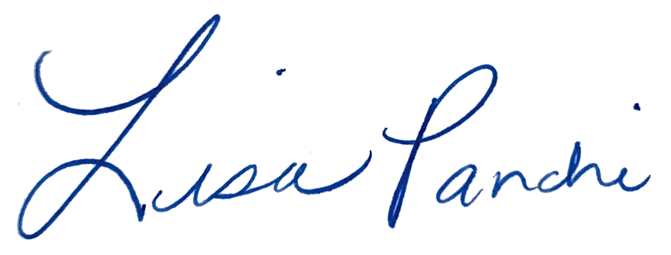
Lisa M. Panahi
FOR THE STATE BAR OF ARIZONA

Electronic copy filed with the
Clerk of the Supreme Court of Arizona
this 1st day of May 2025.

by: PSeguin

