Lisa M. Panahi
Bar No. 023421
State Bar of Arizona
4201 N. 24th Street, Suite 100
Phoenix, AZ 85016-6288
(602) 340-7236

IN THE SUPREME COURT
STATE OF ARIZONA
In the Matter of:  PETITION TO AMEND RULE 32.16 OF THE ARIZONA RULES OF CRIMINAL PROCEDURE | Supreme Court No. R-25-0014  STATE BAR OF ARIZONA COMMENT

Pursuant to Rule 28(e) of the Arizona Rules of Supreme Court, the State Bar of Arizona (the “State Bar”) hereby submits the following as its Comment to the above-captioned Petition.
After review by the State Bar’s Criminal Practice and Procedure Committee, the State Bar supports the Petition as written. As the Petition illustrates, it would affect procedural changes to the length and timeline of reply briefs in Capital PCRs. The State Bar believes these changes appropriately reflect the weight of these proceedings. Furthermore, the State Bar believes that if this Court adopts the changes outlined in this Petition, Petition R-25-0009 would become moot because all the changes proposed in that Petition are also proposed in the current Petition. The State Bar recommends that this Court adopt the changes proposed in this Petition, instead of Petition R-25-0009, because the proposed amendments set forth in this Petition are more comprehensive.
CONCLUSION
The State Bar of Arizona respectfully requests that the proposed rule changes set forth in R-25-0014 be adopted.

RESPECTFULLY SUBMITTED this 1st day of May 2025.

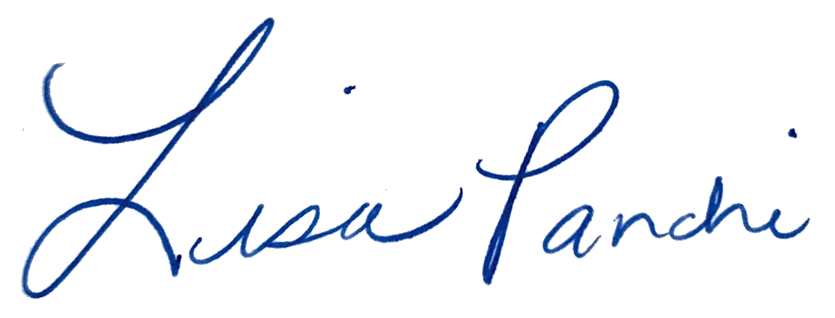
Lisa M. Panahi
FOR THE STATE BAR OF ARIZONA

Electronic copy filed with the
Clerk of the Supreme Court of Arizona
this 1st day of May 2025.

by: PSeguin

