IN THE ARIZONA SUPREME COURT

In the Matter of: )
) Supreme Court No. R-25-0013
)
PETITION TO AMEND )
ARIZ. R. CRIM. P. 31.10 AND )
ARIZ. R. CIV. APP. P. 13 )
)
)

Comment of
Arizona Attorneys for Criminal Justice
in Response to Petition to Amend Ariz. R. Crim. P. 31.10 and ARCAP 13

Grace M. Guisewite Kristen Reller
AZ Bar No. 029536 AZ Bar No. 036470
grace.guisewite@gmail.com kristen.reller@protonmail.com

Pursuant to Rule 28, Rules of the Supreme Court, Arizona Attorneys for Criminal Justice (AACJ) respectfully submit this Comment in support of the Petition to Amend Ariz. R. Crim. P. 31.10 and Ariz. R. Civ. App. P. 13 to Explicitly Permit the Use of Photographs, Charts, Graphs, and Other Visual Aids in Briefs.
AACJ strongly supports the adoption of these rule amendments which would clarify the rules and expressly authorize the optional use of photographs, charts, graphs, and other visual aids in appellate briefs. As detailed below, this amendment will enhance the quality of appellate briefs, and make justice more accessible to the public, thereby fostering public trust in the judiciary.
- Visuals strengthen appellate advocacy by making facts and arguments clearer.

A well-chosen image can deliver an argument with immediacy and force that text often lacks. For a profession that has been using the same general formatting and rules for decades, embracing the use of images and graphics may at first be difficult. However, visuals in appellate briefs can assist the court in many ways.
- Argument through photos.

First, photos can be used to make arguments. For example, a case involving a photographic lineup may benefit from featuring the lineup in the brief. Consider the pair of photos below (the lineup and screenshot from the body-worn camera) used to demonstrate how the lineup was unduly suggestive. The brief explained the suspect’s photo was zoomed in, making him appear larger, and that the black-and-white format obscured distinguishing features like skin tone and hair color. It also noted the individuals in the lineup did not resemble each other and showed the officer standing directly in front of the witness during the viewing, thereby adding undue pressure. While the images were admitted as exhibits, including them in the brief made the issues more immediate and accessible to the court during its review.
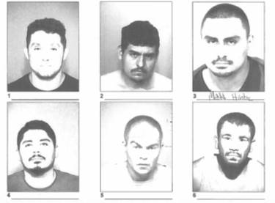

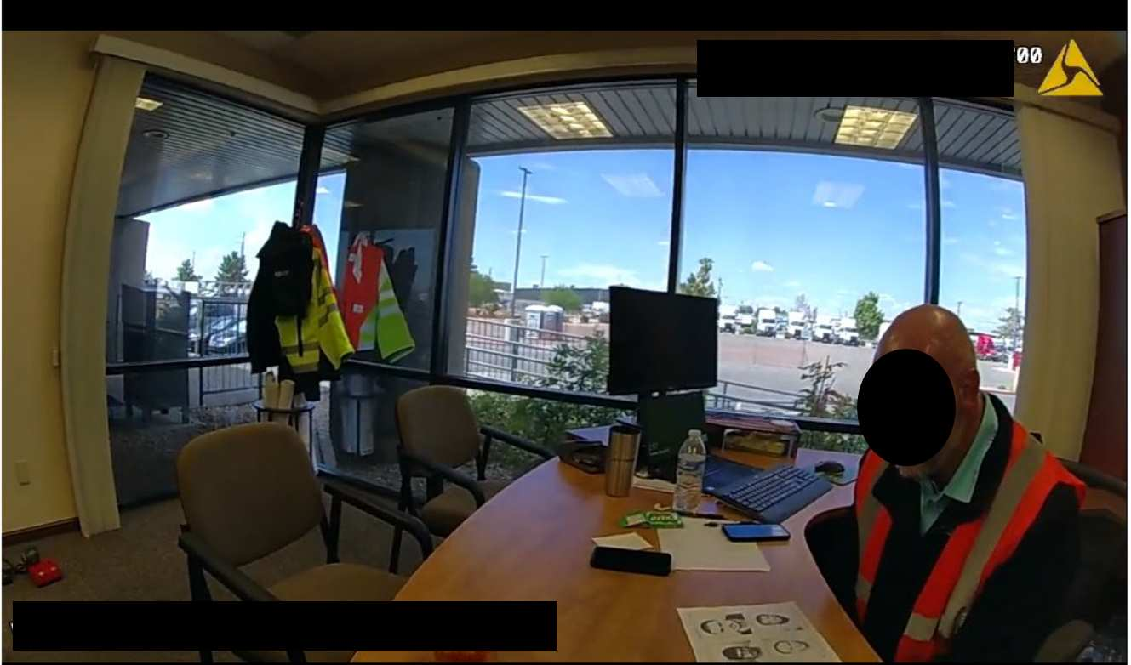

- Photos as context.

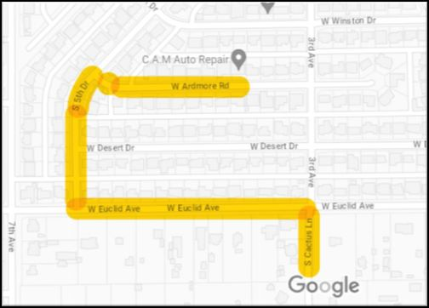
In instances where an argument does not turn on a photo, visuals can provide helpful context. For example, in a case of unlawful flight from law enforcement, a map of the defendant’s route may be instrumental in understanding the argument that he had no intent to evade police. The prose could explain that the defendant travelled northbound on 3rd avenue, turned left to travel westbound on W. Euclid Avenue, turned northbound on S. 5th Drive, and then eastbound on W. Ardmore Road. Or the same information could be succinctly presented with a map.

A well-known example of a photo providing valuable context to the written word comes from Judge Richard Posner in Sroga v. Weiglen, 649 F.3d 604, 608 (7th Cir. 2011).
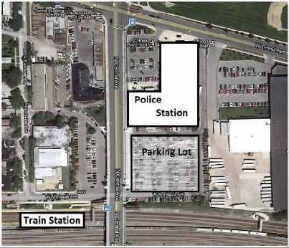
The issue was whether the plaintiff committed trespass by walking across a police parking lot. The plaintiff testified he walked through the parking lot because it was the shortest way to get from the police station to the train station. Judge Posner used the map below to explain, “Without the aerial photo, it would have been difficult to understand how the plaintiff could have thought it permissible to walk through the police parking lot.” Richard A. Posner, Reflections on Judging 143 (2013).

- Charts and graphs simplify complex relationships and processes.

Some arguments are easier to see than read. Flowcharts, bar graphs, pie charts, and organizational hierarchies are useful tools for clarifying more complex connections or topics. The following flowchart illustrates how the “light most favorable” standard has spread outside the context of sufficiency issues. The chart shows how one case can incorrectly influence another, leading to future legal errors. This phenomenon was described in the brief, but the flowchart communicates the same information more clearly and succinctly.
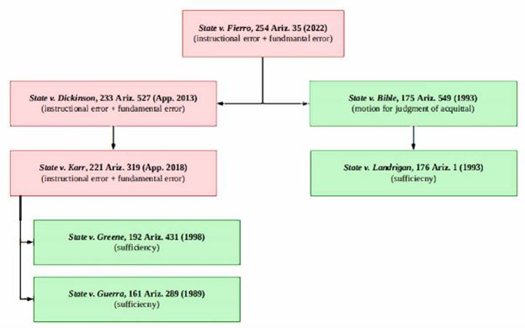

- Timelines.
Chronology described in words can be hard to follow and may require additional notetaking by the reviewing court. Visual timelines, however, can condense important details for easier reference.
- Charts to visualize legal reasoning.
In some instances, legal reasoning can be more effectively conveyed visually. For example, the below graphic demonstrates the cycle of detention that results from repeat petitions to revoke probation filed against an incompetent defendant, absent the protections of Johnson v. Hartsell, 254 Ariz. 585 (App. 2023).
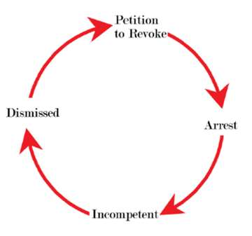

In another example, a color-coded chart was used in a brief to demonstrate how an officer’s mischaracterization of the traffic stop affected the ultimate probable cause determination.
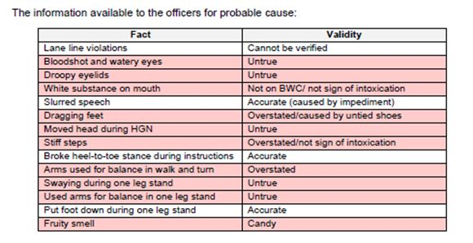
- Visuals are easy to use, and the current rules will prevent abuse.

If this proposed rule is adopted, its interaction with the other procedural rules will prevent the abusive use of visuals in appellate briefs.
First, visuals must be accurate and honest and cite the record when necessary. Ariz. R. Crim. P. 31.10(a)(6), (a)(7), (d); ARCAP 13(a)(5), (a)(7)(A), (d). Additionally, the easy-to-use photo and graphic tools in Microsoft Word reduce concerns that only the most tech-savvy and affluent parties can use visuals in their briefs.

- Photographs, Charts, Graphs, and Other Visual Aids in Briefs Further the Arizona Supreme Court’s Goal of Making Judicial Filings and Decisions More Accessible to the Public, which Fosters Public Trust in the Judiciary.

People learn and retain information in different ways. These differences, known as “learning styles,” are commonly known by the acronym “VAKT,” or visual, auditory, kinesthetic, and tactile.
Around 65% of the population is comprised of visual learners. Visual learning prioritizes the use of photographs, charts, graphs, and other visual aids to enhance comprehension and retention.
Arizona rules and cases have long recognized the importance of visual aids to assist juries in their determinations. See Ariz. R. Evid. 107 (permitting “a party to present an illustrative aid to help the trier of fact understand the evidence or argument. . . ”); Ariz. R. Crim. P. 22.2(a)(4) (permitting juries to bring “tangible evidence” into the jury room); State v. Lopez, 157 Ariz. 23, 25 (App. 1988); and State v. Sanchez, 130 Ariz. 295, 300 (App. 1981) (visual aids such as photographs of a defendant’s tattoos are admissible forms of demonstrative evidence that juries may consider when determining guilt).
As noted in the Petition, this Court incorporated a visual aid in Beck v. Neville, 256 Ariz. 415 (2024), to communicate a boundary by acquiescence dispute in the simplest way possible. Petition, at 2. More recently, this Court introduced AI-generated news reporters to make its opinions more accessible to the public.
This new technology delivers judicial rulings in video format, allowing for quicker dissemination. Chief Justice Ann Scott Timmer advised that the new media platform was in direct response to the fact that “In today’s fast-paced digital world, people turn to short videos for news and updates.” By targeting the public’s precise needs, the Court can increase community access and understanding of judicial decisions. This, in turn, should increase the public’s trust in the judiciary and the judicial process.
- Conclusion.

The Petition aligns with this Court’s goals of increasing the public’s access to and understanding of the judicial process. The use of visual aids in briefs will make them more accessible to the public. Visual aids will also lead to more coherent and concise briefing while making them more accessible to jurists. The result will be a judicial system that is more accessible to all.

Respectfully submitted, this 29th day of April, 2025,

By /s/Grace M. Guisewite & Kristen Reller
Grace M. Guisewite & Kristen Reller
Arizona Attorneys for Criminal Justice

M.H. Sam Jacobson, A Primer on Learning Styles: Reaching Every Student, 25 Seattle U.L. Review 139 (2001).
Zopf R., Giabbiconi C. M., Gruber T., Müller M. M. (2004). Attentional modulation of the human somatosensory evoked potential in a trial-by-trial spatial cueing and sustained spatial attention task measured with high density 128 channels EEG. Brain Res. Cogn. Brain Res. August 20 491–509.
The Comment to Rule 107 explains that illustrative aids include “drawings, photos, diagrams, video depictions, charts, graphs, and computer simulations.” Comment to 2025 Amendment, Ariz. R. Evid. 107.
Since the filing of this Petition, the Ninth Circuit has dramatically shifted the landscape of a court’s use of visual aids in judicial decisions. In Duncan v. Bonta, 131 F.4th 1019 (9th Cir. 2025) (en banc), U.S. Circuit Judge Lawrence VanDyke recorded a video dissent to further his argument that a gun magazine, regardless of capacity, is part of the gun itself and is therefore protected by the Second Amendment. See Dissent Video in 23-55805 Duncan v. Bota (Mar. 20, 2025). https://www.youtube.com/watch?v=DMC7Ntd4d4c.
Arizona Supreme Court Introduces AI-Generated Court News Reporters to Enhance Public Engagement (Mar. 11, 2025).
Id.
Id.
See United States Courts, Issue 2: Issue 2: Preserving Public Trust, Confidence, and Understanding (last viewed on Apr. 2, 2025) (advising federal courts to “improve the sharing and delivery of information about the judiciary generally” to help “[p]reserve public trust, confidence, and understanding” in the federal courts).

