Eric M. Fraser (No. 027241)
OSBORN MALEDON, P.A.
2929 N. Central Ave., Ste. 2000
Phoenix, AZ 85012
(602) 640-9000
efraser@omlaw.com

Arizona Supreme Court

In the Matter of:  Petition to Amend Ariz. R. Crim.  P. 31.10 and Ariz. R. Civ. App. P. 13 | Supreme Court No. R-25-0013  Comment re Petition to Amend Ariz. R. Crim. P. 31.10 and Ariz. R. Civ. App. P. 13

Eric M. Fraser submits this comment under Rule 28 of the Arizona Rules of the Supreme Court, regarding the petition to amend Ariz. R. Crim. P. 31.10 and Ariz. R. Civ. App. P. 13. Although I strongly support permitting visual aids in appellate briefs, I believe the Arizona Attorney General's Office’s alternative proposal of April 8, 2025, provides a better framework for implementation.
I.
I support the premise behind the petition. I agree with Petitioner that photographs, charts, graphs, and other visual aids are frequently helpful in the appellate context. I frequently include them in appellate briefs.
In this Court, for example, I have included such items in briefs in the following cases in which the Court granted review:
- Brush & Nib Studio, LC v. City of Phoenix, No. CV-18-0176-PR (examples of wedding invitations, place cards, and other wedding stationery).
- State v. Jones, No. CR-18-0370-PR (screenshot of Arizona Department of Health Services system).
- Terrell v. Torres, No. CV-19-0106-PR (flowchart showing options permitted and prohibited by contract selections; snippets of contract).
- AFSCME, AFL-CIO, Local 2384 v. City of Phoenix, No. CV-19-0143-PR (mathematical formula; table).
- Cao v. PFP Dorsey Investments, LLC, No. CV-22-0228-PR (snippet of CC&Rs).
- State v. Gordon, No. CR-24-0064-PR (still image from video showing traffic collision).
II.
I agree with the comment filed by the Arizona Attorney General’s Office (dated April 8, 2025), however, that the proposed text in the petition is not the optimal way to address the issue. Instead, the Court should adopt the alternative amendments contained in the AGO’s comment.
The AGO’s proposal has several advantages. First, the AGO’s proposal correctly addresses the word count implications of images containing text. Consider a case involving the interpretation of a billboard advertisement. If a party includes an image of the billboard with the expectation that the Court will read the text in the image, those words should count toward the brief’s word limit because they functionally replace plain text in the brief. Conversely, if a traffic-accident case includes a photo of an intersection where a billboard happens to be visible in the background, the incidental billboard text should not count against the word limit because the party does not expect the Court to read or focus on the peripheral text. The AGO’s proposal makes this important distinction, preventing parties from circumventing word limits by converting text arguments into images.
Second, the AGO’s proposal wisely adopts text from the Ninth Circuit’s established Circuit Rule. This approach leverages a framework that has been tested over several years. Adopting text from the Circuit Rule also promotes consistency for practitioners who practice in both state and federal appellate courts. The familiar structure would reduce confusion and promote efficient implementation. Additionally, the Ninth Circuit’s rule already addresses practical concerns such as text legibility and citation requirements that might otherwise require subsequent rule amendments.
Third, the AGO’s proposal sensibly locates the proposed amendments in the existing rule sets.
III.
The Court may receive comments urging further limitations on the use of visual aids, such as prohibiting materials outside of the appellate record. The Court should reject such further limitations. Most visual aids will come from the record. And for factual matters, litigants are of course limited to the items in the record. But some cases benefit from legal arguments presented visually.
For example, the image below is a flowchart submitted to this Court, which shows the potential paths in a complex contract:
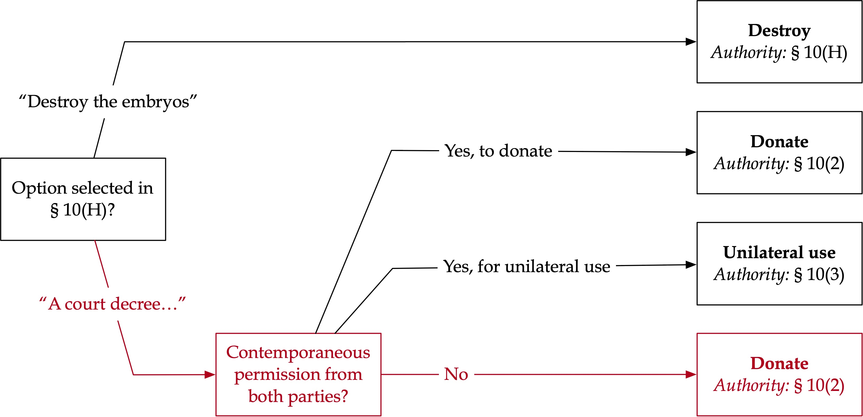
Torres v. Terrell, No. CV-19-0106-PR (Petitioner/Appellee’s Supp. Br. at 6 (filed Sept. 17, 2019)).
As another example, the image below shows a sentence diagram Bryan Garner included in a brief to the Supreme Court of the United States:
Facebook Inc. v. Duguid, No. 19-511 (U.S.) (Brief of Respondent at 17 (filed Oct. 16, 2020).
These images do not come from the record, but they do not need to. They are arguments, not facts. They merely present the arguments (about contract interpretation and grammar) in visual form.
Appellate courts already have adequate tools to address situations when parties attempt to include facts outside the record, whether in text or visual form. Here, too, AGO’s proposal (borrowed from the Circuit Rule) helps. It specifies that “[w]hen a visual image is taken from the record, it must be followed by a citation to its location in the excerpts of record.” The initial qualifying phrase (“When a visual image is taken from the record”) implicitly assumes that some visual images will not come from the record. The rule shines a spotlight on those images because they will not have an accompanying record citation. Appellate courts already know to be wary of any purported facts without a record citation in an appellate brief (whether in text or in images), and already have appropriate tools to address them. But the AGO’s proposed rule amendment implicitly allows non-record images in appropriate circumstances and would therefore allow a party to make a legal argument visually.
AGO’s proposal (and the Circuit Rule from which it came) also complements the existing requirement in Arizona’s rules for record citations. For example, ARCAP 13(a)(5) requires a statement of facts “with appropriate references to the record.” Parties and courts know which items need record citations and which ones do not and have tools to address situations when parties improperly stray from the record.
Accordingly, the Court should not impose limitations on the use of images beyond those in the AGO’s comment.
* * *
For these reasons, I respectfully recommend that the Court adopt the AGO’s alternative proposal rather than the original petition’s text.
Respectfully submitted on April 23, 2025.
/s/ Eric M. Fraser .
Eric M. Fraser (No. 027241)

