Eric M. Fraser (No. 027241)
OSBORN MALEDON, P.A.
2929 N. Central Ave., Ste. 2000
Phoenix, AZ 85012
(602) 640-9000
efraser@omlaw.com

Joshua D. Bendor (No. 031908)
Solicitor General, Arizona Attorney General’s Office
2005 N. Central Ave.
Phoenix, AZ 85004
(602) 542-8958
Joshua.Bendor@azag.gov

Arizona Supreme Court

In the Matter of:  Petition to Amend Arizona Rules of Civil Appellate Procedure 4, 16, and 23; Arizona Rules of Criminal Procedure 31.6, 31.15, and 31.21; and Arizona Rules of Juvenile Procedure 609 | Supreme Court No. R-25-0005  Notice of erratum

Petitioners file this notice of erratum to correct a minor error in the original Petition (filed Jan. 9, 2025).
Page 8 of the Petition contained a chart illustrating the schedules under the current and proposed rules. The chart contained a minor error. In the portion depicting the deadlines under the new rules, the chart indicated deadlines for amicus briefs. Both deadlines erroneously contained the same label, indicating “Deadline for amicus briefs in support of petitioner or neither party (7 days later).” The label for the first amicus deadline was correct. The label for the second deadline was incorrect. It should have indicated “Deadline for amicus briefs in support of respondent (7 days later).”
A corrected version of the chart appears below. The text of the Petition itself and the text of the proposed rules correctly described the deadline. Only the label on the chart was incorrect.
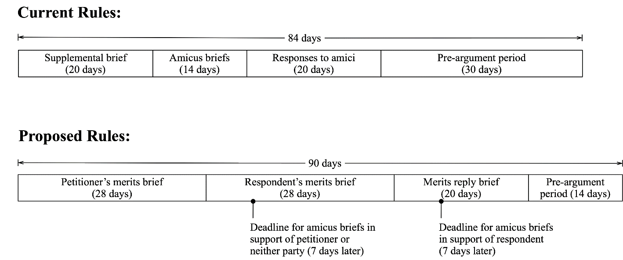
Respectfully submitted on March 25, 2025.
/s/ Eric M. Fraser .
Eric M. Fraser (No. 027241)

/s/ Joshua D. Bendor . Joshua D. Bendor (No. 031908)

A list of all Petitioners is contained in Attachment C to the original Petition.

