Lisa M. Panahi, Bar No. 023421
General Counsel
State Bar of Arizona
4201 N. 24th Street, Suite 100
Phoenix, AZ 85016-6288
(602) 340-7236

IN THE SUPREME COURT
STATE OF ARIZONA
In the Matter of:  PETITION TO AMEND COMMENT [1], ER 4.2, RULE 42 OF THE ARIZONA RULES OF SUPREME COURT | Supreme Court No. R-25-  PETITION

Pursuant to Rule 28(a) of the Arizona Rules of Supreme Court, the State Bar of Arizona (the “State Bar”) hereby petitions the Court to amend Comment [1] to ER 4.2. The proposed amendment will expand upon the exceptions to the ethical rules regarding communications with represented parties, to better follow the American Bar Association (“ABA”) Model Rule 4.2 and to account for the realities of the practice of employment law. Specifically, the amendment will clarify that “a lawyer is not prohibited from advising a client concerning a communication that the client is legally entitled to make.” A redlined version of the proposed amendment is provided herewith at Exhibit A.

BACKGROUND

This Petition was initiated by the State Bar’s Employment and Labor Law Section following deliberations about the challenges employment lawyers face with respect to ER 4.2. The Arizona Rules of Professional Conduct (“RPC”) provide that “a lawyer shall not communicate about the subject of the representation with a party the lawyer knows to be represented by another lawyer in the matter.” ER 4.2. Further, a lawyer engages in misconduct if he or she violates the RPC “through the acts of another.” ER 8.4(a). Read together, the RPC prohibits a lawyer from communicating with a represented party and from assisting or inducing someone else to have a communication that the lawyer on his or her own behalf could not.
Employment lawyers face a unique challenge relating to these rules, as it is not unusual for a lawyer to represent a corporate client in an administrative proceeding with a current employee who is also represented. Similarly, companies often receive demand letters from a lawyer representing a current employee and ask their own outside counsel to respond to the letter. In each of these situations, the employee and the employer have an ongoing relationship which can (and often does) become complicated in light of the dispute. It is natural for both parties to want legal assistance in managing the communications between them. The proposed amendment would benefit clients by expressly permitting Arizona lawyers to provide that assistance.
ARGUMENT

The RPC has long recognized exceptions to ER 4.2. For example, a lawyer may have consent from the other lawyer to make the communication. ER 4.2. Further, the rule “does not prohibit communication with a party…concerning matters outside the representation.” Id., cmt. [1]. “Also, parties to a matter may communicate directly with each other and a lawyer having independent justification for communicating with the other party is permitted to do so.” Id.
The ABA Model Rule 4.2, Comment [4] contains the same language as ER 4.2, Comment [1], except the ABA Model Rule goes further: “Parties to a matter may communicate directly with each other, and a lawyer is not prohibited from advising a client concerning a communication that the client is legally entitled to make.” ABA Model Rule 4.2, cmt. [4] (emphasis added). Other states have adopted the same or similar exceptions. For example:
- CA ST RPC 4.2, cmt. [3]: “The prohibition against communicating ‘indirectly’ with a person represented by counsel in paragraph (a) is intended to address situations where a lawyer seeks to communicate with a represented person through an intermediary such as an agent, investigator or the lawyer’s client. This rule, however, does not prevent represented persons from communicating directly with one another with respect to the subject of the representation, nor does it prohibit a lawyer from advising a client concerning such a communication. A lawyer may also advise a client not to accept or engage in such communications.”
- NY ST RPC 4.2, cmt. [11]: “A lawyer may also counsel a client with respect to communications with a represented person, including by drafting papers for the client to present to the represented person.”
Indeed, 32 states recognize the exception in ABA Model Rule 4.2 Comment [4].

The Restatement similarly notes that the general anti-contact rule “does not prohibit the lawyer from assisting the client in otherwise proper communication by the lawyer’s client with a represented nonclient.” Restatement (Third) of the Law Governing Lawyers § 99(2) (2000). The Restatement explains:
The lawyer for a client intending to make such a communication may advise the client regarding legal aspects of the communication, such as whether an intended communication is libelous or would otherwise create risk for the client. Prohibiting such advice would unduly restrict the client’s autonomy, the client’s interest in obtaining important legal advice, and the client’s ability to communicate fully with the lawyer.
Id., cmt. k.

As discussed, it is not unusual for an employee to file an administrative charge with the Equal Employment Opportunity Commission (“EEOC”), Department of Labor (“DOL”), or similar state or federal agency against his or her current employer. Employees are often represented by counsel through that process, and employers almost always seek counsel to assist in responding to such allegations. Meanwhile, the working relationship between the employer and the employee continues. Although it may be strained, it is typically in both parties’ interests for that relationship to continue as professionally and respectfully as possible. Employees may seek advice on how to communicate appropriately with the employer, to avoid further adverse action; employers, likewise, may seek advice on how to communicate with the employee, to avoid additional claims. In either scenario, the client benefits greatly from the ability to communicate with the attorney and to receive their attorney’s advice regarding the employer-employee communications.
CONCLUSION
Employment lawyers receive frequent, near daily, requests from clients to advise on communications between parties in active employment-related disputes. The ABA, the Restatement, and a majority of other jurisdictions recognize that this is a reality of the practice of law and allow for a lawyer to advise a client regarding communications with a represented party. The proposed amendment would bring Arizona in line with the trend and weight of other authorities, while also addressing the significant concern stated herein that the current RPC does not expressly permit Arizona lawyers to do what is in fact a common and accepted practice. The State Bar of Arizona respectfully requests that the Court amend ER 4.2 Comment [1], as set forth in Exhibit A.
RESPECTFULLY SUBMITTED this 10th day of January, 2025.

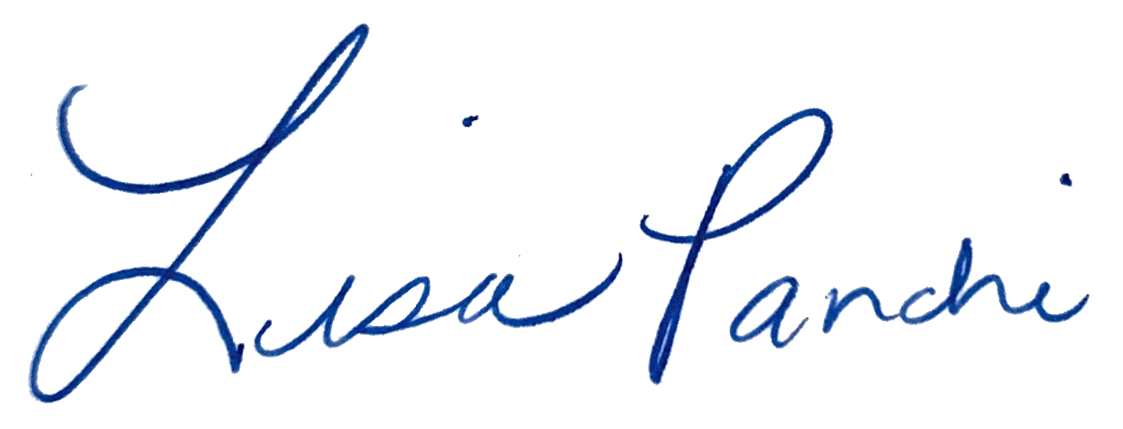
Lisa M. Panahi
General Counsel

Electronic copy filed with the
Clerk of the Supreme Court of Arizona
this 10th day of January, 2025.

by: PSeguin

The following states have adopted this exception (names shortened for brevity): AK, KS, NE, DE, ND, ID, WY, TN, NH, SD, AR, RI, SC, MA, ME, OK, KY, WI, VT, NM, WA, IN, PA, WV, MO, CO, FL, MN, IL, UT, IA, OH.
We can think of several other situations where clients would benefit from the proposed amendment, including in business disputes, educational disputes, and marriage dissolutions.

