Lisa M. Panahi, Bar No. 023421
General Counsel
State Bar of Arizona
4201 N. 24th Street, Suite 100
Phoenix, AZ 85016-6288
(602) 340-7236

IN THE SUPREME COURT
STATE OF ARIZONA
In the Matter of:  PETITION TO AMEND RULES 47(a) AND 47.2(a) OF THE ARIZONA RULES OF FAMILY LAW PROCEDURE | Supreme Court No. R-25-  PETITION

Pursuant to Rule 28(a) of the Arizona Rules of Supreme Court, the State Bar of Arizona (the “State Bar”) hereby petitions the Court to amend Rules 47(a) and 47.2(a) of the Arizona Rules of Family Law Procedure.
After study by the State Bar’s Family Practice and Procedure Committee, the State Bar proposes the amendments set forth herein to provide a legal mechanism for temporary orders to be issued in cases involving third party rights.
Rules 47 and 47.2 allow a party to seek pre-decree or post-decree temporary orders, respectively, for legal decision-making, parenting time, and/or child support by filing a separate verified motion. The Rule does not specify that a party who files for third party placement or visitation may file temporary orders. Pursuant to A.R.S. § 25-409, a third party, under specific circumstances, may petition for placement, decision-making authority, or visitation for a child. While the Courts often issue such temporary orders in third party cases, there is no specific rule or explicit authority permitting such orders to be entered, and they have been met with objections on this basis.
As an initial matter, the rule, as read and construed strictly, would allow a third party to petition for temporary legal decision-making rights and child support, but not for placement or visitation. Third parties do not have “parenting time” rights and are not able to qualify, under a strict reading of the rule, to seek temporary placement or visitation. Only a rare and unique case would allow a third party to qualify for decision-making rights but not placement (or even visitation).
In cases where third party placement rights for a child are sought, the petition must establish, inter alia, that the petitioner stands in loco parentis to the child and that “it would be significantly detrimental to the child to remain or be placed in the care of either legal parent who wishes to keep or acquire legal decision-making.” A.R.S. §25-409(A)(2). In these cases, there is no fit parent for the child. The lack of authority for a person who is already in loco parentis to obtain immediate rights to the child places the child at risk of DCS involvement and being placed in foster case. The ability to obtain immediate temporary orders in appropriate third-party cases avoids unnecessary state involvement and serves the child’s best interest by allowing a third party, with whom they already share a bond, to care for them and meet their needs.
Importantly, the lack of an avenue to seek and obtain temporary orders would likely moot the ability to ever obtain third party rights, thereby rendering the statute to be without effect. If a party who petitions for third party placement cannot obtain or seek to obtain temporary orders, then either the parent or DCS may cease contact between the child and the third party. By the time of a trial, the petitioner may no longer stand in loco parentis to the child because the circumstances have changed that relationship.
Similarly, where a third party seeks visitation rights, such rights will be mooted by the lack of temporary orders. Pursuant to A.R.S. §25-409(C), “a person other than a legal parent may petition the superior court for visitation with a child.” In the absence of an ability to obtain temporary orders, a parent or parents who do not wish for the third party to obtain visitation can simply withhold the child from the third party, which may, in turn, damage that relationship. By the time of a trial, it may be difficult to make an adequate showing that it is in the child’s best interest for the third party, whom they have not seen or spoken to over a period of time, re-establish a close relationship. The lack of a process to protect these rights and the child’s best interest on a temporary basis essentially renders the statute meaningless.
The statutes, rules, current practice, and public policy can be harmonized by simply adding provisions allowing temporary orders rules to also apply to third party placement and third-party visitation cases.
CONCLUSION
Based on the above-mentioned reasons, the State Bar of Arizona respectfully requests that the Court amend the rules as proposed in the attached Appendix.
RESPECTFULLY SUBMITTED this 10th day of January, 2025.

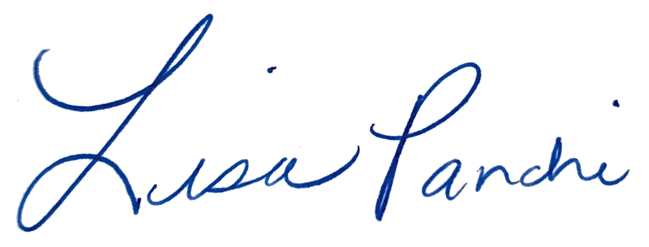
Lisa M. Panahi
General Counsel

Electronic copy filed with the
Clerk of the Supreme Court of Arizona
this 10th day of January, 2025.

by: PSeguin

