Lisa M. Panahi, Bar No. 023421
General Counsel
State Bar of Arizona
4201 N. 24th Street, Suite 100
Phoenix, AZ 85016-6288
(602) 340-7236

IN THE SUPREME COURT
STATE OF ARIZONA
In the Matter of:  PETITION TO AMEND RULE 47(k) OF THE ARIZONA RULES OF FAMILY LAW PROCEDURE | Supreme Court No. R-25-  PETITION
Pursuant to Rule 28(a) of the Arizona Rules of Supreme Court, the State Bar of Arizona (the “State Bar”) hereby petitions the Court to amend Rule 47(k), Arizona Rules of Family Law Procedure (“Family Rule(s)”). This proposed amendment will promote access to justice and prevent abuse of the Rules and the judicial process.
Family Rule 47(k)(1) states that temporary orders terminate and are unenforceable upon dismissal of an action. However, this same Rule does not indicate what happens to temporary orders when that matter is reinstated.
The absence of language specifying what happens to temporary orders upon reinstatement creates ambiguity because a litigant could easily draw two separate, but equally reasonable conclusions based on the language in Family Rule 47(k)(1): either the temporary orders are reinstated along with the matter, or they are not reinstated because they were terminated and became unenforceable when the matter was dismissed.
Unfortunately, the latter of these two options is ripe for abuse. A party who receives an unfavorable ruling at a temporary orders hearing can simply stop being diligent, let the matter dismiss, and then reinstate the matter after the unfavorable temporary orders terminated and became unenforceable by operation of Family Rule 47(k)(1). This strategy could easily be employed by a person knowledgeable in family law – an attorney, for example – against a party lacking that same knowledge, such as a self-represented litigant. Given the critical nature of certain temporary orders (such as spousal and child support payments, supervised parenting time, exclusive use and possession of a home, etc.) the ambiguity surrounding the fate of temporary orders entered in a dismissed matter that is thereafter reinstated should be eliminated.
This amendment proposes a new rule, Family Rule 47(k)(3), which solves this problem by making it clear that all temporary orders in effect at the time a matter was dismissed are returned to full force and effect following reinstatement, and as of the date of the reinstatement, unless the court specifically orders otherwise.
Making this change to the Family Rules will eliminate ambiguity surrounding the fate and enforceability of temporary orders in a reinstated matter and will prevent knowledgeable parties from securing unjust results and abusing less-knowledgeable parties via the strategic dismissal of cases in which unfavorable temporary orders are entered.
CONCLUSION
The State Bar of Arizona respectfully requests that the Court implements Family Rule 47(k)(3) as set forth in the attached Appendix.
RESPECTFULLY SUBMITTED this 10th day of January, 2025.

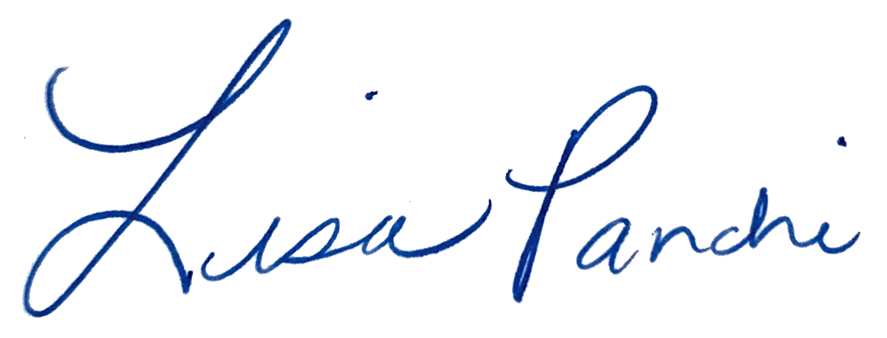
Lisa M. Panahi
General Counsel

Electronic copy filed with the
Clerk of the Supreme Court of Arizona
this 10th day of January, 2025.

by: PSeguin

