Lisa M. Panahi, Bar No. 023421
General Counsel
State Bar of Arizona
4201 N. 24th Street, Suite 100
Phoenix, AZ 85016-6288
(602) 340-7236

IN THE SUPREME COURT
STATE OF ARIZONA
In the Matter of:  PETITION TO AMEND RULE 45 OF THE ARIZONA RULES OF SUPREME COURT | Supreme Court No. R-25-  PETITION

Pursuant to Rule 28 of the Arizona Rules of Supreme Court, the State Bar of Arizona (“State Bar”) petitions the Court to amend Rule 45, of the Arizona Rules of Supreme Court. The purpose of the amendment is to increase the amount of Continuing Legal Education (CLE) credit awarded to arbitrators who complete a hearing for the State Bar Fee Arbitration Program, (Program). Currently, arbitrators are eligible for one (1) hour of CLE for each hearing conducted with a maximum of two (2) hours in an educational year. The provision permitting this CLE award is less than the amount of CLE awarded to Rule 73, Ariz. R. Civ. P. arbitrators and does not differentiate the allocation of credit awarded for the service provided by a panel chair. This petition seeks to increase the amount of CLE awarded to two (2) hours of CLE for each hearing completed, unless the arbitrator serves as panel chair. The panel chair would be eligible to receive four (4) hours of CLE credit for each hearing completed. All Program arbitrators could receive a maximum of eight (8) hours of CLE in each educational year; up to two (2) hours would be eligible to be professional responsibility credit. The proposed amended Rule is provided in Exhibit 1.
Background and Purpose of the Proposed Rule Amendment
The Program began in 1971. Since its inception it has served as a cost-effective, fair forum for the prompt resolution of fee disputes between lawyers and clients, or among lawyers. The Program also serves as an alternative to discipline where a bar charge is based solely on the alleged unreasonableness of the fees. See In re Connelly, 203 Ariz. 413, 55 P.3d 756, 757 (2002) (“We hold than when a lawyer and client have agreed to binding fee arbitration and the disciplinary complaint involves no allegations of other misconduct, the State Bar should await the conclusion of fee arbitration proceedings before initiating formal disciplinary proceedings.”).
The Program averages approximately 150 cases per year. Arbitrators are eligible to serve only after attending a mandatory training conducted by the Program. Arbitrators must take at least one (1) CLE every three (3) years regarding Arizona Rules of Supreme Court, Rule 42, ER 1.5. Eligible fee arbitrators serve as single arbitrators in disputes where the amount at issue is less than $25,000. Or three (3) arbitrators comprise a panel, which is appointed at the request of a party to a matter where the disputed amount is greater than $25,000. Panel hearings require more time and more work, particularly by the panel chair. The panel chair is responsible for overseeing compliance with the Rules, scheduling, communication with both parties, ruling on preliminary issues and takes the lead on drafting the fee arbitration award in matters involving greater amounts of evidence than in disputes where less than $25,000 is at issue.
Rule 45, Ariz. R. Sup. Ct. currently includes specific provisions for the award of CLE credit for several activities including: (1) serving as an appointed arbitrator in civil compulsory arbitration under Rule 73, Ariz. R. Civ. P., (2) provision of pro bono services through an approved legal services organization under Rule 38, Ariz. R. Sup. Ct. and (3) completing the State Bar Mentor Program.
Currently, Program arbitrators receive less credit for completing arbitrations than do those appointed to serve in Rule 73, Ariz. R. Civ. P. civil compulsory arbitrations. This petition asks the Court to increase the amount of CLE credits Program arbitrators earn to be on par with that earned by civil compulsory arbitrators, and to differentiate between panel chairs and other arbitrators. The greater award of CLE for panel chairs would acknowledge the amount of work they do, the service provided to the public and would further incentivize volunteer arbitrators to serve as panel chairs.
The success of Program is dependent on volunteer arbitrators. The Program has benefited the public and attorneys for over fifty years. The proposed amendment would recognize the value of Program arbitrators by raising the amount of CLE they are eligible for to that consistent with Rule 73, Ariz. R. Civ P. arbitrators, and would further recognize and incentivize attorneys to serve as panel chair in more time intensive, complex fee arbitrations.

CONCLUSION
The State Bar of Arizona respectfully requests an amendment of Rule 45, Ariz. R. Sup. Ct. as detailed in Exhibit 1, increasing the amount of CLE awarded to two (2) hours of CLE for each hearing completed, unless the arbitrator serves as panel chair. The panel chair would be eligible to receive four (4) hours of CLE credit for each hearing completed. All Program arbitrators could receive a maximum of eight (8) hours each educational year and up to two (2) hours are eligible to be professional responsibility credit. These changes permit the Program to ensure its arbitrators are awarded CLE for their service, and to incentivize attorneys to participate in the Program as a panel chair.
RESPECTFULLY SUBMITTED this 10th day of January, 2025.

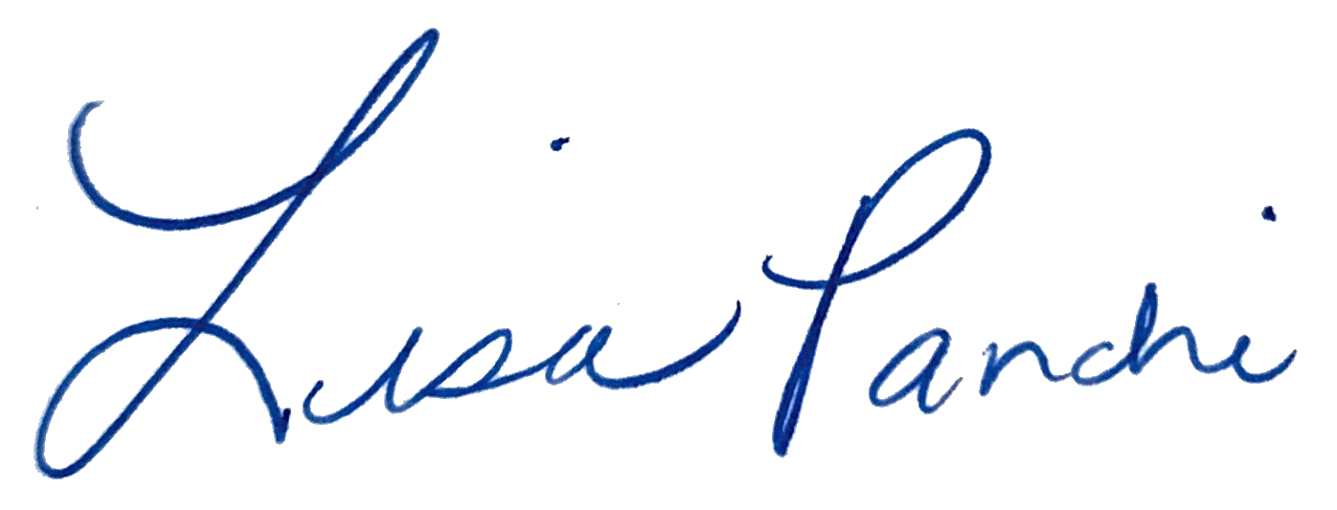
Lisa M. Panahi
General Counsel

Electronic copy filed with the
Clerk of the Supreme Court of Arizona
this 10th day of January, 2025.

by: PSeguin

In disputes where the amount at issue is greater than $25,000, the State Bar of Arizona Fee Arbitration Program Rules of Arbitration of Fee Disputes permits either party to request the hearing be conducted by a panel of three: two (2) attorney arbitrators and one (1) public member. If a panel is requested, the Program Coordinator assigns one attorney arbitrator as the panel chair. The panel chair rules on preliminary issues and takes the lead on preparing the written fee award.
See Ariz. R. Sup. Ct., Rule 45(a)(3), awarding up to two (2) hours of CLE.
See Ariz. R. Sup. Ct., Rule 45(a)(4), awarding one (1) hour of CLE for every five (5) hours of pro bono service provided, up to a maximum of (5) five hours per educational year.
See Ariz. R. Sup. Ct., Rule 45(a)(6), awarding mentors or mentees up to eight (8) hours of CLE, two (2) of which may qualify as professional responsibility credits up to a maximum of eight (8) hours of CLE per educational year.

