Lisa M. Panahi, Bar No. 023421
General Counsel
State Bar of Arizona
4201 N. 24th Street, Suite 100
Phoenix, AZ 85016-6288
(602) 340-7236

IN THE SUPREME COURT
STATE OF ARIZONA
In the Matter of:  PETITION TO AMEND RULES 42, 60, 64 AND 65 OF THE ARIZONA RULES OF SUPREME COURT | Supreme Court No. R-25-  PETITION

Pursuant to Rule 28(a) of the Arizona Rules of Supreme Court, the State Bar of Arizona (the “State Bar”) hereby petitions the Court to amend Rules 42, 60, 64 and 65 of the Arizona Rules of Supreme Court. The purpose of this amendment is to address the current inequities in the sanctions available when disciplining attorneys not admitted to the State Bar of Arizona but engaged in the authorized practice of law here pursuant to an exception in the rules allowing for the practice.
Background and Purpose of the Proposed Rule Amendment
The Arizona Supreme Court Rules has exceptions that allow a non-admitted attorney licensed in another jurisdiction to practice law in Arizona. The Rules provide that a non-member engaged in the practice of law in the State of Arizona
submits himself or herself to the disciplinary and disability jurisdiction of the Court in accordance with the rules. See, Rule 46(d), Ariz. R. Sup. Ct., and Rule 42, Ariz. Sup. Ct., Rules, specifically ER 8.5(a). Although the Court has jurisdiction to sanction such a lawyer if he has engaged in misconduct, the Court is currently limited in the sanctions available to address that misconduct. This limitation was stated in Matter of Olsen, 180 Ariz. 5, 881 P.2d 337 (1994). Olsen sought permission to appear pro hac vice in a civil matter pending in Maricopa County Superior Court. Olsen submitted an affidavit that he was an active member of the Utah and California Bars when he was in fact suspended from both. The Court concluded that although Olsen’s conduct warranted disbarment, he was not a member of the State Bar of Arizona and could not be suspended or disbarred from that association. The only sanction that could be imposed was a censure, now reprimand. A reprimand does not affect the lawyer’s authorization to practice law.
The current restriction in sanctions allows serious misconduct to be addressed by a lesser sanction that does not serve to protect Arizona.
By way of example, a non-admitted attorney who has a license in good standing in another jurisdiction could reside in Arizona and practice exclusively
immigration law. If that lawyer stole money from his Arizona clients and is charged with misconduct and made the subject of a disciplinary proceeding, the most serious
sanction currently available is a reprimand. A reprimand does not prevent the lawyer from continuing to engage in the practice of law in Arizona. Moreover, the lawyer’s home licensing jurisdiction is likely to impose reciprocal discipline on the lawyer rather than seek to investigate and prosecute the case to obtain a more serious sanction. This leaves the lawyer’s license in good standing and does not prevent further practice in Arizona.
To rectify this situation, the proposed amendment to ER 8.5(a) would explicitly state that all sanctions cited in Rule 60, Ariz. R. Sup. Ct., would be available to impose on non-admitted attorneys found to have engaged in misconduct, if appropriate. The effect of the change would allow the presiding disciplinary judge, a hearing panel or the Court to disbar or suspend the lawyer’s privilege to engage in the practice of law pursuant to the exceptions in the rules.
The proposed amendment to Rules 64 and 65 changes some references to “member” to “attorney” to address the reinstatement of these lawyers to practice. They would not be reinstated as a member but a lawyer who can once again practice in accord with the exceptions set out in the rules.

CONCLUSION
The State Bar of Arizona respectfully requests that the Court amend Rule 42, specifically ER 8.5(a), Rules 60, 64 and 65 of the Arizona Rules of Supreme Court as detailed in the Appendix.
RESPECTFULLY SUBMITTED this 10th day of January, 2025.

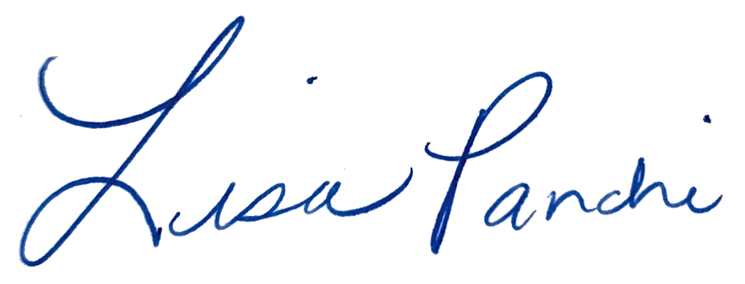
Lisa M. Panahi
General Counsel

Electronic copy filed with the
Clerk of the Supreme Court of Arizona
this 10th day of January, 2025.

by: PSeguin

