Kevin D. Heade
AZ State Bar # 029909
P.O. Box 2457
Florence, AZ 85132
(480) 251-8534
Kevin.Heade@Gmail.com

IN THE SUPREME COURT
IN AND FOR THE STATE OF ARIZONA

In the matter of:  Petition to Amend Ariz. R. Crim. P. 31.10 and Ariz. R. Civ. App. P. 13 |  | Arizona Supreme Court  No. R-25-  Petition to Amend Ariz. R. Crim. P. 31.10 and Ariz. R. Civ. App. P. 13 to Explicitly Permit the Use of Photographs, Charts, Graphs, and Other Visual Aids in Briefs

Pursuant to Rule 28(a) of the Arizona Supreme Court Rules, undersigned counsel petitions this Court to amend Ariz. R. Crim. P. 31.10 and Ariz. R. Civ. App. 13 so that both rules explicitly permit a party’s optional incorporation of photographs, charts, graphs, or other visual aid into the body of a brief.
On rare occasion, undersigned counsel has previously filed briefs with Division One of the Court of Appeals which included photographs, graphs, or charts that were central to the resolution of an issue on appeal. Similarly, undersigned counsel or his co-counsel have done the same before this Court.
In no instance was a brief stricken by either court for such use of visual aids in written appellate advocacy. And for good reason. “A picture can be worth . . . well, it can help win a lawsuit.” Bryan Garner, The Winning Brief 328 (2d ed. 2004). Leading jurists have lamented the absence of visual aids from briefs. Judge Posner has opined that “so disfavored are pictures, maps, objects, and diagrams in appellate briefs ... that I’ve said some lawyers think a word is worth a thousand pictures.” Richard A. Posner, Reflections on Judging 143 (2013).
Two reasons may exist for the absence of visual aids in Arizona’s appellate advocacy.
The first is that it seems that Division Two of the Arizona Court of Appeals may have an unwritten rule prohibiting their use. Undersigned counsel recently submitted a brief containing photographs central to a dispute over whether the evidence at trial supported the defendant’s request jury instruction. Although otherwise in compliance with Ariz. R. Crim. P. 31.10, the brief was stricken without an order explaining why. A deputy clerk explained, via telephone, that the brief was not accepted because it contained photographs and photographs are not permitted im Division Two of the Court of Appeals.
Although Ariz. Crim. P. 31.10 does not explicitly authorize the use of photographs in briefs, it also does not prohibit them. The absence of express authorization for such use of visual aides may be the second reason why they are not generally used in appellate practice.
Some of the best decisions issued by this Court and the United States Supreme Court contain visual depictions. For example, this Court included “a photo from the record depicting the area as an appendix” im Beck v. Neville, 256 Ariz. 415, n. 1 (2024, a case about boundary by acquiescence dispute. The photograph of the area in dispute was central to the resolution of the issue and helpful to understanding this Court’s resolution of the issue:

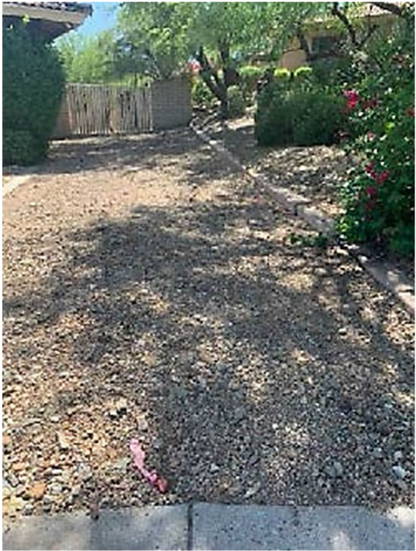
Beck v. Neville, 256 Ariz. 415 (2024) (Appendix).
And in Andy Warhol Found. for the Visual Arts, Inc. v. Goldsmith, 598 U.S. 508 (2023) the majority and dissent collectively included over fifteen different images in resolving a copyright dispute concerning this 1984 Andy Warhol print based off of Lynn Goldsmith’s photograph of the musician then known as Prince Rogers Nelson:

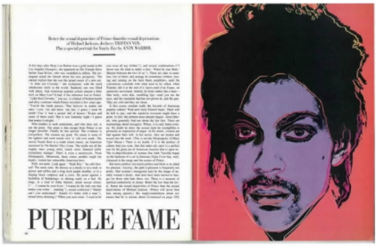

Andy Warhol Found. for the Visual Arts, Inc. v. Goldsmith, 598 U.S. 508, 518 (2023) (Figure 2. A purple silkscreen portrait of Prince created in 1984 by Andy Warhol to illustrate an article in Vanity Fair).
Advocates should not be deprived the communicative ability available to jurists via visual aids.
Thus, this Court should adopt this proposal to explicitly authorize the optional use of “photographs, charts, graphs, or other visual aids that are central to the resolution of an issue.” by amending Ariz. R. Crim. P. 13(a) and Ariz. R. Civ. App. P. 13 (a).

Respectfully submitted this 10th day of January, 2025

By: /s/ Kevin D. Heade
Kevin D. Heade
AZ State Bar #029909

APPENDIX A

Arizona Rules of Criminal Procedure
(deletions shown with strikethrough, new language is underlined)

Rule 31.10. Content of Briefs
(a) Appellant's Opening Brief. An appellant's opening brief must set forth under headings and in the following suggested order the items listed below, except for items (4) and (9), and (10), which are optional:
(1)-(9) (no change)
(10) photographs, charts, graphs, or other visual aids that are central to the resolution of an issue.
(b)-(j) (no change)
(j) Briefs of Amicus Curiae. A brief of amicus curiae must comply with Rule 31.10(a)(1), (2), (3), (7), (8), and (9), and (10), and Rule 31.15.
(k) (no change)

APPENDIX B

Arizona Rules of Civil Appellate Procedure
(deletions shown with strikethrough, new language is underlined)

Rule 13. Content of Briefs
(a) Appellant's Opening Brief. An appellant's opening brief must set forth under the following headings and in the following order all of the items listed below, except for items (3), and (10), and (11), which are optional.
(1)-(10) (no change)
(11) photographs, charts, graphs, or other visual aids that are central to the resolution of an issue.
(b)-(h) (no change)
(i) Briefs of Amicus Curiae or Intervenor. An intervenor is a person not a party to a judgment that the appellate court allows to participate as a party in an appeal on motion under Rule 24 of the Arizona Rules of Civil Procedure. An intervenor is subject to any requirements that the court may set. A brief of amicus curiae or an intervenor must comply with Rules 13(a)(1), (2), (7), (8), (9), and (10), and (11). A brief of amicus curiae must also comply with the requirements of Rule 16.

