Lisa M. Panahi, Bar No. 023421
General Counsel
State Bar of Arizona
4201 N. 24th Street, Suite 100
Phoenix, AZ 85016-6288
(602) 340-7236

IN THE SUPREME COURT
STATE OF ARIZONA
In the Matter of:  PETITION TO AMEND RULES 32(b) AND (c) OF THE ARIZONA RULES OF SUPREME COURT | Supreme Court No. R-24-0030  STATE BAR OF ARIZONA COMMENT

Pursuant to Rule 28(e) of the Arizona Rules of Supreme Court, the State Bar of Arizona (the “State Bar”) hereby submits the following as its second comment to the above-captioned Petition.
In January 2024, Petitioner filed a Petition proposing to amend Rules 32(b) and (c), Ariz. R. Sup. Ct. The State Bar filed a Comment in opposition in April 2024. After considering the Petition, the public comments, and the Reply during its August 2024 Rules Agenda, the Court issued an Order on August 22, 2024, proposing a revision to Rule 32(c)(9), continuing consideration until it’s December 2024 Rules Agenda, and opening an abbreviated public comment period on a proposed amendment to Rule 32(c) only.
The amended language proposed by this Court to Rule 32 would codify in Rule 32(c)(9) that all activities conducted by the State Bar shall comply with Keller v. State Bar of California, 496 U.S. 1 (1990). The State Bar supports the amended language set forth in the Court’s Order.
RESPECTFULLY SUBMITTED this 1st day of October, 2024.

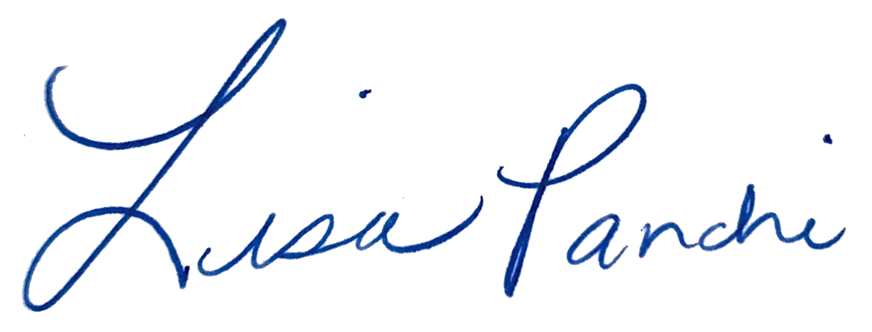
Lisa M. Panahi
General Counsel

Electronic copy filed with the
Clerk of the Supreme Court of Arizona
this 1st day of October, 2024.

by: PSeguin

