Lisa M. Panahi, Bar No. 023421
General Counsel
State Bar of Arizona
4201 N. 24th Street, Suite 100
Phoenix, AZ 85016-6288
(602) 340-7236

IN THE SUPREME COURT
STATE OF ARIZONA
In the Matter of:  PETITION TO AMEND THE RULES OF PROCEDURE FOR SPECIAL ACTIONS | Supreme Court No. R-23-0055  COMMENT OF  THE STATE BAR OF ARIZONA

Pursuant to Rule 28, Ariz. R. Sup. Ct., the State Bar of Arizona (“State Bar”) submits the following comment with respect to Petition R-23-0055 (the “Petition”) filed by the Task Force on Rules of Procedure for Special Actions (the “Task Force”).
The Petition seeks to abrogate the current Rules of Procedure for Special Actions (“RSPA” or “SA Rules”) and replace them in their entirety with new rules. Having reviewed the Petition, the State Bar recommends that the new SA Rules proposed by the Task Force be adopted in their entirety with slight modifications as identified herein.

I. INTRODUCTION.
The State Bar commends the Task Force for its work and believes adoption of the proposed new SA Rules will provide much needed clarity to special action practice in Arizona to the benefit of litigants, practitioners, and our courts alike.
The Task Force furnished a “vetting draft” of the proposed, amended SA Rules to the State Bar’s Civil Practice and Procedure Committee (“CPPC”) on a pre-Petition basis for review and comment. In response, the CPPC provided a memorandum and accompanying redline version of the “vetting draft” reflecting the CPPC’s suggested revisions to the Task Force. The Task Force incorporated many, but not all, of the CPPC’s recommended revisions into the draft new SA Rules proposed through its Petition for adoption by the Court.
By this Comment, the State Bar recommends adoption of the new SA Rules in their entirety and requests the Court consider the additional suggested revisions to the proposed new SA Rules identified herein.
II. Suggested Revisions to Select New Special Action Rules.
The State Bar requests that the Court consider its following concerns and suggested revisions to select rules within the proposed new SA Rules:
Rule 5(b)(2). Proposed new SA Rule 5(b)(2) provides, in part, that “[t]he court may allow other persons to respond” to a special action petition. The State Bar is concerned as to the lack of guidance in the Rule regarding who is permitted to respond and whether there are any limits on a court’s discretion in making these allowances such as long-established limits and formal requirements applicable to intervenor status.
Rule 7(a)(2), (b), and (e). Proposed new Rule 7(a)(2) requires a defendant to file an “answer or other appropriate response” within a certain time. The State Bar does not understand what types of motions or other filings are intended to be included within the meaning of the phrase “other appropriate response.” If the Rule contemplates the filing of a motion to dismiss or other pre-answer motion as authorized in Rule 12, Ariz. R. Civ. P., the State Bar suggests replacing the word “response” in the title of the Rule and the phrase “other appropriate response” in the body of the Rule with “dispositive motion.” For the same reason, the State Bar recommends replacing the phrase “or an answer or response to a complaint” in proposed new Rule 7(b) with “an answer to a complaint or a dispositive motion.”
Rule 7(g). This proposed new Rule in part empowers a court to issue special orders regarding discovery if an action raises a material issue of fact. Recognizing that the discovery and disclosure processes are complimentary under Arizona procedure and based on a narrow majority vote of the CPPC, the State Bar recommends inserting the words “and disclosure” to the final sentence of the Rule.
Rule 11(b). Rule 11(b) of the proposed new SA Rules sets forth factors supporting accepting special action jurisdiction. For clarity and precision, the State Bar recommends that the phrase “of privileges or immunities” be replaced with “of legal or evidentiary privileges, or of immunity from suit” in proposed new SA Rule 11(b)(2).
Proposed new SA Rule 11(b)(7) additionally enumerates, as a factor weighing in favor of accepting special action jurisdiction, whether the petition seeks resolution of questions “which will materially advance the efficient management of the case, other than issues presented by ordinary dispositive motion practice.” The State Bar recognizes this language likely represents an intentional policy decision to make special action review more readily obtainable. However, the language pertaining to dispositive motion practice may unreasonably deter litigants from seeking special action review of rulings resulting from such practice even where appropriate. For this reason, he State Bar recommends deletion of the phrase “other than issues presented by ordinary motion practice” from proposed new Rule 11(b)(7). Likewise, and for the same reason, the State Bar suggests deleting of Rule 11(c)(2), which identifies as a factor weighing in favor of declining special action jurisdiction petitions which seek review of questions “resolved under Rule 12(b)(6) of the Rules of Civil Procedure, or Rule 29(a)(6) or 79 of the Rules of Family Law Procedure.
Rule 17(c). Proposed new SA Rule 17(c) provides that the “decision [in an appellate special action] will become effective when the mandate or termination letter is issued unless the decision states that it is effective immediately.” The State Bar’s understanding is that because an appellate special action occurs during the course of an on-going proceeding instead of after judgment is entered, the lower court never loses jurisdiction over the case. As stated in Coffee v. Ryan-Touhill, 247 Ariz. 68, 71–72, ¶¶ 14-15, 445 P.3d 666, 669–70 (App. 2019) with respect to the issue of the trial court’s jurisdiction while a special action is pending:

Unlike an appeal, jurisdiction never transfers from the superior court to the court of appeals in the special action context. A special action represents a separate, original proceeding where an appellate court examines the action or inaction of public officials and may issue orders (similar to a common law writ) affecting future proceedings in a case. As a result, unless the appellate court issues a stay, the superior court may proceed in the underlying action during a special action. And even when a stay is entered, the superior court is only limited in its actions by the express language of the stay order. Although the superior court must comply with such orders, it does not lose jurisdiction as it would when an appeal is commenced.

(internal citations omitted).
As such, no mandate should be issued as a mandate simply re-vests jurisdiction in the lower court. The State Bar suggests that a procedure more consistent with these jurisdictional notions would be for the court in which the special action was brought to enter its decision accepting jurisdiction, granting relief, and lifting any stay, with its decision effective immediately. If the losing party to the special action seeks further review, that the party should seek a new stay before filing a motion for reconsideration or petition for review. This process would seem to be speedier and more efficient than that contemplated by proposed new SA Rule 17(c).

IV. CONCLUSION.
The State Bar supports the Task Force’s Petition and recommends modification of specific proposed new SA Rules as described in this comment.

RESPECTFULLY SUBMITTED this 17th day of May 2024.

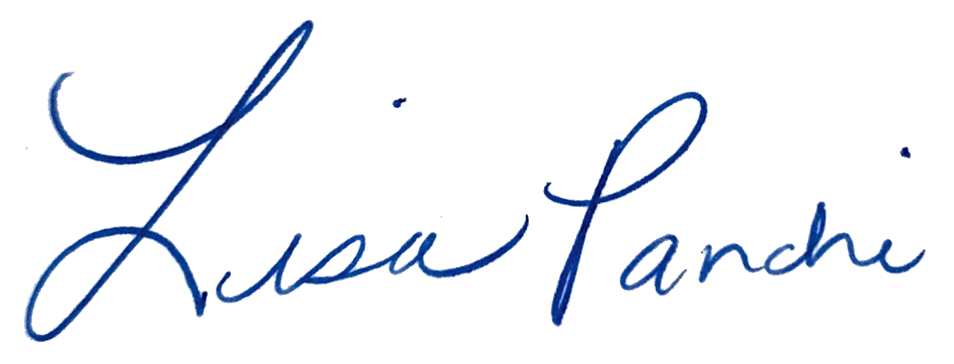
Lisa M. Panahi
General Counsel

Electronic copy filed with the
Clerk of the Supreme Court of Arizona
this 17th day of May 2024.

by: PSeguin

