Lisa M. Panahi, Bar No. 023421
General Counsel
State Bar of Arizona
4201 N. 24th Street, Suite 100
Phoenix, AZ 85016-6288
(602) 340-7236

IN THE SUPREME COURT
STATE OF ARIZONA
In the Matter of:  PETITION TO AMEND RULE 34(f) OF THE ARIZONA RULES OF SUPREME COURT | Supreme Court No. R-24-0028  STATE BAR OF ARIZONA COMMENT

Pursuant to Rule 28(e) of the Arizona Rules of Supreme Court, the State Bar of Arizona (the “State Bar”) hereby submits the following as its Comment to the above-captioned Petition. The Petition seeks to amend Rule 34(f), Ariz. R. Sup. Ct., which provides the process for attorneys admitted in other states to become authorized to practice law in Arizona. The State Bar opposes two aspects of the Petition, as discussed further below, and takes no position on the other proposed amendments to Rule 34(f) set forth in the Petition.
Petitioners propose four amendments to Rule 34(f), which create an easier path for lawyers licensed in other jurisdictions to become authorized to practice in Arizona. The State Bar opposes two of the four proposed amendments to Rule 34(f): 1. The proposal to remove the active practice requirement; and 2. The proposal to substitute another jurisdiction’s character and fitness examination for Arizona’s current process under which the Committee on Character and Fitness conducts a comprehensive review of applicants prior to licensure in this jurisdiction.
The State Bar opposes the total elimination of an active practice requirement. The current requirement states that an attorney must have engaged in the active practice of law for three of the last five years immediately preceding the application. Rule 34(f)(1)(A) The State Bar does not believe it is prudent to waive this active practice requirement for an attorney seeking admission on motion. If the Court is inclined to grant the Petition, the State Bar respectfully requests that the Court maintain a minimum requirement for years in active practice prior to applicant’s application for admission on motion.
The State Bar also does not support relying on another jurisdiction’s character and fitness examination as establishment of an applicant’s successful character and fitness to practice in Arizona. The State Bar believes that the current character and fitness requirement under Rule 34 should remain intact and Arizona’s Committee on Character and Fitness process should not be disturbed by any amendments to Rule 34(f).
CONCLUSION
For the reasons stated above, the State Bar of Arizona respectfully requests that the Court deny the changes proposed in the Petition that would eliminate the active practice requirement and allow a character and fitness examination in another jurisdiction to be accepted as evidence of sufficient character and fitness to practice law in Arizona. The State Bar takes no position on the other proposed amendments to Rule 34(f) in the Petition.
RESPECTFULLY SUBMITTED this 1st day of May 2024.

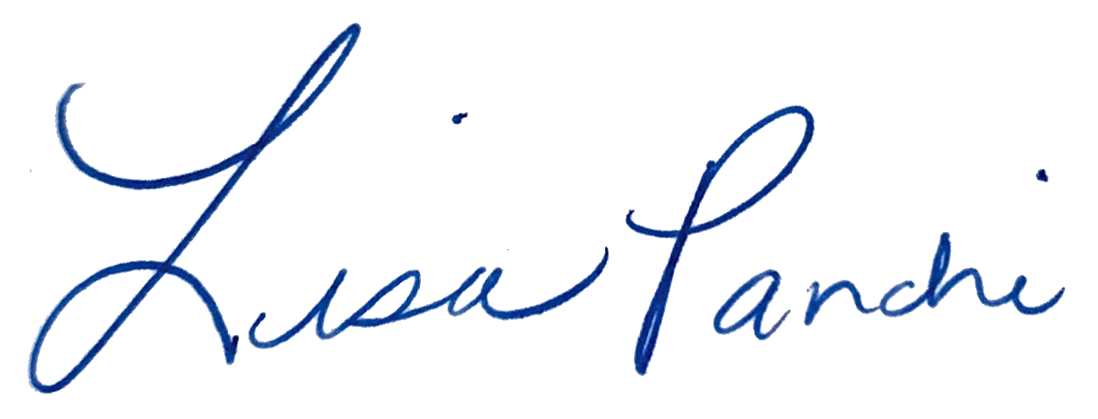
Lisa M. Panahi
General Counsel

Electronic copy filed with the
Clerk of the Supreme Court of Arizona
this 1st day of May 2024.

by: PSeguin

