Lisa M. Panahi, Bar No. 023421
General Counsel
State Bar of Arizona
4201 N. 24th Street, Suite 100
Phoenix, AZ 85016-6288
(602) 340-7236

IN THE SUPREME COURT
STATE OF ARIZONA
In the Matter of:  PETITION TO AMEND RULE 23 OF THE ARIZONA RULES OF CIVIL PROCEDURE | Supreme Court No. R-24-0027  COMMENT OF THE STATE BAR OF ARIZONA

Pursuant to Rule 28(e) of the Arizona Rules of Supreme Court, the State Bar of Arizona (the “State Bar”) hereby submits the following as its comment to the above-captioned Petition.
The State Bar supports a modified version of the Petition to add a section (i) concerning the disposition of residual funds that remain from class settlements. In light of the worthy objectives of the Petition, the State Bar recommends adopting an amendment to Rule 23 along the lines of what the Petition proposes. The State Bar, however, suggests two modifications to the proposed amendment to clarify and confirm that (1) the disposition of residual funds as described in the new subsection 23(i) is discretionary, not mandatory; and (2) the disposition of residual funds is done in a manner consistent with the purposes of the class (i.e., that the rule change is consistent with the cy pres doctrine). The State Bar’s proposed modifications are shown below.
Background
When a class action is settled via a “common fund” settlement, such settlements sometimes leave residual funds when not all funds can be distributed to the class or as otherwise contemplated by the settlement. The Petition would amend Rule 23 to “provide direction for the distribution of residual funds . . . where there are no statutory directives.” Pet. at 1. In those circumstances, the Petition’s proposed rule change would require the court to distribute residual funds “to the Arizona Bar Foundation to grant to Arizona legal services nonprofit entities for use, in accordance with judicial instructions for the award, toward the provision of legal services and access to justice for low-income residents of Arizona.” Id. The proposed rule does not require such a distribution to the Foundation if the parties to a class action settlement have designated a different recipient of residual funds. However, in the absence of such a choice or designation by the parties, the proposed rule would require the court to distribute the residual funds to the Foundation.
Similar amendments were proposed in 2013 and 2015 but were not adopted. Pet. at 2-3 (describing earlier proposals at Rule Petition R-13-0061 and R-15-0007). As the Petition observes, these earlier proposals “did not clarify” that the proposed amendment would require the Foundation to “administer the cy pres residual funds in accordance with the judgment in each specific case, similar to the responsibility the Arizona Supreme Court has given the Foundation with” IOLTA revenue. Pet. at 2.
The State Bar created the Foundation as a separate 501(c)(3) organization in 1978 with the mission of promoting access to justice for all Arizonans. The State Bar supports the efforts and work of the Foundation and believes it is well situated to administer residual funds in the public’s interest and consistent with the interests of the settlement class. The State Bar agrees, however, that under the sound principles of the cy pres doctrine, residual funds intended to benefit a class should also be distributed consistent with the purposes of the class. Accordingly, the State Bar supports the Petition with two modest modifications to ensure that the rule change is fully consistent with the substantive law of cy pres.

I. The Petition Addresses the Acute Need for Funding Legal Services in Arizona Using a Tool Adopted in Many Other Jurisdictions.

As the Petition correctly explains, funding for legal services programs has been under substantial pressure. The gap between funding and need in Arizona is significant, as the sources in the Petition show. Pet. at 6-8. The existing sources of funding are proving inadequate to meet this need. The main sources of funding—federal funding through the Legal Services Corporation and IOLTA fund—fluctuate up-and-down with the economy while the need for legal services increases over time, especially when there is economic uncertainty.
The Petition’s proposal is a modest tool to help meet the extraordinary need for legal services funding. If adopted, Arizona would join a number of other states with similar rules or statutes. Since the Court last considered a similar proposal in 2015, multiple additional jurisdictions have adopted similar provisions bringing the current, and growing, total to twenty-four states. Pet. at 5. Accordingly, adopting this rule now would put Arizona squarely in the mainstream of an established movement to put unused, unallocated residual class action settlements to good use.

II. With Two Minor Modifications, the Petition Is Fully Consistent with Existing Cy Pres Law.

Although the State Bar supports the proposal generally, this comment respectfully suggests two revisions to the Petition’s submitted rule amendment.
First, the State Bar suggests that the proposed text of Rule 23(i)(2) delete the word “shall” and insert the word “may.” Thus, the text would read: “In matters where residual funds remain and are not subject to statutory directives the residual funds shall may be disbursed to the Arizona Foundation for Legal Services and Education . . . .” This change is meant to confirm that the superior court has discretion in the administration of residual funds. That change is also consistent with the other language in the proposed amendment, which provides that an order regarding a class settlement “may provide for the disbursement of residual funds.”
Second, the State Bar proposes that text be added to the proposed text of Rule 23(i) to ensure that any distribution of funds is consistent with the purposes of the class. Here is the Petition’s amendment with both proposed modifications in bold:

(2) Any order entering a judgment or approving a proposed compromise or settlement of a class action certified under this rule that establishes a process for identifying and compensating members of the class, or where such process is impossible or economically impractical, may provide for the disbursement of residual funds in a manner that is consistent with the purposes of the class. If consistent with the purposes of the class and the parties have not directed otherwise, Iin matters where residual funds remain and are not subject to statutory directives the residual funds shall may be disbursed to the Arizona Foundation for Legal Services and Education to grant to Arizona legal services nonprofit entities for use, in accordance with judicial instructions for the award, toward the provision of legal services and access to the justice system for low-income residents of Arizona.
These changes accommodate the Petition’s laudable goal of promoting access to justice while ensuring that Rule 23 remains consistent with substantive law governing cy pres funds. See, e.g., In re Google Inc. St. View Elec. Commc’ns Litig., 21 F.4th 1102, 1116 (9th Cir. 2021) (describing the “factors that guide judicial oversight of cy pres settlement provisions” as “whether the distributions account for the nature of the plaintiffs’ lawsuit, the objectives of the underlying [claims], and the interests of the silent class members” (cleaned up)).
The proposal offers a flexible, reasonable alternative to the rigid rules adopted in other states by allowing—but not requiring—the distribution of residual funds to promote access to justice. See Conn. R. Super. Ct. Civ. Sec. 9-9(g)(2) (absent designation, residual funds “shall be disbursed” to legal services organization); Ind. St. Trial P. Rule 23(F)(2) (50% of residual funds must go to legal services organizations); Ky. R. Civ. P. 23.05(6)(b) (25% of residual funds must go to legal services fund); Mont. R. Civ. P. 23(i)(3) (50% of residual funds must go to legal services organization); Pa. R. Civ. P. 1716(b) (50% of residual funds must go to legal services organization); S.D. Codified Laws § 16-2-57 (residual funds must go to legal services organization); Wash. Super Ct. Civ. R. 23(f)(2) (50% of residual funds must go to legal services organization). Moreover, it is important to note that the Petition does not give funds to the Foundation for its own discretionary use but rather requires the Foundation to grant the funds “in accordance with judicial instructions for the award.” Pet. at 1. This is another check to ensure that the funds go toward a purpose that aligns as closely as possible with the underlying goals of the class action, as is true in the current law of cy pres. Finally, the Petition as a whole leaves the parties and the court in control of whether to designate recipients of their choice to receive residual funds. The amended Rule 23(i)(2) merely provides that the court “may provide for the disbursement” of residual funds to the Foundation. Pet. at 4. In all of these ways, the proposed amendment to Rule 23 should dispel any perception that the proposed rule amendment represents improper favoritism of an entity that, though a 501(c)(3) organization separate from the State Bar, the State Bar long ago formed.
III. The Proposed Amendment Permissibly Modifies a Rule of Judicial Construction—It Does Not Alter the Substantive Law.

The State Bar also supports the Petition because it believes that potential criticisms of it are ultimately incorrect.
First, while some members of the Bar are concerned that the proposed rule amendment alters a substantive aspect of the law, making legislation the appropriate vehicle to effect any such change, the State Bar believes that concern is misplaced for multiple reasons. For one thing, class actions are judicial creations; “[e]quity courts created class action procedures to manage group litigation fairly and efficiently.” Federal Judicial Center, Manual for Complex Litigation, Fourth § 21, at 243 (2004). The 1966 amendments to Federal Rule of Civil Procedure 23 then gave rise to damages class actions. Similarly, it is widely recognized that “[c]y pres is an equitable doctrine with roots in trusts and estates law . . . .” William B. Rubenstein, et al., 4 Newberg And Rubenstein On Class Actions § 12:32 (6th ed. 2023 Update). Because this is a judicially created device, there is no impediment to modifying it through a procedural rule that this Court adopts. In explaining that a number of jurisdictions have similar rules or statutes, the leading class action treatise noted, “Providing legal services for the indigent is surely a worthy goal, so much so that one wonders why all unclaimed class action funds are not simply shifted to that end.” 4 Newberg And Rubenstein on Class Actions § 12:35. At bottom, the criticism also fails because the Petition—especially with the State Bar’s proposed modifications—makes clear that it is not effecting a substantive change to the law of cy pres. The trial court retains complete discretion to designate recipients of residual funds as it deems appropriate. Where designation to the Foundation would not further the purposes of the class action suit and its resolution, the trial court can do justice as it sees fit. This is no change in the law at all.
Second, some have also raised concerns that the proposed rule change focuses exclusively on providing access to justice for low-income residents, but that purpose does not necessarily align with the purpose of Rule 23(b)(3) class actions generally. Under this view, the class action device is a procedural tool designed to make it feasible to pursue claims that would otherwise be economically infeasible because of the small damages at issue. The State Bar appreciates the sincerity of this view but believes it is erroneous. Rather than focusing on who benefits from the Foundation’s work, it is more appropriate to focus what that work does. That is, the Foundation facilitates access to justice when it otherwise would not exist. In that respect, the underlying purposes of Rule 23(b)(3) class actions squarely align with the goals of the Foundation. Moreover, the proposal in the Petition would make it possible to pursue some claims that would not otherwise be pursued, for reasons including the inefficiency or difficulty of litigating small claims, thus contributing to the goals and purposes of Rule 23(b)(3).
Conclusion
For the foregoing reasons, the State Bar respectfully asks the Court to approve, with minor modifications, the change proposed in Petition No. R-24-0026 to Amend Rule 23 of the Arizona Rules of Civil Procedure.
RESPECTFULLY SUBMITTED this 1st day of May 2024.

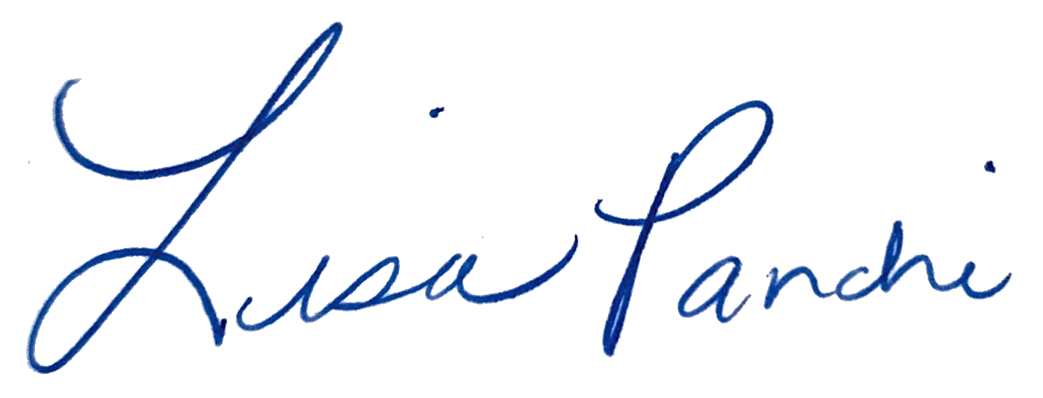
Lisa M. Panahi
General Counsel

Electronic copy filed with the
Clerk of the Supreme Court of Arizona
this 1st day of May 2024.

by: PSeguin

