Lisa M. Panahi, Bar No. 023421
General Counsel
State Bar of Arizona
4201 N. 24th Street, Suite 100
Phoenix, AZ 85016-6288
(602) 340-7236

IN THE SUPREME COURT
STATE OF ARIZONA
In the Matter of:  PETITION TO AMEND RULE 49(d)(1) OF THE ARIZONA RULES OF CIVIL PROCEDURE AND RULE 18.1 OF THE ARIZONA RULES OF CRIMINAL PROCEDURE | Supreme Court No. R-24-0026  COMMENT OF  THE STATE BAR OF ARIZONA

Pursuant to Rule 28(e) of the Arizona Rules of Supreme Court, the State Bar of Arizona (the “State Bar”) hereby submits the following as its opposing comment to the above-captioned Petition.
I. BACKGROUND
The Petition has its genesis in what the AOC perceives is a conflict between recently enacted Senate Bill 1310 from the 2022 Regular Session of the 55th Legislature (“the Bill”) and Arizona constitutional and statutory law that require a unanimous jury verdict in all criminal cases.
The Arizona Constitution requires a unanimous verdict in all criminal cases. Ariz. Const. art. 2, § 23. It also requires twelve jurors in “criminal cases in which a sentence of death or imprisonment for thirty years or more is authorized by law” and requires “not less than six” in all other criminal cases, with the number to be “specified by law.” Ariz. Const. art. 2, § 23.
A.R.S. §21-102 (A) and (B) collectively require unanimous jury verdicts in all criminal cases, with the constitutionally-required twelve jurors in cases in which a sentence of death or imprisonment for thirty years or more could be imposed and eight jurors for all other cases, Rule 18.1 of the Arizona Rules of Criminal Procedure, entitled “Trial by Jury,” incorporates the above: “The number of jurors required to try a case and render a verdict is provided by law.” Ariz. R. Crim. P. 18.1(a).
By contrast, juries in civil trials are governed by Ariz. R. Civ. P. 49(d), which departs in two significant ways from its criminal-trial counterpart: (i) it allows for eight-member juries in all cases and (ii) it does not require a unanimous verdict, but instead requires only “6 or more members” of an eight-member jury to reach a verdict. Ariz. R. Civ. P. 49(d).
It was against this backdrop that the Bill was enacted. As explained in the Petition, the Bill, effective January 1, 2024, amends A.R.S. Title 13 (“Criminal Code”) in two significant ways:
(i) It adds a new subsection (4) to § 13-4517(A). This new subsection provides that if a criminal defendant charged with a serious offense as defined in A.R.S. § 13-706 is found by the court to be incompetent to stand trial with no substantial probability of regaining competency within the allowable timeframe, any party may request that the court order a trial to determine if the defendant is dangerous (a defined term) and should be involuntarily committed pursuant to newly-created A.R.S. § 13-4521.
(ii) Within new A.R.S. § 13-4521, it includes subsection (C), which provides that the Arizona Rules of Civil Procedure apply to these new A.R.S. § 13-4521 trials.
The Petition, noting all of the above, reasons that because the § 13-4521 trial will occur in the criminal case, the constitutional and statutory provisions requiring jury unanimity and number of jurors in criminal cases apply, and that § 13-4521(C), which applies the Arizona Rules of Civil Procedure to these proceedings (including, by inference, the different jury standards set forth in Ariz. R. Civ. P. 49(d)) conflicts with the criminal-case constitutional and statutory provisions. The Petition’s solution to this perceived conflict is to amend both the civil and the criminal rules to require that in § 13-4521 proceedings, the criminal rules regarding the number of jurors and unanimity control. The proposed amendment directly contradicts the language of the newly enacted statute.

II. THE STATE BAR OPPOSES THE PETITION
The State Bar is mindful of the constitutional and statutory laws that protect the rights of defendants in criminal cases. Many of them, including the right to a unanimous jury verdict, are sacrosanct and are among the most well-established in our jurisprudence. The Petition rests on the assumption that a § 13-4521 proceeding is a criminal case. However, it is not clear whether the new proceeding authorized by § 13-4521 falls within the definition of “criminal case” to which these constitutional and statutory guarantees attach.
While the new statute is placed in Title 13, the Criminal Code, that might not necessarily be dispositive as to whether a § 13-4521 proceeding is a “criminal case.” While the proceeding may occur while the criminal case is pending, the consequences to the person subject to the proceedings are not criminal in nature. Proceedings under the newly enacted statute do not authorize imprisonment or a sentence of death. Rather, the consequence, should the fact finder find beyond a reasonable doubt that the person is dangerous, is that the criminal case is dismissed, and the court must issue a civil commitment order against the defendant.
The language and procedure set forth in A.R.S. §13-4521 is similar, although not identical to the procedure set forth in the statutes governing sexually violent persons. See A.R.S. §§36-3701 et seq. In the sexually violent persons context, the Court of Appeals has held that, because sexually violent persons cases are civil according to the statute, a unanimous verdict is not required, and that a verdict of six of eight jurors was sufficient to justify commitment. See State ex. Rel. Romley v. Superior Court, 198 Ariz. 164 (2000).
There is an argument that, notwithstanding the placement of the statute or the fact that it occurs in a criminal case before a dismissal is entered, it is functionally a Title 36 proceeding to which the civil rules apply. However, even if the Petition’s assumption is correct (i.e., § 13-4521 can be said to violate constitutional and statutory guarantees of a unanimous jury in criminal cases), the remedy sought by the Petition is extraordinary – employing the rules to nullify the express provision of a statute. The plain language of the statute states the proceedings are to be governed by the civil rules. Whether the legislature has enacted an unconstitutional statute is a question the Court may one day have to decide. Amending the rules to alter the plain language of the statute, absent a Court ruling determining the issues is premature.
Given the uncertainty about whether the conflict posited by the Petition exists in the first place, the State Bar believes that any such decision, if the Court is even inclined to consider it, should be deferred until after the question whether the Bill does present the conflict that the Petition assumes has been decided by the Court. The alternative is for the Court to deny the Petition without further rules-petition proceeding and instead resolve the questions presented by it (and, possibly more, such as whether applying any or other of the civil rules to § 13-4521 proceedings passes constitutional muster) within the traditional procedure of litigation, in which adverse parties and amici are incentivized to raise, develop, and rebut all possible arguments pro and con, and there is a well-recognized mechanism for the Court to resolve whether a statute violates the Constitution and, if so, what the remedy is.
The State Bar recognizes, as does the Petition, that the Bill has been in effect since January 1 and that the problems it presents, if they exist, are real, not theoretical. However, if the Court denies the Petition, either with prejudice or without prejudice to the AOC’s right to present supplemental authority and the right of others to further comment, the number of cases likely to impacted by the issue presented by the Petition is relatively few. Further, each affected defendant is free to challenge the Bill’s provisions along the lines argued for by the Petition. Thus, either way, the constitutionality of the Bill can be assessed without undue prejudice.
- CONCLUSION
If the Court believes that the amendments requested by the Petition might be advisable should the Bill be deemed to conflict with existing constitutional provisions, then the Court should deny the Petition without prejudice to the AOC’s right to present authority that such conflict exists and may be remedied by the Court’s rule-making authority, and the right of others to comment on any such AOC submission; otherwise, the Court should deny the Petition and not make any of the requested rules amendments.
RESPECTFULLY SUBMITTED this 1st day of May 2024.

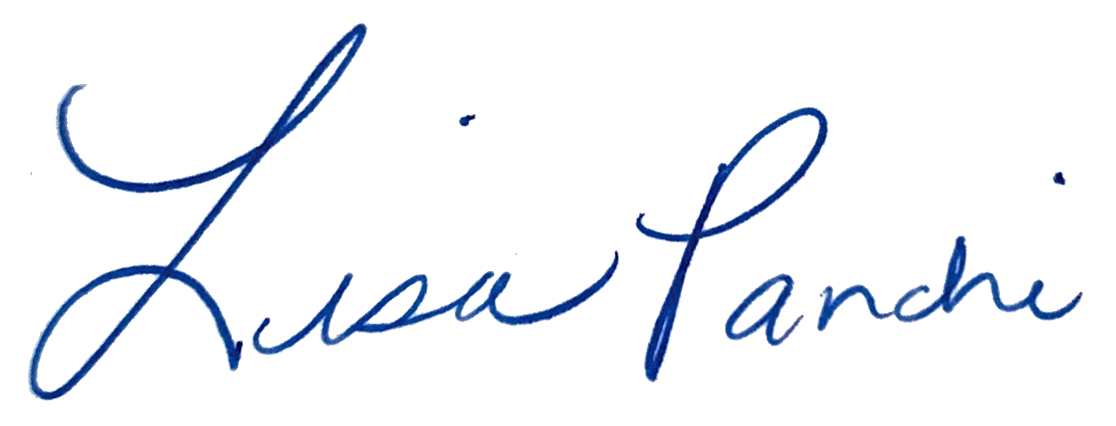
Lisa M. Panahi
General Counsel

Electronic copy filed with the
Clerk of the Supreme Court of Arizona
this 1st day of May 2024.

by: PSeguin

