Lisa M. Panahi, Bar No. 023421
General Counsel
State Bar of Arizona
4201 N. 24th Street, Suite 100
Phoenix, AZ 85016-6288
(602) 340-7236

IN THE SUPREME COURT
STATE OF ARIZONA
In the Matter of:  PETITION TO AMEND RULES 14.4 AND 17.2 OF THE ARIZONA RULES OF CRIMINAL PROCEDURE | Supreme Court No. R-24-0025  STATE BAR OF ARIZONA COMMENT

Pursuant to Rule 28(e) of the Arizona Rules of Supreme Court, the State Bar of Arizona (the “State Bar”) hereby submits the following as its comment to the above-captioned Petition.
After review by the State Bar’s Criminal Practice and Procedure Committee, the State Bar supports the Petition, apart from its proposal to add a new Rule 17.2(b)(3).
The State Bar agrees with the aim of the proposed amended rule to better inform criminal defendants about collateral consequences associated with a guilty plea. The State Bar believes that the proposal adding Rule 14.4(e)(7)–(8) and Rule 17.2(b)(1) accomplish this. However, the State Bar is concerned that the proposal to add Rule 17.2(b)(3) (Other Collateral Consequences) could confuse criminal defendants, lead to delays, and invite litigation concerning the adequacy of the court’s advisement.
Proposed Rule 17.2(b)(3) would require courts to “advise that a plea may have other collateral consequences, depending on the nature of the case.” This requirement is vague and does not provide courts guidance as to what additional collateral consequences it is required to advise a defendant of. If the court provides the advisement as it is written in the rule, defendants may ask for clarity as to what the additional collateral consequences may be. This, in turn, could result in delays in the case as continuances are requested to allow counsel to further advise defendants concerning what those collateral consequences may be.
Further, the vagueness in the rule could invite litigation in post-conviction relief proceedings. Defendants could assert that their plea was not knowing, intelligent or voluntary because the court did not specifically advise the defendant of every conceivable collateral consequence of their guilty plea. Likewise, it could lead assertions that trial counsel was ineffective for failing to make sure that the trial court advised the defendant of a specific collateral consequence.
Because of the uncertainty created by the vague language contained in Proposed Rule 17.2(b)(3), the State Bar does not support its adoption as part of Rule Petition. The State Bar otherwise supports the Petition.
CONCLUSION
The State Bar of Arizona respectfully requests that this Court adopt the Proposed Rule, except for Proposed Rule 17.2(b)(3).
RESPECTFULLY SUBMITTED this 1st day of May 2024.

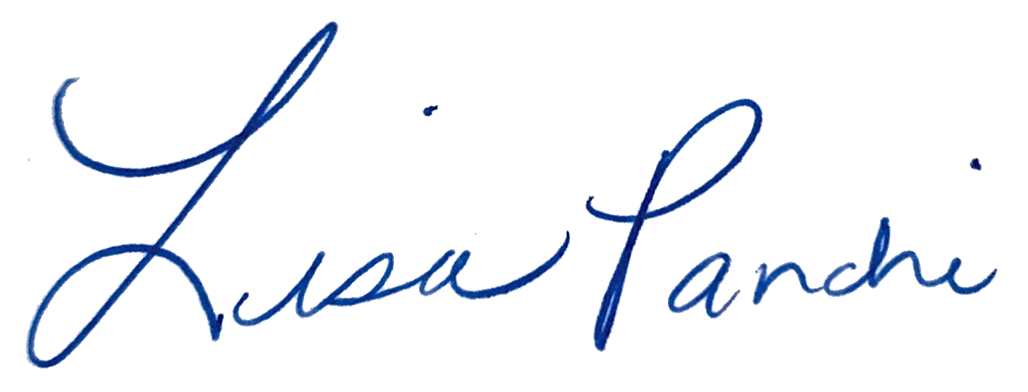
Lisa M. Panahi
General Counsel

Electronic copy filed with the
Clerk of the Supreme Court of Arizona
this 1st day of May 2024.

by: PSeguin

While Proposed Rule 14.4(e)(7)–(8) is similarly vague in terms of identifying possible collateral consequences, because this advisement is given as part of the arraignment, the State Bar does not have the same concerns that it would lead to delays and invite unnecessary litigation.

