Lisa M. Panahi, Bar No. 023421
General Counsel
State Bar of Arizona
4201 N. 24th Street, Suite 100
Phoenix, AZ 85016-6288
(602) 340-7236

IN THE SUPREME COURT
STATE OF ARIZONA
In the Matter of:  PETITION TO AMEND APPENDIX A OF THE ARIZONA RULES OF PROCEDURE FOR EVICTION ACTIONS | Supreme Court No. R-24-0023  STATE BAR OF ARIZONA COMMENT

Pursuant to Rule 28(e) of the Arizona Rules of Supreme Court, the State Bar of Arizona (the “State Bar”) hereby submits the following as its comment to the above-captioned Petition.
After study and discussion by the State Bar’s Civil Practice and Procedure Committee, the State Bar supports the Petition to revise the Residential Eviction Information Sheet (“REIS”) and submits this Comment urging the Court to adopt the Petition.
- INTRODUCTION
The State Bar is in support of any efforts to make a court form or any accompanying instructions more user-friendly in the interests of greater access to justice. If a court form is unintelligible to many of its lay users, that is problematic even if it is intelligible to an attorney. The State Bar applauds petitioners’ efforts to improve accuracy, completeness, and plain language in the REIS. Also laudable is the participation of Community Legal Services, DNA People’s Legal Services, and Southern Arizona Legal Aid, all of which provided substantial input on the substance and linguistic details of proposed revisions based on their day-to-day experiences with clients utilizing the current REIS.
The State Bar has only a few minor changes to suggest:
- In the third line of the REIS, under Notice, the words “In certain cases, if” should be deleted and the words, “In cases where” should be inserted in their place.
- The State Bar questions the use of the word “can” in place of “may” throughout the document, as we believe that imprecise or non-standard English usage in official documents has the potential to confuse tenants, lawyers, or the court even if it is commonplace in colloquial speech. This confusion factor may tend to outweigh any purported plain-English advantage.
- The “Legal Representation” section only references attorneys representing parties in these cases. However, if legal paraprofessionals are eligible to represent both landlords and tenants in eviction matters, that reference should be added.
- CONCLUSION
Based on the above, and with the suggested changes, the State Bar of Arizona urges the Court to grant this Petition.
RESPECTFULLY SUBMITTED this 1st day of May 2024.

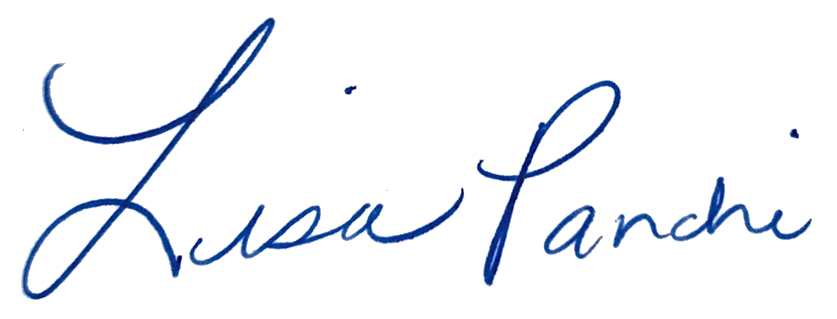
Lisa M. Panahi
General Counsel

Electronic copy filed with the
Clerk of the Supreme Court of Arizona
this 1st day of May 2024.

by: PSeguin

