Lisa M. Panahi, Bar No. 023421
General Counsel
State Bar of Arizona
4201 N. 24th Street, Suite 100
Phoenix, AZ 85016-6288
(602) 340-7236

IN THE SUPREME COURT
STATE OF ARIZONA
In the Matter of:  PETITION TO AMEND RULE 613(b) OF THE ARIZONA RULES OF EVIDENCE | Supreme Court No. R-24-0019  STATE BAR OF ARIZONA COMMENT

Pursuant to Rule 28(e) of the Arizona Rules of Supreme Court, the State Bar of Arizona (the “State Bar”) hereby submits the following as its comment to the above-captioned Petition.
On January 9, 2024, the Advisory Committee on the Rules of Evidence, through its Co-Chairs, the Honorable Sara Agne and the Honorable Maria Elena Cruz, filed a Petition to Amend Arizona Rule of Evidence 613(b). The State Bar supports the Petition. The proposed amendment will make Arizona’s rule consistent with the anticipated amendments to Federal Rule of Evidence 613(b) and will clarify the procedural requirements for admitting extrinsic evidence of a witness’s prior statement.
Arizona Rule of Evidence 613 states that extrinsic evidence of a witness’ prior inconsistent statement is admissible only if the witness “is given an opportunity to explain or deny the statement and an adverse party is given an opportunity to cross examine the witness about it, or if justice so requires.” However, the rule is silent on when these opportunities must occur.
The common law required the adverse party to give a witness an opportunity to explain or deny a prior statement before the witness could be impeached with extrinsic evidence of the prior statement. Current Arizona Rule of Evidence 613(b) allows extrinsic evidence before a witness is given an opportunity to explain or deny the statement, provided there is an opportunity to explain or deny the statement at some point in the trial. The proposed amendment makes it clear that extrinsic evidence of a prior statement is not admissible until the witness is given an opportunity to explain or deny the statement first. The amendment also gives trial courts discretion to dispense with the requirement if the trial court deems it appropriate.
The State Bar concurs with the conclusions of both the federal Advisory Committee and the Arizona Advisory Committee that including a prior presentation requirement is the better rule. Amending Rule 613(b) to include the prior presentation requirement will provide clear timing requirements and avoids the difficulty of re-calling a witness if extrinsic evidence is admitted. The amendment may also save time because witnesses often concede making a prior statement when presented with extrinsic evidence of its making. The proposed amendment also gives appropriate discretion to trial judges to allow later opportunities if appropriate. Finally, the amendment will make Arizona’s rule consistent with the anticipated amended federal rule.
CONCLUSION
The State Bar of Arizona respectfully requests that the Court adopt the proposed amendment.
RESPECTFULLY SUBMITTED this 1st day of May 2024.

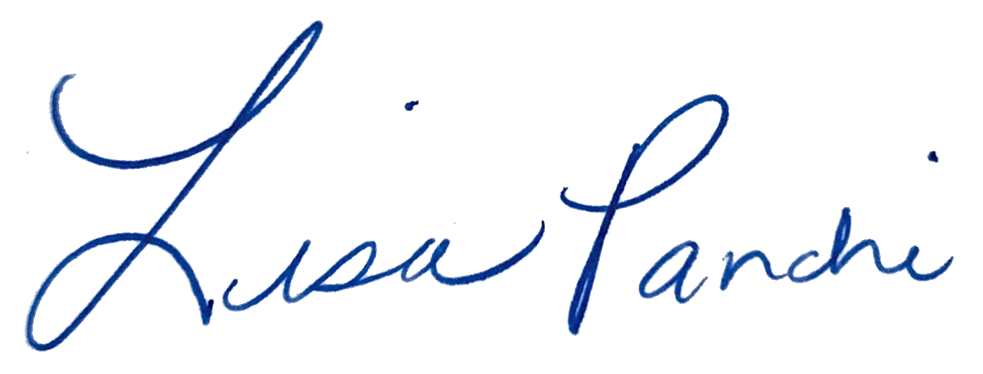
Lisa M. Panahi
General Counsel

Electronic copy filed with the
Clerk of the Supreme Court of Arizona
this 1st day of May 2024.

by: PSeguin

