Lisa M. Panahi, Bar No. 023421
General Counsel
State Bar of Arizona
4201 N. 24th Street, Suite 100
Phoenix, AZ 85016-6288
(602) 340-7236

IN THE SUPREME COURT
STATE OF ARIZONA
In the Matter of:  PETITION TO AMEND RULE 10.2(a) OF THE ARIZONA RULES OF CRIMINAL PROCEDURE | Supreme Court No. R-24-0010  COMMENT OF  THE STATE BAR OF ARIZONA

Pursuant to Rule 28(e) of the Arizona Rules of Supreme Court, the State Bar of Arizona (the “State Bar”) hereby submits the following as its comment to the above-captioned Petition.
After review by the State Bar’s Criminal Practice and Procedure Committee, the State Bar does not support the Petition as written. The stated purpose of the Petition was to correct “an imbalance between prosecutors and defendants.” But instead of correcting an imbalance, the Petition recreates the imbalance, now in favor of a defendant, by removing only the state’s access to relief under Arizona Rule of Criminal Procedure 10.2. Additionally, the Petition’s use of the undefined phrase “a prosecution involving the same subject matter” will lead to unneeded litigation as courts are forced to grapple with the meaning behind the amorphous new phrase.
CONCLUSION
The State Bar of Arizona respectfully requests that the Court not grant the Petition.
RESPECTFULLY SUBMITTED this 1st day of May 2024.

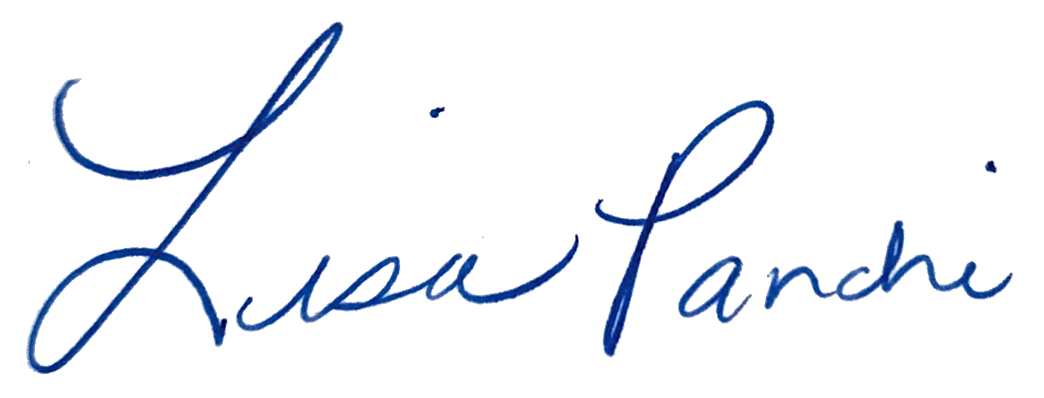
Lisa M. Panahi
General Counsel

Electronic copy filed with the
Clerk of the Supreme Court of Arizona
this 1st day of May 2024.

by: PSeguin

