Lisa M. Panahi, Bar No. 023421
General Counsel
State Bar of Arizona
4201 N. 24th Street, Suite 100
Phoenix, AZ 85016-6288
(602) 340-7236

IN THE SUPREME COURT
STATE OF ARIZONA
In the Matter of:  PETITION TO AMEND RULES 32.14(a) & 33.14(a) OF THE ARIZONA RULES OF CRIMINAL PROCEDURE | Supreme Court No. R-24-0009  STATE BAR OF ARIZONA COMMENT

Pursuant to Rule 28(e) of the Arizona Rules of Supreme Court, the State Bar of Arizona (the “State Bar”) hereby submits the following as its comment to the above-captioned Petition.
After review by the State Bar’s Criminal Practice and Procedure Committee, the State bar supports the Petition as written. As the Petition establishes, prior to restyling, the Arizona Rules of Criminal Procedure permitted a party to file a motion for rehearing after “a final decision.” Ariz. R. Crim. P. 32.9(a)(1) (2017).
In 2017, this Court granted the Petition to Amend the Rules of Criminal Procedure filed under R-17-0002. See Final Order for R-17-0002 (filed Aug. 31, 2017.) The Petition noted its purpose in rewriting the Arizona Rules of Criminal Procedure was to “restyle, simplify, and clarify the language of existing rules, as well to make certain procedural and substantive changes to promote the just resolution of criminal cases.” Petition to Amend the Arizona Rules of Criminal Procedure at 1, R-17-0002 (filed Jan. 08, 2017).
The 2017 Petition included a rule-by-rule explanation of each “substantive and major organizational change” to the Rules. Id. at 6-10. In doing so, the 2017 Petition only recommended a “handful of substantial changes to Rule 32,” none of which limited a party’s ability to a file a motion for rehearing following a court’s dismissal of a notice. Id. at 9-10.
Thus, the 2017 restyling effort appears to have unintentionally limited a party’s ability to file a motion for rehearing following the dismissal of a notice by using more restrictive language authorizing such motions only from a dismissal of a petition. Ariz. R. Crim. P. 32.14(a) & 33.14(a). This omission appears to be unintentional and is exemplified by the ability of a party to seek review in a higher court. Ariz. R. Crim. P. 32.16(a)(1) & 33.16(a)(1) (authorizing a party to petition an appellate court for review of “the dismissal of a notice.”).
If courts construe Rules 32.14(a) and 33.14(a) as written, parties will be forced to burden appellate courts with more litigation to resolve an issue that lower courts have historically been entrusted to resolve. Alternatively, a party may be required to file a successive notice for post-conviction relief. Either result is at odds with the goal of the 2017 restyling objective of promoting clarity and the just resolution of criminal cases. Petition to Amend the Arizona Rules of Criminal Procedure at 1, R-17-0002 (filed Jan. 08, 2017).
CONCLUSION
The State Bar of Arizona respectfully supports the proposed amendments outlined in the Petition.
RESPECTFULLY SUBMITTED this 1st day of May 2024.

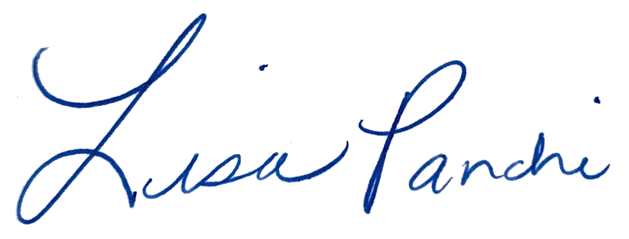
Lisa M. Panahi
General Counsel

Electronic copy filed with the
Clerk of the Supreme Court of Arizona
this 1st day of May 2024.

by: PSeguin

A later petition also led to the adoption of a new Rule 33 to govern post-conviction procedures after a guilty plea, but these changes were not substantive in nature. See State v. Reed, 252 Ariz. 236, 237, ¶1, n. 1 (App. 2021).

