Lisa M. Panahi, Bar No. 023421
General Counsel
State Bar of Arizona
4201 N. 24th Street, Suite 100
Phoenix, AZ 85016-6288
(602) 340-7236

IN THE SUPREME COURT
STATE OF ARIZONA
In the Matter of:  PETITION TO AMEND RULE 31.8(b)(1)(B) OF THE ARIZONA RULES OF CRIMINAL PROCEDURE | Supreme Court No. R-24-0008  STATE BAR OF ARIZONA COMMENT

Pursuant to Rule 28(e) of the Arizona Rules of Supreme Court, the State Bar of Arizona (the “State Bar”) hereby submits the following as its comment to the above-captioned Petition.
After review by the State Bar’s Criminal Practice and Procedure Committee, the State Bar supports the Petition. The State Bar does not believe the proposed rule change would lead to increased delays or expenses to criminal appeals. Including the additional transcripts may, in fact, reduce delays occasioned by requests to expand the record to include jury selection. Additionally, as the Petition notes, including jury selection and hearings establishing prior felony convictions would allow appellate courts to conduct a more thorough review of the record when appellate counsel files a brief pursuant to Anders v. California, 386 U.S. 738 (1967).
CONCLUSION
The State Bar of Arizona respectfully requests that the Proposed Rule be adopted.
RESPECTFULLY SUBMITTED this 1st day of May 2024.

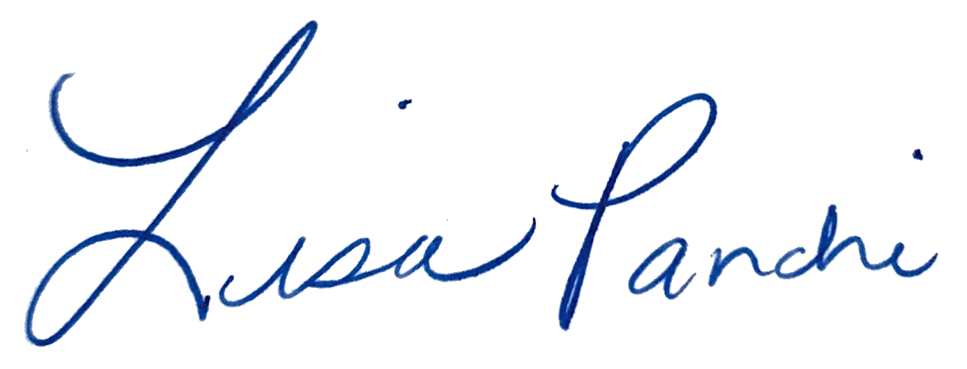
Lisa M. Panahi
General Counsel

Electronic copy filed with the
Clerk of the Supreme Court of Arizona
this 1st day of May 2024.

by: PSeguin

