Lisa M. Panahi, Bar No. 023421
General Counsel
State Bar of Arizona
4201 N. 24th Street, Suite 100
Phoenix, AZ 85016-6288
(602) 340-7236

IN THE SUPREME COURT
STATE OF ARIZONA
In the Matter of:  PETITION TO AMEND RULES 1.5, 17.1, 17.2, AND 17.3 OF THE ARIZONA RULES OF CRIMINAL PROCEDURE | Supreme Court No. R-24-0005  STATE BAR OF ARIZONA COMMENT

Pursuant to Rule 28(e) of the Arizona Rules of Supreme Court, the State Bar of Arizona (the “State Bar”) hereby submits the following as its comment to the above-captioned Petition.
After review by the State Bar’s Criminal Practice and Procedure Committee, the State Bar does not support the Petition as written. The Committee has concerns as to the efficacy and constitutionality of the requested changes.
Arizona Rule of Criminal Procedure 1.5(c) treats an appearance using interactive audiovisual system as the equivalent to an appearance in person. The rule currently limits the types of proceedings in which a court can, without the consent of the parties, require the use of an interactive audiovisual system. The proceedings included in the rule currently are generally uncontested.
The Petition seeks to extend the types of proceedings which a court can require a defendant’s appearance, without the consent of either party, by use of an interactive audiovisual system far beyond the proceedings contemplated by the current rule. The new proceedings would include sentencings and dispositions, which are traditionally contested. Additionally, the Petition’s amendment of Rule 1.5(c) from “a change of plea in a misdemeanor case” to “a change of plea to any misdemeanor offense and sentencing” would allow the use of such systems without the consent of the parties in non-limited jurisdiction courts. A result that exceeds the stated purpose of the Petition.
The Petition’s changes to Rule 17.1 also raise concerns for the State Bar’s Criminal Practice and Procedure Committee. First, proposed Rule 17.1(f) seems to be modeled after current Rule 17.1(f) and relates to telephonic pleas. However, current Rule 17.1(f)(1)(B) details what documents must be provided to the court, while proposed Rule 17.1(f)(1)(B) details what documents are given to the defendant.
Second, the proposed rule does not require that a defendant be given a physical copy of the plea agreement before, during, or after the proceeding. This is a particular issue with defendants who are in custody who may not have access to a means to view the electronic copy of the plea agreement the rule requires be provided to them.
Finally, the Petition’s proposed change to Rule 17.3 is overbroad. It seeks to remove the requirement that a defendant be addressed personally in open court to determine whether a plea is entered voluntarily and intelligently. This is a broad change that would apply to all cases in all courts. This change exceeds the stated purpose of the Petition and raises serious constitutional concerns.
CONCLUSION
The State Bar encourages the use of interactive audiovisual systems under appropriate circumstances. However, the Petition seeks to extend their use without consent of the parties to potentially contested hearings in a manner that would likely violate the United States and Arizona Constitutions. Therefore, the State Bar of Arizona respectfully requests that the Court not grant the Petition.
RESPECTFULLY SUBMITTED this 1st day of May 2024.

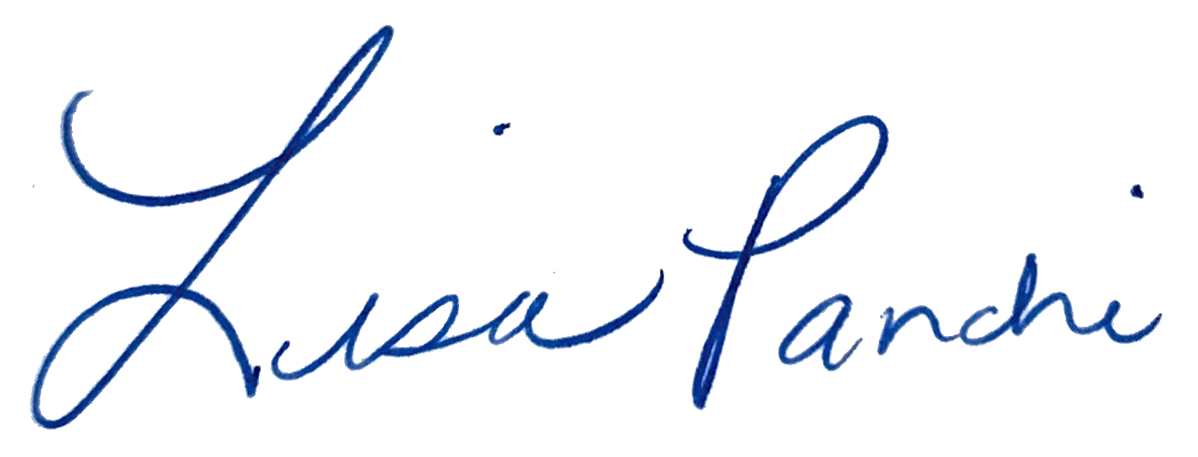
Lisa M. Panahi
General Counsel

Electronic copy filed with the
Clerk of the Supreme Court of Arizona
this 1st day of May 2024.

by: PSeguin

