Lisa M. Panahi, Bar No. 023421
General Counsel
State Bar of Arizona
4201 N. 24th Street, Suite 100
Phoenix, AZ 85016-6288
(602) 340-7236

IN THE SUPREME COURT
STATE OF ARIZONA
In the Matter of:  PETITION TO PERMANENTLY ADOPT RULES FOR THE FAST TRIAL AND ALTERNATIVE RESOLUTION PROGRAM (“FASTAR”) | Supreme Court No. R-24-0004  STATE BAR OF ARIZONA COMMENT

Pursuant to Rule 28(e) of the Arizona Rules of Supreme Court, the State Bar of Arizona (the “State Bar”) hereby submits this comment in support of the Petition filed in this matter.
The State Bar endorses the Petition proposed by the Honorable Jeffrey Bergin on behalf of the Superior Court in Pima County. The Petition requests the Court permanently adopt the Fast Trial and Alternative Resolution (“FASTAR”) Rules (currently designated as FASTAR Rules 101 through 126 and associated forms) in any county that authorizes its use in lieu of compulsory arbitration under Arizona Rules of Civil Procedure 72 through 77. The Petition also requests the Court modify the FASTAR Rules to remove specific references in FASTAR Rule 101(a) to FASTAR being a pilot program in Pima County—as granting the Petition would make it a permanent program—and to modify FASTAR Rule 126(a)(2) so that de novo appeals from arbitration hearings on the Alternative Resolution Track would occur via a fast trial governed by FASTAR Rules 110 through 119, rather than by a trial governed by the regular rules of procedure applicable to other civil cases as occurs at present.
The State Bar supports the Petition to make the FASTAR pilot program permanent, subject to the proposed modifications, for the reasons explained therein. The FASTAR program has reduced the disposition time for the class of cases within the pilot program without burdening the superior court bench or administration. This reduced disposition time, in turn, furthers the Court’s strategic goal of improving access to the justice. The Superior Court in Pima County is pleased with this program and wishes for it to continue permanently. If the courts in other counties wish to adopt the FASTAR program, they should have the opportunity to adopt it too.
RESPECTFULLY SUBMITTED this 1st day of May 2024.

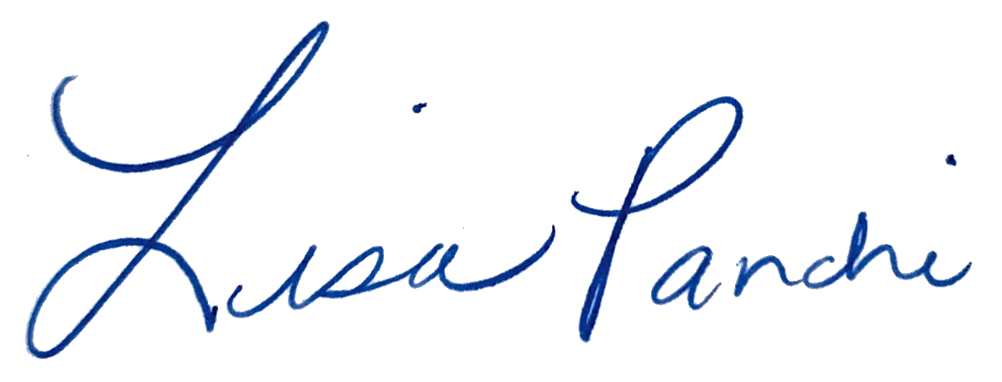
Lisa M. Panahi
General Counsel

Electronic copy filed with the
Clerk of the Supreme Court of Arizona
this 1st day of May 2024.

by: PSeguin

