Lisa M. Panahi, Bar No. 023421
General Counsel
State Bar of Arizona
4201 N. 24th Street, Suite 100
Phoenix, AZ 85016-6288
(602) 340-7236

IN THE SUPREME COURT
STATE OF ARIZONA
In the Matter of:  PETITION TO AMEND RULE 4.1(d) OF THE ARIZONA RULES OF CIVIL PROCEDURE AND RULE 41(c) OF THE ARIZONA RULES OF FAMILY LAW PROCEDURE | Supreme Court No. R-24-0002  STATE BAR OF ARIZONA COMMENT

Pursuant to Rule 28(e) of the Arizona Rules of Supreme Court, the State Bar of Arizona (the “State Bar”) hereby submits the following as its comment to the above-captioned Petition.
- the rules and the PETITION’S proposed changes
The Rules govern the manner of service of an individual. Under each Rule,
an individual may be served by:

(1) delivering a copy of the summons and the pleading being served to that individual personally;

(2) leaving a copy of each at that individual's dwelling or usual place of abode with someone of suitable age and discretion who resides there; or

(3) delivering a copy of each to an agent authorized by appointment or by law to receive service.
See Ariz. R. Civ. P. 4.1(d); Ariz. R. Fam. L. P. 41(c).
The Petition proposes amending subsection (2) by requiring that the person of “suitable age and discretion” residing at the “individual’s dwelling or usual place of abode” be “at least 16 years of age.”
- THE STATE BAR OPPOSES THE PETITION
The State Bar opposes the amendments proposed in the Petition for four reasons.
First, although Petitioner refers to “attorneys, self-represented litigants and process servers who don’t really care about proper service” and thereby abuse the current Rules, it does not provide any specific evidence of this, let alone any evidence of a systemic problem. The Rules presently provide that the subsection (2) person be “of suitable age and discretion,” a familiar term that has been in the Rules for decades. Given this, there is little reason, even in the abstract, to provide a minimum age requirement. Further, non-inclusion of a minimum age in the Rules constitutes persuasive evidence that the question of whether a person is of “suitable age and discretion” is intended to be a question of fact under the circumstances presented in each case. See Holmen v. Miller, 296 Minn. 99, 206 N.W.2d 916 (1973).
Second, although not technically required by the proposed amendments, the State Bar is concerned that the amendment would alter the practice of service by having process servers ask the person to be served for identification to confirm age, which could implicate of a number of privacy and other rights of that person. If the amendment were adopted, it is unclear how a process server would verify that someone is at least 16 years of age to confirm that substitute service was proper. Would the sub-service recipient affirm, or must they present identification? Would a method of age verification then need to be described in the affidavit of service? And further, would false information provided by a sub-service recipient later invalidate service? These interactions might also take place disproportionally in low-income households, in which adults are less likely to have any childcare or have childcare in out-of-home programs and settings.
Third, again, although not technically referred to by the proposed amendment, the State Bar is concerned that the amendment could create the false impression that, so long as the individual is at least sixteen years old, the “suitable age and discretion” requirement is satisfied. This concern is heightened because, once made, proof of service “can be impeached only by clear and convincing evidence.” See General Elec. Capital Corp. v. Osterkamp, 172 Ariz. 191, 194 (App. 1992).
Fourth, the proposed amendments would render the Rules inconsistent with their federal counterpart. See Fed. R. Civ. P. 4(e)(2). Although the state rules do depart in some instances from their federal counterparts, in general, there should be a good reason, at the very least, to justify the departure. The fact that the federal rules have not been amended to add this minimum-age requirement is further evidence that there is not a systemic problem that needs to be redressed.
- CONCLUSION
The State Bar opposes the Petition, and requests that the Court deny it.
RESPECTFULLY SUBMITTED this 1st day of May 2024.

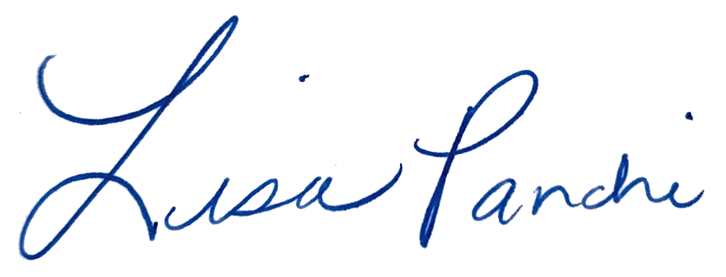
Lisa M. Panahi
General Counsel

Electronic copy filed with the
Clerk of the Supreme Court of Arizona
this 1st day of May 2024.

by: PSeguin

United States Census Bureau, “Most Parents Don’t Have Any Formal Child Care Arrangements,” Figure 3, (November 29, 2023), available at https://www.census.gov/library/stories/2023/11/child-care.html (last visited February 16, 2024).

