Lisa M. Panahi, Bar No. 023421
General Counsel
State Bar of Arizona
4201 N. 24th Street, Suite 100
Phoenix, AZ 85016-6288
(602) 340-7236

IN THE SUPREME COURT
STATE OF ARIZONA
In the Matter of:  PETITION TO AMEND ER 1.8, RULE 42 OF THE ARIZONA RULES OF SUPRME COURT | Supreme Court No. R-23-0051  STATE BAR OF ARIZONA COMMENT

Pursuant to Rule 28(e) of the Arizona Rules of Supreme Court, the State Bar of Arizona (the “State Bar”) hereby submits the following as its comment to the above-captioned Petition.
Petition R-23-0051 proposes to amend Ethical Rule (“ER”) 1.8, Arizona Rule of the Supreme Court 42. In its current form, ER 1.8(e) generally prohibits a lawyer from providing “financial assistance to a client in connection with pending or contemplated litigation.” This Petition proposes to modify this Rule to allow lawyers to provide modest gifts for living expenses to indigent clients. The State Bar generally supports this proposed Rule change and its underlying rationale, albeit with two revisions. Specifically, the State Bar recommends the deletion of the last sentence in proposed ER 1.8(e) and deletion of proposed Comment [11], as explained further below.
The proposed addition to ER 1.8(e), in the last sentence, states that, “Financial assistance under this Rule may be provided even if the representation is eligible for fees under a fee-shifting statute.” Proposed Comment [11], in turn, states:
Financial assistance, including modest gifts pursuant to paragraph (e)(3), may be provided even if the representation is eligible for fees under a fee-shifting statute. However, paragraph (e)(3) does not permit lawyers to provide assistance in other contemplated or pending litigation in which the lawyer may eventually recover a fee, such as contingent-fee personal injury cases or cases in which fees may be available under a contractual fee-shifting provision, even if the lawyer does not eventually receive a fee.

The Petition contains no explanation for permitting financial assistance to indigent clients when fees may be awarded or recovered, but only when recovery is pursuant to a fee-shifting statute. See Ariz. R. Sup. Ct. 28(a)(4)(A)(i) (a rule petition “must . . . explain why the Court should adopt, amend, or abrogate rules”).
This carve-out could lead to confusion about the scope of the Rule, as well as inconsistent application and enforceability.
A hypothetical illustrates some of these concerns: Two parties are litigating an alleged breach of contract. The contract contains a fee-shifting provision (which would mean the lawyer could not give financial assistance under proposed ER 1.8(e)).
At the outset of the representation, one party disputes the validity of the contract (and, by extension, the contractual fee-shifting provision). If the contract is found to be valid and enforced, the contractual provision likely would apply to shift fees to the prevailing party. But if the contract is not upheld, fees still may be available pursuant to statute, such as A.R.S. § 12-341.01 (which generally permits fee shifting in cases arising out of contract). In the latter instance, a lawyer would be permitted to provide financial assistance to a client under proposed ER 1.8(e).
A lawyer in such a representation, however, would have a very difficult time discerning whether he/she could offer financial assistance to the client, particularly before any conclusions regarding fee shifting (and the basis therefore) are reached. Arguably, ER 1.8(e) as-written both expressly permits AND disallows such assistance in this case, unless application of the Rule requires the parties to wait until the court awards or denies fees. In addition to causing confusion, such delays would be of little help to lawyers or clients subject to the financial assistance permitted by proposed ER 1.8(e), particularly in the absence of any meaningful justification for the distinction.
As another example, under the current proposal, a lawyer in a contingency fee representation could not provide financial assistance to a client, even if all other provisions of proposed ER 1.8(e) are met; yet if the court determines a lawyer or party in that representation has engaged in unreasonable conduct, fees could be awarded pursuant to A.R.S. § 12-349. In this example, financial assistance both would be prohibited due to the contingent nature of the representation and expressly permitted because of the presence of a fee-shifting statute. To the degree financial assistance will be allowed only if and when statutory fees are awarded, it is difficult to see why the availability of statutory fees at this later date justifies the charitable financial assistance prescribed by proposed ER 1.8(e).
Finally, the proposed Comment [11] appears to limit the scope and application of the Rule in a manner not found in the text of the Rule, which could lead to additional confusion regarding the Comment’s application and effect. See Ariz. R. Sup. Ct. 42, Preamble [21] (“The Comments are intended as guides to interpretation, but the text of each Rule is authoritative.”).
Ultimately, the State Bar believes that the proposed language found in the last sentence of ER 1.8(e)(3), as well as proposed Comment [11] to that Rule, will cause confusion and potentially inconsistent application of the Rule, and recommends that it be stricken. The State Bar recommends that Petition R-23-0051 be granted with this language and comment removed.
CONCLUSION
The State Bar of Arizona respectfully requests that the Court grant Petition R-23-0051, absent the following language:
ER 1.8(e)(3) . . . Financial assistance under this Rule may be provided even if the representation is eligible for fees under a fee-shifting statute.

ER 1.8 proposed cmt [11] Financial assistance, including modest gifts pursuant to paragraph (e)(3), may be provided even if the representation is eligible for fees under a fee-shifting statute. However, paragraph (e)(3) does not permit lawyers to provide assistance in other contemplated or pending litigation in which the lawyer may eventually recover a fee, such as contingent-fee personal injury cases or cases in which fees may be available under a contractual fee-shifting provision, even if the lawyer does not eventually receive a fee.

RESPECTFULLY SUBMITTED this 1st day of May 2024.

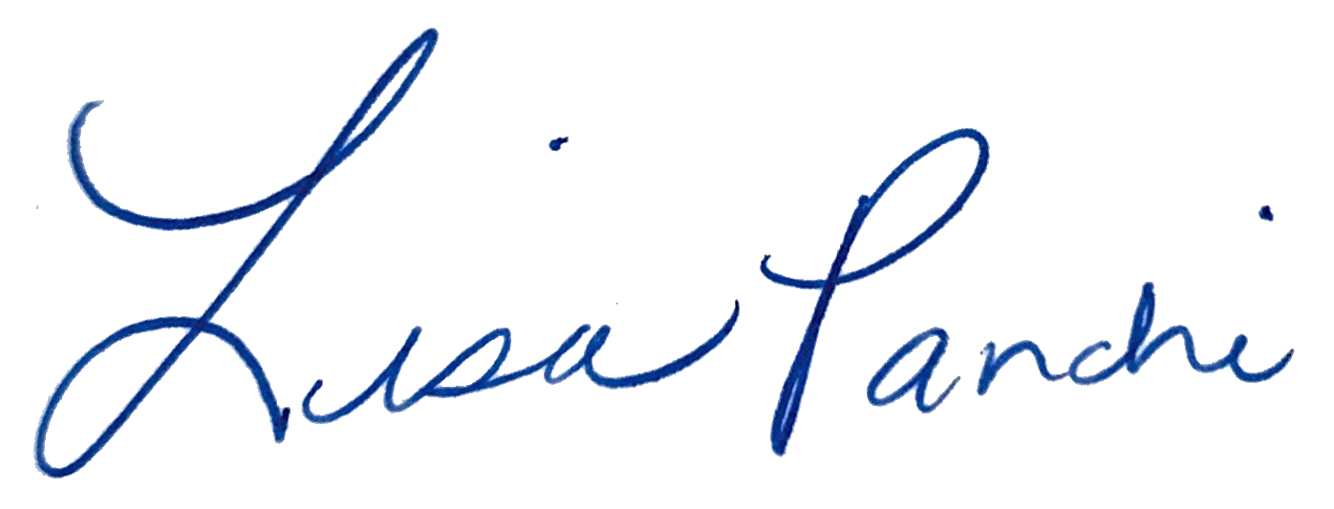
Lisa M. Panahi
General Counsel

Electronic copy filed with the
Clerk of the Supreme Court of Arizona
this 1st day of May 2024.

by: PSeguin

